Department of Veterans Affairs

HealtheLiving Assessment (HLA)

System Design Document



September 2014

Version 1.0

Revision History

|  |  |  |  |
| --- | --- | --- | --- |
| Date | Version | Description | Author |
| June 26, 2014 | 0.1 | Updated HRA SDD for initail draft of the HLA SDD by Vail Kelly | Jim Reich |
| September 2014 | 0.2 | Updates and edits to SDD by Cheryl Rasband | Julius Allen |
| October 3, 2014 | 0.3 | Updates and edits to SDD by Justin Ellery | Justin Ellery |
| October 2014 | 1.0 | Baselined for Signatures by Cheryl Rasband | Justin Ellery |

Table of Contents

1. Introduction 1

1.1. Purpose of this Document 1

1.2. Identification 2

1.3. Scope 2

1.4. Relationship to Other Plans 2

1.5. Methodology, Tools, and Techniques 2

1.6. Policies, Directives and Procedures 3

1.7. Constraints 3

1.8. Design Trade-offs 3

1.9. User Characteristics 4

1.9.1. User Problem Statement 4

1.9.2. User Objectives 4

1.10. Document References 4

2. Background 5

2.1. Project Increments 5

2.2. Overview of the System 5

2.3. Overview of the Business Process*.* 6

2.4. Business Benefits 7

2.5. Assumptions, and Constraints 7

2.5.1. Design Assumptions 7

2.5.2. System Load Assumptions 7

2.5.3. Expected Impact on Network Infrastructure base on NCP-Forecasted HLA Usage 8

2.5.4. Concurrent User Capacity of the Expert-24 COTS Application** 9

2.5.5. Environments 9

2.6. Design Constraints 10

2.7. Overview of the Significant Requirements 10

2.7.1. Overview of Significant Functional Requirements 10

2.7.2. Functional Workload and Functional Performance Requirements 19

2.7.3. Operational Requirements 19

2.7.4. Overview of the Technical Requirements 19

2.7.5. Overview of the Security or Privacy Requirements 20

2.7.6. System Criticality and High Availability Requirements 20

2.7.7. Special Device Requirements 20

2.8. Legacy System Retirement 20

3. Conceptual Design 21

3.1. Conceptual Application Design 21

3.1.1. Application Context 21

3.1.2. High Level Application Design 23

3.1.3. Application Locations 27

3.1.4. Application Users 28

3.2. Conceptual Data Design 28

3.2.1. Project Conceptual Data Model 28

3.2.2. Database Information 28

3.3. Conceptual Infrastructure Design 29

3.3.1. System Criticality and High Availability 29

3.3.2. Special Technology 29

3.3.3. Technology Locations 30

3.3.4. Conceptual Infrastructure Diagram 31

4. System Architecture 34

4.1. Hardware Architecture 34

4.1.1. Hardware Infrastructure Design 34

4.2. Software Architecture 35

4.2.1. System Software 35

4.2.2. Software Modules 35

5. Data Design 39

5.1. Database Management System Files 39

5.1.1. Logical Database Model 39

5.1.2. Physical Database Model 45

5.1.3. Database Schema 49

5.1.4. Database Files 93

5.1.5. Database Access 93

5.2. Non-Database Management System Files 93

5.2.1. Properties Files 93

5.2.2. Log Files 101

6. Detailed Design 102

6.1. Hardware Detailed Design 102

6.2. Software Detailed Design 104

6.2.1. Genereric Components 104

6.2.2. Main Application 104

6.2.3. Integration Application 105

6.2.4. Administration Application 105

6.2.5. Analytics Application 105

6.2.6. Static Content Application 105

6.2.7. Expert-24 Data Service 105

6.3. Communications Detailed Design 115

7. External Interface Design 115

7.1. Interface Architecture 115

7.2. Interface Detailed Design 116

8. Human-Machine Interface 117

8.1. Interface Design Rules 117

8.2. Inputs 117

8.3. Outputs 117

8.4. Navigation Hierarchy 117

8.4.1. Main Application: Welcome Page 117

8.4.2. Main Application: Privacy Reminder Page 123

8.4.3. Main Application: User Profile Page 123

8.4.4. Main Application: Assessment History Page 124

8.4.5. Main Application: Answer Questions Pages 127

8.4.6. Main Application: Review Answers Page 134

8.4.7. Main Application: Share Assessment Page 136

8.4.8. Main Application: Summary Report Page 137

8.4.9. Main Application: Full Report Page 140

8.4.10. Main Application: Help Topics Page 145

8.4.11. Main Application: Frequently Asked Questions (FAQs) Page 146

8.4.12. Main Application: Tips Page 149

8.4.13. Analytics Application: Login Page 149

8.4.14. Analytics Application: Welcome Page 150

8.4.15. Analytics Application: Synchronization Page 152

8.4.16. Analytics Application: View Report History Page 153

8.4.17. Analytics Application: Create Report Page 154

8.4.18. Analytics Application: View Report Page 156

8.4.19. Analytics Application: Printer-friendly View Report Page 156

8.4.20. Analytics Application: Create Extract Page 157

8.4.21. Administration Application: Login Page 158

8.4.22. Administration Application: Welcome Page 159

8.4.23. Administration Application: User Account List Page 160

8.4.24. Administration Application: User Account Creation Page 161

8.4.25. Administration Application: Change Password Page 162

8.4.26. Administration Application: Change Temporary Page 163

8.4.27. Administration Application: Change Profile Page 164

8.4.28. Administration Application: Edit Account Information Page 165

8.4.29. Administration Application: Audit Log Page 166

8.4.30. Administration Application: View Audit Details Page 167

8.4.31. Administration Application: Message Log Listing Page 168

8.4.32. Administration Application: Clinical Model Information Page 169

9. System Integrity Controls 170

10. Appendix A 171

10.1. Requirements Traceability Matrix 171

10.2. Packaging and Installation 171

10.3. Design Metrics 171

10.4. Glossary of Terms 171

10.5. Required Technical Documents 171

10.6. Definitions, Acronyms and Abbreviations 172

Attachment A - Approval Signatures 174

# Introduction

The Veterans Health Administration (VHA), within the Department of Veterans Affairs, is the agency responsible for delivery of health care to eligible Veterans. The VHA National Center for Health Promotion and Disease Prevention (NCP), a section of the Office of Patient Care Services within VHA, was established in 1995 to provide a central office for monitoring and improving VHA services related to health promotion and disease prevention. The NCP is charged with coordinating an administration-wide initiative to develop and implement a HealtheLiving Assessment (HLA) for use by VA beneficiaries. As the business owner of this initiative, NCP is working closely with designated representatives from the VHA Office of Health Information (VHA OHI) and VA Office of Information and Technology (VA OI&T) to ensure an efficient acquisition and deployment process.

Electronic HLAs are tools that collect information directly from patients through the use of structured questionnaires that are presented to patients through an online/web portal or interface. The questions presented to patients often use skip patterns or branching logic to minimize respondent burden and control the flow and granularity of items presented. Based on patient responses, HLAs can provide tailored feedback about an individual’s health status, with specific recommended steps to improve health. Core features of an HLA include assessment of personal information, past medical and surgical history, medications, family history, health behaviors, and receipt of preventive care. Elements also desirable include information of self-care management for common chronic conditions such as diabetes and heart disease, health risks relevant to the elderly (such as fall risk), and readiness-to-change for health behaviors that increase patient risk for disease and/or injury.

The core of this HLA system is Expert-24’s COTS software suite that is used to power several prominent healthcare organizations in the U.S. such as WebMD, the Mayo Foundation, and Group Health. The system uses HLA content authored with the Expert-24 technology based on Microsoft Visio tools. The content is stored within a database.The data is supplied from an Expert-24 data web service to a VA custom front-end web application.This approach provides flexibility and unlimited customization. Since the system is data and model driven, the HLA content can be changed without requiring any changes to web application code.

## Purpose of this Document

The purpose of this document is to describe in sufficient detail how the proposed system is to be constructed. The System Design Document translates the Requirement Specifications into a document from which the developers can create the actual system.

This document identifies the system architecture consisting of the hardware infrastructure and top-level software required to support the various instances of the HLA system in a VA environment. It describes all system instances used in the development lifecycle of the system. This document includes specifications for all hardware, such as application servers, web servers, data base servers, and storage devices.

Furthermore, the document identifies the system communication and interface components, as well as a design for the custom HLA application.

## Identification

## Scope

**Table 1 Scope Inclusions**

|  |
| --- |
| Includes |
| Hardware, software and custom application needed to run the VA customized Expert-24 application, including notification/reporting services used by My HealtheVet/CPRS. |

Table 2 Scope Exclusion

|  |
| --- |
| Excludes |
| Hardware, software and custom applications needed for web service(s) at My HealtheVet (MHV)/Master veteran Index (MVI)/Medical Domain Web Services (MDWS) that will support the HLA system |

## Relationship to Other Plans

|  |  |  |
| --- | --- | --- |
| Document | Version | Relationship |
| HLA Requirements Specification Document | 3.6 | System Requirements |
| Healthy Living Assessment (HLA) Core System – System Security Plan | 1.0 | System Security Planning |
| Healthy Living Assessment (HLA) Core System – Risk Assessment Plan | 1.0 | System Security Planning |
| Healthy Living Assessment (HLA) Core System – Incident Reponse Plan | 1.0 | System Security Planning |
| Healthy Living Assessment (HLA) Core System – Configuration Management Plan | 1.0 | Configuration Management |

## Methodology, Tools, and Techniques

The HLA project uses the following tools:

* Rational Requirements Composer (RRC) to develop requirements, specifically Use Case Spectifications and Wireframes
* Rational Quality Manager (RQM) to plan and manage testing.
* Rational Team Concert (RTC) to plan development activities and monitor progress, as well a for Source Code Control (SCC). RTC integrates with RRC and RQM, such that many activities and artifacts can be linked. This provides traceability from requirements through to test results.
* Microsoft Sharepoint to maintain version tracking of various documents, such as the Requirement Specification Document (RSD), Configuration Management Procedures and Subsystem Design documents.
* Microsoft Word to maintain the various documents
* Microsoft Visio to maintain UML (and other) diagrams in support of the various documents.

## Policies, Directives and Procedures

The following policies apply to the hardware infrastructure:

* OIT Infrastructure Standards
* OIT System Engineering and Design Review (SEDR) process
* Enterprise Architecture
* One-VA TRM

## Constraints

The preselected COTS HLA solution provided by Expert-24 must be deployed on the Microsoft Server 2008 platform, as it requires the .NET Framework. Furthermore, it depends on using a Microsoft SQL Server 2008.

Any hardware selected for the Windows Server platforms must be listed in the Cluster Solutions section of the Microsoft Hardware Compatibility List (HCL), which can be found at <http://www.windowsservercatalog.com/>.

Likewise when using virtualization for the Windows Server Platforms, hardware must be validated using the Microsoft Windows Server validation Program, which can be found at <http://windowsservercatalog.com/svvp.aspx?svvppage=svvp.htm>

## Design Trade-offs

The following design trade-offs have been made:

* The web application code will use JPA, the Java object-relational mapping (ORM) that is part of the Java EE standard. ORM is a programming technique for converting data between the incompatible type systems of object-oriented language (here: Java) and the relational query language. Compared to traditional techniques of exchange between an object-oriented language and a relational database, ORM often reduces the amount and the complexity of the code that needs to be written. ORMs also prevent SQL Injection attacks by default (when not using native queries). A disadvantage of ORMs (JPA) is that it cannot always utilize highly optimized database-specific capabilities, such that performance may not be optimal. In this case, the added simplicity of an ORM outweighs possible performance reduction.
* The web application will use Spring framework (core, security and MVC) for inversion of control. Inversions of control techniques help build code that is highly decoupled.
* The web application will use tag libraries to generate most of its web output. Tag libraries may increase cost of generating the output, but can help to ensure consistency and ease of maintainability (specifically, fixing problems in the tag library will fix the problem across the entire code base).

## User Characteristics

The user community consists mainly of veterans that may or may not be patients at a VA Medical Center (VAMC). These users will access the system through the veteran’s health care portal MyHealtheVet (MHV). The proficiency of this user base with software systems ranges from near illiterate to very competent.

### User Problem Statement

Patients need to have a tool that allows them to assess their health risks themselves, perform what-if analysis on the assessment results, and share those results with their health care teams.

In addition, the current VA electronic health records do not include lifestyle information such as alcohol use and dieting habits. Users need that data to be added to their records.

### User Objectives

* Veteran’s Experience & Information
* Provision of Patient Summary Report
* Increase Awareness of Personal Risk Factors
* Actions for Maintaining/Improving Health
* Providing Sensitive Health Info to VHA
* Establishing Collaborative Health-Related Goals & Monitoring Progress

## Document References

* HLA Development Manual
* HLA Requirements Traceability Matrix
* HLA Installation Instructions document
* HLA Framework Subsystem Design
* HLA User Authentication Subsystem Design
* HLA Assess Health Risks Subsystem Design
* HLA PDF Report Generation Subsystem Design
* HLA Summary Report Subsystem Design
* HLA Health Care Team Report Subsystem Design
* HLA Integration Subsystem Design
* HLA User Management Subsystem Design
* HLA Auditing Subsystem Design
* HLA Analytics Subsystem Design
* MVI-HLA Integration System Design Document

# Background

## Project Increments

The project will be implemented in 1 increment. The following is the planned scope for Increment #1:

1. Improved data capture from VistA
2. Capture of VA facility information
3. Redesign of existing Summary and Health Care Team reports
4. Addition of clinical and Secure Messaging reports
5. Migration of the reporting database to the Corporate Data Warehouse
6. Responsive design methodology to access the HLA on portable devices

## Overview of the System

The HLA system will have the following business functions that will be implemented throughout the aforementioned increments

* Online Healthy Living Assessment
* Users of the My HealtheVet (MHV) system can assess their health risks online. The questionnaire will be prepopulated with health Information from 3 different sources:
* Previous health assessments will provide self-entered health information.
* The Personal Health Record (eVault, the MHV repository) will provide self-entered health information
* The VA Electronic Health Record, the Veterans Health Information Systems and Technology Architecture (VistA), will provide health information recorded by VA health care teams.
* The users will be provided with a Healthy Living Assessment report after completing the HLA questions.
* Modification of HLA Clinical Model
* Clinicians can modify all the HLA questions and branching logic using the Expert-24 authoring toolset.
* Note that these changes can be made in a special staging environment without any application code changes. Authors can use the Expert-24 AssetBuilder application to generate an database update script, after completion of testing the changes to the clinical model. As testing is completed the changes are promoted to the appropriate pre-production environments, before applying it to the production environment. A Configuration Manager or DBA updates the database of the various environments with the generated update scripts.
* Modification of Patient Feedback
* Patient feedback can also be updated using the Expert-24 toolset. This process is similar to the process of modifying HLA clinical model.

## Overview of the Business Process*.*

Figure 1 Authoring Processes Diagram

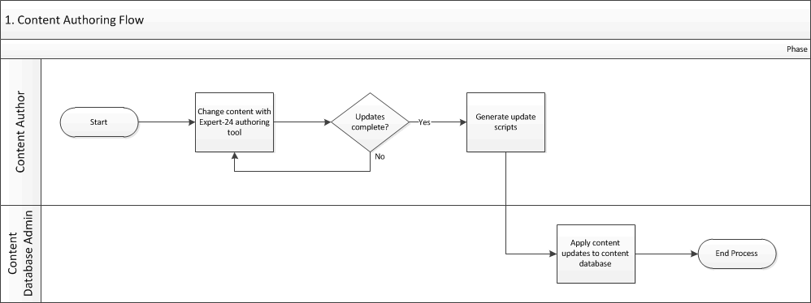

Figure 2 Business Processes Diagram

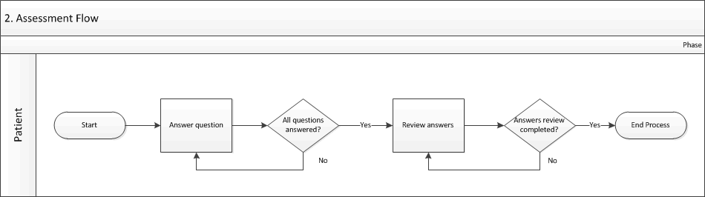

Table 3 Business Processes

|  |  |  |  |  |
| --- | --- | --- | --- | --- |
| Business Process ID | Business Process Name | Type | Owner | Description |
| 1 | Content Authoring Flow | Existing | VA Content Authoring Expert | The Content Authoring Expert makes changes to the content, using the Expert-24 content authoring tool. When changes are complete, the Content Authoring Expert generates update scripts. The Content Database Administrator then applies the scripts to the content database.  Note that business flow does NOT occur in the production system. |
| 2 | Assessment Flow | Existing | VA Patient | The VA patient takes an assessment. |

## Business Benefits

The content authoring approach provides flexibility and unlimited customization. Since the system is data and model driven, the HLA content can be changed without requiring any changes to web application code. Assessments are taken by patients and provide tailored feedback to the NCP about patients’ health status, with specific recommended steps to improve health.

## Assumptions, and Constraints

This section describes any assumptions, and constraints that impact the design of the system.

### Design Assumptions

This section describes any assumptions that impact the design of the hardware infrastructure of the system.

### System Load Assumptions

The targeted user community for the HLA will be Basic, Advanced, and Premium members of MHV. Below are the aggregate FY2014 through Q22017 total usage estimates provided by the HLA Business Owner (NCP) on the total number of HLA’s taken along with the month-over-month details in the table below it.

Total FY2014 61,476

Total FY2015 101,837

Total FY2016 96,375

Total FY2017-Q1-2 48,097

**Total 307,785**

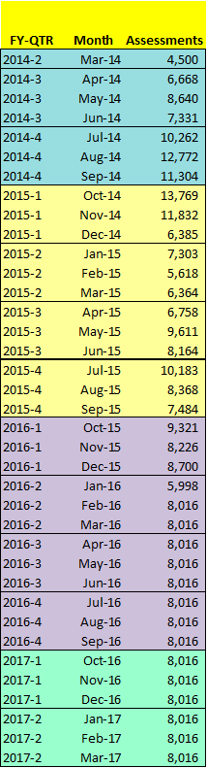

### Expected Impact on Network Infrastructure base on NCP-Forecasted HLA Usage

* NCP-supplied a peak figure of 13,767 assessments over a 30-day period
* Assume that a majority will be entered in an 8 hour day (east coast)
* 30 * 8 = 240 hours
* 240 * 3600 = 864000 seconds
* 13767/864000 = 0.0159340277777778 assessments started per second
* Time spent taking a survey = 25 min = 1,500 seconds
* Little's Law states: The average number of customers in a queuing system N is equal to the average arrival rate of customers to that system λ, times the average time spent in that system T
* Average number of concurrent users = 0.0159340277777778 * 1500 =  23.9
* Rule of thumb: peak = 4 * average = 4 * 23.9 = 95.6 or 96 concurrent users
* 150 concurrent users can be accomplished with 2/3 of production’s hardware

From the perspective of the VA Telecom WAN group that conducted the System Engineering Design Review (SEDR) for the HLA, only if the number of concurrent users reaches 50K would the HLA strain the network infrastructure.

### Concurrent User Capacity of the Expert-24 COTS Application**

Expert-24 COTS application with standard hardware configuration is guaranteed to work with 3,000 concurrent users. That is, 3000 users concurrently completing a survey, with a average number of 200 questions, in 1 hour. Note that performance tests that Expert-24 routinely carries out on a non-customized system with the standard hardware configuration have shown the system can handle 15,000 – 17,000 concurrent users

1. The information in section 2.5.4 was provided at he beginning of the project based on a non-customized version of the Expert-24 COTS application which has over the course of the project has undergone significant customizations to meet the needs of the veteran population. Based on the assumptions in Section 2.5.3, the customized version of the Expert-24 COTS application will meet the expected usage and load capacity.

### Environments

It is assumed that the following environments will be used through the lifecycle of the system::

* Integration – An environment used developer testing of system and system interfaces. There need to be 2 instances of the integration environment. This environment always contains the latest development version for the next release.
* Test - Support SQA testing of the entire system. This environment contains the latest development version of the system that was submitted for testing.
* Authoring – An environment that runs the latest development cycle release version that was promoted from the Test environment. This environment is used to modify the clinical model using the Expert-24 authoring tool set.
* Pre-Production - Support User Acceptance and performance testing of the entire system.
* Production – The live system.

The Pre-Production, IV&V and Test environments are considered *production-identical* environments and must have architectures that are *identical* to the Production environment. This means that all components of hardware infrastructure must be the same. However, clusters may be scaled down from the actual production configuration. That is, the number of instances in a cluster and/or the hardware resources assigned to an instance in a cluster may be reduced.

In production-identical environments the number of instances in a cluster should be at least 2. These environments must have an identical architecture in order to provide a valid testing platform. E.g. clustering can introduce subtle problems that should be detected as early as possible in pre-production environments. Other environments may use further reduced configurations, such a single-node clusters and/or combining components on a machine.

## Design Constraints

The commercial product as provided by Expert-24 has driven the choise of the database and the operating system for several of the (virtual) machines used in the system. The Expert-24 COTS requires a Microsoft SQL Server database (2008 R2) running on Microsoft Server (2008 R2) operating system.

The customization of the front-end is being developed using Java EE. The front-end development uses WebLogic Server to deploy the applications, because no other Java Enterprise Edition (or Java EE) container has been approved by the TRM. Apache TomCat, also approved on the TRM, provides an insufficient subset of the Java EE standard.

1. Although Microsoft .NET Framework may have been a more obvious choice, at the time of the project start this technology had not yet been approved on the Technical Reference Manual (TRM).

## Overview of the Significant Requirements

### Overview of Significant Functional Requirements

Table 4 Functional Requirements

| IDs | Specific Requirement / Synopsis | Requirement |
| --- | --- | --- |
| *Accessibility* | | |
| DES-01 | Section 508 Compliance | The HLA System shall adhere to all Section 508 requirements as referenced in the PWS or Attachment #6. |
| *Business Rules* | | |
| BR-02 | Demographics to be unchanged | The HLA System shall not allow a User who has been through IPA or proofed against the MPI to change or manipulate any demographic information being pulled from any external data source within that database on the HLA. |
| BR-03 | Pre-Population Precedence Based on Rules | The HLA System shall pre-populate answers to assessments from data sources (VistA, MHV SEI, and previous assessments) based on a defined set of rules. |
| BR-04 | HLA Only Imports Data From Other Systems | The HLA System is not expected to send any changes in patient demographic or clinical information back to other VA systems beyond the reports |
| *Design Constraints* | | |
| DC-02 | MPI Remains Authoritative for identity traits | Data from the HLA System cannot flow back to the MPI, as the MPI is the authoritative source for patient identity traits. |
| DC-04 | Section 508 Compliance | The HLA System shall adhere to all Section 508 requirements as referenced in the PWS or Attachment #6. |
| *Documentation* | | |
| DOC-01 | Learn About | The HLA System shall provide “Learn About” text which will explain the basics of the HLA and its purpose. This will be consistent with other “Learn About” text found in MHV. |
| DOC-02 | Help | The HLA System shall provide a “Help” button that will provide additional information on every screen which will explain the basics of how to navigate through an assessment. This will address only the navigation and how to use the application. Any further help regarding the content of the HLA will be provided within the HLA itself. |
| *System Access* | | |
| ACC-01 | HLA in Separate Window | The HLA application shall open in a separate window from the MHV window. When the user ends an assessment, either through completing it or terminating it, the user shall *not be* required to log back into the MHV application to access other MHV tools or resources. |
| ACC-02 | Signon – With MHV interface | The HLA System shall receive a request to access the HLA system which includes the credentials/authentication information from MHV |
| ACC-03 | User Type | The HLA System shall determine the access level of the Patient.  Premium User – In-Person Authenticated (IPA) or Online Authenticated users who are both veterans enrolled at a VA health care facility and registered as a VHA patient in My Health*e*Vet (pre-populate demographics from MVI/locked MHV identity traits, pre-populate other data from prior HLAs, self-entered MHV Personal Health Record data, VistA extracts from MHV Personal Health Record).  Non-Premium User – Holds an account in MHV, but is not necessarily a VHA patient or a Veteran (pre-populate demographics from self-entered MHV identity traits, pre-populate other data from self-entered MHV Personal Health Record, no data pre-population from VistA extracts.). |
| ACC-04 | User Type Determines Access | Access to functionality shall be determined by user type: User Type, vs. Health Care Team member vs. Content Expert vs. Business Administrator vs. IT Administrator *(please see Definitions Section)*. |
| ACC-05 | User Profile Maintained | A User Profile shall be managed by the HLA system for each User. This account will include login credentials and essential user characteristics such as gender and birthdate, as well as the user type |
| ACC-06 | User Type Change | The HLA System shall provide for a change in User Type – such as a Veteran becoming an IPAed User after having previously completed an assessment as MPI-Proofed or MHV User. |
| ACC-10 | HLA Welcome Page | An HLA System “Welcome Page” shall be provided which will give access to a history of assessments taken, quick links to start or continue an assessment, access to an explanation of the HLA tool, a brief explanation of how to complete it, and a link to terms and conditions. |
| *Assessments* | | |
| MNG-01 | View List of Existing Completed or Started Assessments | The HLA System shall allow the User to see a list of existing Assessments previously completed (ever) or started within the previous (x) (x = system setting – currently 30) days for that User. |
| MNG-02 | Distinguish Incomplete Assessment | In the list of assessments provided, the HLA System shall allow the User to distinguish between completed and incomplete assessments. |
| MNG-03 | Take New Assessment | The HLA System shall allow the User to take a new assessment. |
| MNG-04 | Singular Incomplete Assessment | The HLA System shall enable the user to select to continue an incomplete assessment (which has not expired) or start a new assessment. Thus, only one incomplete assessment shall be allowed at a time. |
| MNG-05 | MHV Personal Health Record Pre-Population | The HLA System shall utilize the most current information available through MHV to pre-populate selected data fields. Business rules and logic for every data element will be determined to handle conflicts between self-entered and extracted data. The HLA System shall enable the users to change pre-populated data (with the exception of demographics). Data elements that were pre-populated with extract from CPRS and not changed by the user will retain designation as “CPRS data” to distinguish it from self-entered data.  *(The specific data that will be exchanged will certainly include sex and birthdate. Further information to be drawn from MHV into the HLA will be based on the content customization and availability of data through MHV.* |
| MNG-06 | Copying Previous Assessment | When a User chooses to take a new assessment, and one or more previous assessments exist, the HLA System will retrieve the most recent selected health history information gathered from (a) previous assessment(s) to pre-populate the newly-created assessment. Thus, health-history answers (such as medical and family history) would not need to be reentered, but could simply be reviewed for accuracy and changed where necessary. |
| MNG-07 | HLA Precedence | When copying a previous assessment the HLA System shall determine precedence for which data to use to pre-populate on a per-asset basis based on a set of business rules managed by the Business Administrator. |
| MNG-08 | Resume Assessment | The HLA System shall allow the User to select an assessment that is marked as “Incomplete” and open that assessment for completion, provided that the Incomplete Assessment is less than (x+1) days old. The User will be given a choice of whether to continue an incomplete assessment (which has not expired) or starting a new assessment. The screen that will be given to the User is the last screen displayed when they exited the last session. |
| MNG-09 | View Summary Report | The HLA System shall enable the User to select any assessment from a list of completed assessments and view the Summary report associated with it. |
| MNG-10 | Interact With Summary Report | The HLA System shall enable the user to recalculate the health risks on the summary report. This shall include effect on various health risks/calculations if one or more recommendations are followed. |
| MNG-11 | View Assessment Full Report | The HLA System shall enable the user to view a full report associated with a selected completed assessment. |
| MNG-12 | Delete Assessment – Incomplete > x Days | The HLA System shall delete incomplete assessment 30 days after initiation. The User will be notified that this deletion has occurred when they enter the HLA System. |
| MNG-13 ** | Archive Assessment | The HLA System shall enable a user to archive a completed assessment on the active assessment list. |
| MNG-14 | Print & Save Assessment From List | The HLA System shall provide the option for the User to print or save the User reports from a selected complete assessment from the View Assessment History list. |
| MNG-15 ** | Restore Archived Assessment | The HLA System shall enable the user to restore an archived assessment to active status. |
| MNG-16 | Identity Info Unchanged for IPA’d Users | The HLA System shall not allow any identity information (such as name or birthdate) interfaced from IPA’d or MPI’d patients to be manipulated or changed. |
| SRV-01 | User’s Progress Displayed | The HLA System shall display the user’s progress though the assessment. |
| SRV-02 | Questions Presented to User | The HLA System shall provide questions for the User to answer. The questions, answers, and conclusions presented to the User shall be driven by the HLA content specification and branching logic specified in the HLA content. |
| SRV-03 | Questions Presented Until Assessment Fulfilled | The HLA System shall present questions until no more questions remain. |
| SRV-04 | Assessment Question Types | The system shall present the following types of questions:  Single Answer  Multiple Answer  User Entry  Table of Single-Answer Questions  Table of Multiple-Answer Questions |
| SRV-05 | Question – Single Answer | The HLA System shall require the user to select one response to a single-answer question. |
| SRV-06 | Question – Multiple Answer | The HLA System shall enable the user to select multiple responses for a multiple answer question. |
| SRV-07 | Question – User Entry | The HLA System shall require the user to enter information for a user entry question. |
| SRV-08 | Question – Table: Exclusive | The HLA System shall require the user to select one response for a table of single answer questions. |
| SRV-09 | Question – Table: Non-exclusive | The HLA System shall enable the user to select multiple responses for a table of multiple-answer questions. |
| SRV-10 | Explanation Display | The HLA System shall display an indicator when more information is available on a particular question, answer or conclusion. When selected, the resulting text will inform the User about the nature of this question/answer/conclusion. |
| SRV-11 | Navigation Through Questions | The HLA System shall present to the User all questions which comprise a complete assessment. This should include the ability to navigate through “Next” or “Back” questions. |
| SRV-12 | Reviewing Answers Prior to Completing | When all questions have been answered, the HLA System shall give the User a chance to review questions/answers that have been given. The User shall be allowed to open a selected question and change the answer. When the User chooses to change an answer to a question he/she will only be required to answer that question, and related questions in the question group, before being returned to the “Review Questions & Answers” page. |
| SRV-13 | Assessment Completeness | The HLA System shall allow the assessment to be annotated “Complete” if, and only if, all required questions/answers are completed. Required questions will be determined by the Business Administrator. |
| SRV-14 | Marking Assessment as Complete | Upon reviewing questions/answers the User shall be asked whether to “Submit Assessment and Receive Report”. An appropriate warning shall be given that the answers to questions can no longer be changed after this is done. |
| SRV-15 | Non-Changeable Fields | The HLA System shall not allow any of the following identity information from in-person-authenticated (IPAed) or MPI-Proofed Users to be manipulated or changed: name, sex or birthdate. |
| SRV-16 | Questions can be ”prefer not to answer” | The HLA System shall provide the capability for users to answer “prefer not to answer” on selected, highly sensitive items (e.g., sexual behaviors). The CCGW will indicate which questions will offer “prefer not to answer” as a reply, in consultation with Expert-24. |
| SRV-17 | Save & Exit Assessment | The HLA System shall allow the User to select a “Save & Exit” option provided on the screen. This will allow the User to return to complete an assessment at a later date. The HLA System will check to make sure the current question is correctly filled out (e.g. answered and within range) (see also: SRV-11). After the User exits the assessment, the assessment is listed as an incomplete assessment on the list of assessments for that User. |
| SRV-18 | Consistency of Assessment Place | The HLA System shall keep track of the last-displayed question set which needs to be answered by the User. |
| SRV-19 | Current Questioned Stored Upon Exit | If the User should choose to “Exit” the assessment, the HLA System shall store the “current question” and the state of the assessment traversal – which includes all of the answers to questions previously posed and the “logic branching” of the conditional and other questions needed to complete the assessment. Any changes made in the browser/client will not be saved (see also: SRV-17). |
| SRV-20 | Resume Assessment At Current Question | When the User comes back to the assessment the “current question” will be presented for answering and the “assessment traversal” shall be resumed. |
| SRV-21 | Valid Ranges for Fill-In Fields | The HLA System shall provide for validity checking of fill-in fields (such as blood pressure, height & weight) and prompt the User to re-enter value if outside of valid range. (Relates to SRV-07) |
| SRV-22 | ’BACK’ Does Not Commit Current Answers | The HLA System shall display a notice warning the loss of entered information on the current screen with the use of the browser back option. The HLA System shall provide an option to return the user to the current screen. |
| *Reporting* | | |
| REP-01 | Generate Report | The HLA System shall provide the ability to generate a report, customized from the COTS HLA report for the VHA, including items such as health risks, educational content links, and recommended follow-up options if, and only if, the assessment is marked “Complete”. (Please see REP-12, REP-13 & REP-14) |
| REP-02 | Interact with report | The User shall be able to view the report and utilize the User interactive portions of the report if, and only if, the assessment is marked “Complete”. |
| REP-04 | Once Shared There is No Unshare | Once the Veteran has chosen to share a completed assessment with the Healthcare Team and submitted the assessment, the Veteran will no longer have the option of not sharing that completed assessment. |
| REP-05 | Print – Patient Reports | The HLA System shall allow the User to print each of the available reports. |
| REP-06 | Save Patient Reports | The HLA System shall to allow the User to save each of the available reports to his/her own location for future reference. |
| REP-07 | Non-VHA Patients | The HLA System shall provide non-VA enrolled patient a tailored feedback report based on their age, sex, and self-reported condition, but no information will be interfaced with other systems. |
| REP-08 | Text-based Secure Messaging | For Users that are MHV-authenticated, enrolled in Secure Messaging, and who opt to share an assessment with their healthcare team, the HLA System shall send the results of the HLA taken as a Healthcare Team Report (HCTR) in the form of a Secure Message (SM) to the triage groups (aka, healthcare teams). The triage groups access the HCTR sent as an SM through CPRS and sign it as a progress note in the HLA users’ Electronic Health Record. |
| REP-09 | PDF-based Secure Message Report Attachment | The healthcare team report shall be generated in a PDF version to include graphics. |
| REP-10 | Patient Reports Available to Healthcare Team | When IPAed and Secure Messaging Enrolled Users share assessments with their healthcare team, the healthcare team shall be have access to each of the reports available to the user. |
| REP-12 | HLA Summary Report | The HLA System shall enable the user to access the Summary Report for each completed assessment. This HLA Summary Report will include sections determined by the CCGW which provide information about health status, disease risks, recommendations for health behavior changes and immediate follow-up. |
| REP-13 | HLA Full Report | The HLA System shall enable the user to access the Full Report for each completed assessment. This Full Report will provide more in-depth information on a number of the sections provided in the HLA Summary Report (see REP-12). The information that will be included in the HLA Full Report will be determined by the CCGW. |
| *Analytics* | | |
| ANA-02 | Assessment Report Type | The HLA System shall provide the capability to create assessment activity report. |
| ANA-03 | User Report Type | The HLA System shall provide the capability to create user account report. |
| ANA-04 | Report Filter Criteria | The HLA System shall provide the capability to select filter criteria to restrict the results on a report. |
| ANA-05 | Report Grouping Criteria | The HLA System shall provide the capability to select criteria used to group the results on the report. |
| ANA-06 | User Start New Report from Existing Report | The HLA System shall provide the capability to start a new report specification from an existing report. |
| ANA-10 | Generate an On-Demand Report | The user shall have the ability to generate a scheduled report from a report specification. |
| ANA-11 | View Report History | The HLA System shall provide the capability to view a list of generated reports. |
| ANA-12 | View Generated Report Details | The HLA System shall provide the capability to view a report details after it has been successfully generated. |
| ANA-13 | View On-Demand Generated Report | Once a report has been generated, the HLA System shall provide the capability to view the generated report. |
| ANA-22 | Data extract shall include assessment start date timestamp | The extract shall include the date timestamp the assessment was started for each included assessment. |
| *Program Administration* | | |
| ADMIN-04 | IT Administrator Application | The HLA System shall provide an IT Administrator application for system administration capabilities. |
| ADMIN-05 | HLA Analytics | The HLA System shall allow building population-level reports of HLA data from a permanent data repository. Report generation will be provided through a portal with a menu of standardized reports and the capability to generate ad-hoc reports. |
| *User Interface* | | |
| UI-01 | User Friendly Error Messaging | Any error messaging provided by the HLA System shall be reviewed and approved by the business owner (NCP) for appropriateness of language (consistent with the language principles utilized in the HLA assessment itself). |
| *User Interface* | | |
| INT-01 | Utilizing Secure Messaging APIs | The HLA Core System shall integrate with Secure Messaging to utilize its APIs to transmit the Healthcare Team Report as a secure message and PDF report as referenced in REP-08 and REP-09. |
| INT-05 | Assessment Reminders | The HLA System shall utilize an MHV email notification mechanism to enable email reminders and notifications to be sent to MHV members that have begun a or completed a minimum of one HLA as defined in the following user stories:  “As a Basic, Advanced, or Premium MHV member, I shall receive email notifications to remind me that I must complete an HLA that I have started and to inform me that it will expire 30 days from when I first started the HLA.”  “As a Basic, Advanced, or Premium MHV member, I shall receive periodic email reminders to take a new HLA after a period of time has lapsed since I last took an HLA.” |
| INT-06 | Interface Flexibility | The HLA System should have a flexible interface capability such that any back-end system interface requirements changes or additions that may come up in the future can be accomplished efficiently. |
| INT-07 ** | CPRS View Alert Notification | The HLA System shall provide CPRS View Alert Notifications for events such as indicating an assessment has been completed for a IPAed User &/or other such assessment events as indicated by the CCGW (see BR-01 – e-Triggers). |
| INT-08 | System Open from MHV | The HLA System shall open from the MHV portal in a separate window. |
| INT-09 | Keeping MHV Login Active | The HLA System shall keep a MHV session running in the background to allow the user access to MHV portal without having to log in to MHV again provided the HLA session has not yet expired. |
| INT-10 | One HLA Session at a Time | One login session / HLA window for any use account open at one time. Thus, if a user account has an active login session and another request for a HLA login for the same account is received the first login session will be logged out. If the user tries to go back to the first login session they will be given a “session logged out” message. |

** De-scoped from project, not implemented.

### Functional Workload and Functional Performance Requirements

Table 5 Workload and Performance Requirements

| ID | Requirement | Maximum Acceptable Response Delay |
| --- | --- | --- |
| No specific IDs. These are in the Performance Specifications section of the Functional Requirement Document. | Mouse click; pointer movement; window movement or resizing; key press; button press; drawing gesture; other user-input event involving hand-eye coordination | 0.1 second (100 milliseconds) |
|  | Displaying progress indicators; completing ordinary user commands (for example, closing a dialog box); completing background tasks (for example, reformatting a table) | 1.0 second |
|  | Displaying a graph or anything else that a typical user would expect to take time (for example, displaying a new list of all a company's financial transactions for an accounting period) | 10.0 seconds |
|  | Accepting and processing all user input to any task | 10.0 seconds |

### Operational Requirements

Table 6 Operational Requirements

| ID | Requirement |
| --- | --- |
| N/A |  |

### Overview of the Technical Requirements

Table 7 Technical Requirements

| ID | Requirement |
| --- | --- |
| N/A |  |

The project is 100% compliant with the VA Enterprise Architecture. The following major compliant technologies are in use:

| Technology | One-VA TRM Desicion | Decision Date |
| --- | --- | --- |
| Windows Server 2008 | Approved for general use. | 09/17/2008 |
| Windows SQL Server 2008 | Approved for general use. | 08/17/2011 |
| Microsoft .NET Framework | Approved for general use. | 09/29/2011 |
| Oracle WebLogic Server | Approved for general use. | 09/17/2008 |
| Red Hat Enterprise Linux | Approved for general use. | 09/17/2008 |
| Expert-24 | Approved for general use. | 05/31/2013 |
| Spring Framework Core | Approved for general use. | 01/07/2009 |
| Spring Framework Security | Approved for general use. | 08/17/2011 |
| Hibernate Core | Approved for general use. | 09/17/2008 |
| Apache Ant | Approved. | 06/20/2011 |
| Apache FOP | Approved for general use. | 10/25/2011 |
| i-Text Core | Approved for general use. | 01/31/2012 |

### Overview of the Security or Privacy Requirements

The system shall adhere to all VA and VHA security requirements. Cross-cutting security requirements are contained in the VA Enterprise Requirements Repository (ERR). The system shall comply with all applicable VA and VHA security requirements.

Table 8 Security Requirements

| ID | Requirement |
| --- | --- |
| N/A | Please review the HLA Core and Cloud Services , as well as the Terremark Security Plans |

This project is in compliance with the VA Certification and Accreditation (C&A) process.

### System Criticality and High Availability Requirements

The system is not a mission critical system. It provides health guidelines. The following targets have been established for the system:

* RPO (Recovery Point Objective) of 24 hours
* RTO (Recovery Time Objective) of 30 days.

### Special Device Requirements

N/A

## Legacy System Retirement

Table 9 Proposed Legacy Retirements

| Legacy System or Legacy System Component | Retired or Workload Reduced | If Workload Reduced – How Much |
| --- | --- | --- |
| N/A |  |  |

# Conceptual Design

## Conceptual Application Design

### Application Context

Figure 3 Application Context Diagram



The HLA system is integrated into My HealtheVet (MHV) portal for Veteran-type users. These users can use the HLA system via the portal, once authenticated without the further need to provide credentials. Once connected to the HLA system the Veteran-type users are connected to the HLA system directly. Organizational type users, Administrators and Analysts, interact with the system directly and be authenticated. All users interact with the system via a web-based application interface.

Any time an MHV user connects to HLA through MHV, the latest MHV account information is shared with HLA. In the case of premium account MHV users, HLA will retrieve the most recent applicable identity information from the Master Veteran Index (MVI). This information includes a list of the patient’s identity at a list of treatment facilities.

When a user performs a Healthy Living Assessment, health information is retrieved from the Personal Health Record of the user. That is, eVault, the health repository maintained by MHV. In the case of premium account MHV users, health data is also retrieved from the Electronic Health Record. That is, the Veterans Health Information Systems and Technology Architecture (VistA). Information in VistA is accessed to the unified interface provided by the Medical Domain Web Services (MDWS). The information provided by MVI determines for which treatment facilities to retrieve health data.

Table 1 Application Context Description

|  |  |  |  |  |  |  |  |  |  |
| --- | --- | --- | --- | --- | --- | --- | --- | --- | --- |
|  | Objects | | | | | | | | |
| ID | Name | | Description | | | | Interface Name | | Interface System |
| MHV | My HealtheVet | | My HealtheVet (MHV) is the VA's Personal Health Record. It was designed for Veterans, active duty Servicemembers, their dependents and caregivers. My HealtheVet helps them partner with their health care team(s).  The role of MHV is to provide authenticated users the opportunity to use HLA to assess the statoe of their health | | | | N/A | | MHV |
| MVI | Master Veteran Index | | MVI provides identity services for within the VA  All VA applications are required to obtain identity information from MVI to ensure that references to the identity of Veterans and their beneficiaries are reflected accurately and appropriate levels of security protecting the identities, information, and interests of the VA stakeholders are implemented. | | | | VAAFI | | MVI |
| MDWS | Medical Domain Web Services | | Medical Domain Web Services (MDWS) (pronounced meadows) is a suite of Service Oriented Architecture (SOA) middle-tier web services that exposes medical domain functionality, Medical Domain Objects (MDO). MDWS is equipped with the capacity to virtualize any legacy Veterans Health Information Systems and Technology Architecture (VistA) Remote Procedure Call (RPC) as a web service. The web service(s) uses Simple Object Access Protocol (SOAP). | | | | EmrSvc | | MHV |
|  | Interfaces External to OIT | | | | | | | | |
| ID | Interface Name | | | Related Object | Input Messages | Output Messages | | External Party | |
| *No Interfaces external to OIT* | | | | | | | | | |
|  | | Interfaces Internal to OIT | | | | | | | |
| ID | | Interface Name | | Related Object | Input Messages | Output Messages | | Other CBP Party | |
| Session | | MHV | | MHV | Identity Information | Session Information + Self-entered Health Information | | - | |
| PRPA_IN201305UV | | Retrieve Person Composite call Corresponding IDs | | MVI | Correlation Information | Identity Traits + Source IDs of visited facilities | | - | |
| EmrSvc | | EmrSvc | | MDWS |  | connect  login  select  setupMultiSiteQuery  getLatestVitalSigns  getChemHemReportsSimple  disconnect | | - | |
|  | | Externally Shared Data Stores | | | | | | | |
| ID | | Name | | Data Stored | Owner | Access | |  | |
| *No Externally Shared Data Stores* | | | | | | | | | |

### High Level Application Design

Figure 4 High Level Application Design



Table 11 Objects in the High Level Application Design

| Objects | | | | | | | |
| --- | --- | --- | --- | --- | --- | --- | --- |
| Name | ID | Description | External Interface Name | External Interface ID | Internal Interface Name | Internal Interface ID | SDP Sections 1&2 |
| HLA Main Application | HLA‑MAIN-APP | Provide a web-based user interface to the end-users of the system.  Allows Veterans to take a survey assess their health risks | HLA-main | HLA-MAIN-WEB | - | - | [Approved] |
| HLA Admin Application | HLA‑ADMIN-APP | Provides a web-based user interface to the administrative users of the system  Allows Administrators to execute administrative functions | HLA-admin | HLA-ADMIN-WEB | - | - | [Approved] |
| HLA Analytics Application | HLA-ANALYTICS-APP | Provides a web-based user interface to the NCP analysts. Allows users to create population–base analysis reports and to save data extracts. The reports contain no information about individual users or assessments, but aggregated results. Users under 18 or over 89 years old are excluded from the results. The extracts contain information for individual anonymized assessments and users. | HLA-analytics | HLA-ANALYTICS-WEB | - | - | [Approved] |
| HLA Integration Application | HLA-INTEGRATION-APP | Provides web service for MHV to connect to HLA. Also provides the capabilities to connect to to MVI to obtain identity traits for (IAM) authenticated users, as well as obtain health records from ViatA | HLA-integration | HLA-INTEGRATION-WEB | - | - | [Approved] |
| Sync Process | HLA- SYNC | A background process that pushes HLA Assessment and User Information to the HLA Analytics Data Store. During this transfer of information all identifying information is removed and/or anonymized | - | - | - | - |  |
| Traversal Engine | DATA‑SERVICE | Expert-24 COTS survey traversal engine  Provides a means start or continue and traverse a health risk survey | - | - | Data Service | DATA-SERVICE | - |
| Authoring Service | BUILDER-SERVICE | Expert-24 COTS authoring service  Provides a means to author the content using the Expert-24 authoring tools  *This component is used in pre-production environments ONLY.* | - | - | Builder Service | BUILDER-SERVICE | - |

| Internal Data Stores | | | | |
| --- | --- | --- | --- | --- |
| Name | ID | Data Stored | Steward | Access |
| HLA Application Information | HLA‑APPLICATION-DB | Data store containing application level information, such as user information and roles, and associates users with surveys stored in the HLA Content & Traversal information data store. | HLA-MAIN-APP, HLA-ADMIN-APP, HLA-INTEGRATION-APP | Creates, reads, updates and deletes user account information  Creates, reads, updates and (possibly) deletes traversal ID information |
| HLA Content & Traversal Information | HLA‑EXPERT-DB | Data store consisting of an Expert-24 COTS database that stores the questions and branching logic of HLA surveys, as well as particular survey instances | DATA-SERVICE | Creates, reads and updates assessment traversal information  Reads survey content information |
| HLA Infrastructure Information | HLA-INFRASTRUCTURE-DB | Data store containing all user account, audit log and message log information | HLA-ADMIN-APP | Creates, reads and updates user account information, reads audit and message log information |
| HLA Analytics Information | HLA‑ANALYTICS-DB | Datastore containing an anonymized copy of assessment and user account information.  Also contain population-based report information. | HLA-SYNC, HLA-ANALYTICS-APP | Creates and reads anonymized assessment and user information.  Creates, reads and updates reports created based on the assessment and user information |

### Application Locations

Table 12 Application Locations

| Application Component | Description | Location at Which Component is Run | Type |
| --- | --- | --- | --- |
| HLA-MAIN-APP | HLA Application deployed to Oracle WebLogic Application Server running on a Linux host | Private VA-cloud at Terremark | Presentation and Business Logic |
| HLA-ADMIN-APP | HLA Application deployed to Oracle WebLogic Application Server running on a Linux host | Private VA-cloud at Terremark | Presentation and Business Logic |
| HLA-ANALYTICS-APP | HLA Application deployed to Oracle WebLogic Application Server running on a Linux host | Private VA-cloud at Terremark | Presentation and Business Logic |
| HLA-INTEGRATION-APP | HLA Application deployed to Oracle WebLogic Application Server running on a Linux host | Private VA-cloud at Terremark | Integration and Business Logic |
| DATA-SERVICE | Expert-24 COTS Application deployed on a WindowsServer host | Private VA-cloud at Terremark | Business Logic |
| HLA- SYNC | Cron job deployed on a Linux host | Private VA-cloud at Terremark | Business Logic |
| HLA-EXPERT-DB | Expert-24 COTS SQL Server Database with Customizations Applied deployed on a WindowsServer host | Private VA-cloud at Terremark | Persistence |
| HLA-APPLICATION-DB | Custom Application Server Database deployed on a WindowsServer host | Private VA-cloud at Terremark | Persistence |
| HLA-ANALYTICS-DB | Custom Application Server Database deployed on a WindowsServer host | Private VA-cloud at Terremark | Persistence |
| HLA-INFRASTRUCTURE-DB | Custom Application Server Database deployed on a WindowsServer host | Private VA-cloud at Terremark | Persistence |

### Application Users

Table 13 Application Users

| Application Component | Location | User |
| --- | --- | --- |
| *HLA Main Application* | Internet (anywhere) | MHV User (Anyone / Veteran / VAMC Patient) |
| *HLA Admin Application* | Local network at private VA-cloud at Terremark | System Administrator |
| *HLA AnalyticsApplication* | VA Network | (NCP) Analyst |

## Conceptual Data Design

### Project Conceptual Data Model

The following diagram describes the conceptual data model of the project. This does not include the data model of the HLA-EXPERT data store (i.e. the Expert-24 (COTS) database schema), as this is a COTS product and should be considered a black box.

Figure 4 Project Conceptual Data Model

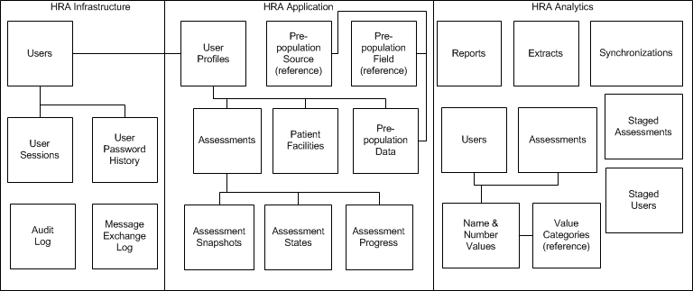

### Database Information

The following table identifies all databases that will be created as part of this effort.

Table 14 Database Inventory

| Database Name | Description | Type | Steward |
| --- | --- | --- | --- |
| HLA-INFRASTRUCTURE | Contains all user account, user session tracking, audit log and message log information | Create | HLA Web Applicatiuons |
| HLA-APPLICATION | Contains HLA application-level information, including user details and assessments | Create | HLA Main Web Application |
| HLA‑ANALYTICS | Contains assessment and user information, copied from the HLA-APPLICATION, anonymized and optimized for querying  Furthermore, contains reports (definition and results) | Create | Sync Process and HLA Analytics Application |
| HLA-EXPERT | Contains Expert-24 standard database with custom VA HLA content and survey traversal information | Modify  (Custom Content) | Expert-24 Web Service |

## Conceptual Infrastructure Design

### System Criticality and High Availability

The system is not mission critical and high availability is not required. The approach towards availability and workload distribution is handled by server clusters.

Disaster recovery will be defined by HLA Cloud Services using the following:

* The Recovery Point Objective (RPO) is 24 hours
* The Recovery Time Objective (RTO) is 30 days

### Special Technology

The following tables describe the special technology used on this project.

Table 15 Special Technology Requirements

| Special Technology | Description | Notional Location | TRM Status |
| --- | --- | --- | --- |
| Expert-24 Authoring tools | Provides the ability to specify and test (dynamic) questionnaire(s) build with its authoring tools.  NOTE: The authoring tools are never used in the production system | Content Developer computer | Approved |
| Expert-24 Runtime system | Provides the ability to run through the questionnaire(s) via the web-service traversal engine API.  The tool is build using the following TRM approved technologies:  Microsoft .NET Framework  Microsoft SQL Server | Hosted System | Approved |

### Technology Locations

The following table describes the technologies and the datacenter where they will be installed.

Table 16 Technology Location

| Technology Component | Location | Usage |
| --- | --- | --- |
| Production | | |
| Oracle WebLogic Application Server | Private HLA Production VA-cloud at Terremark | Provides platform to deploy custom HLA web application(s) |
| Expert-24 .NET Web Builder | Private HLA Production VA-cloud at Terremark | Provides API to traversal engine |
| Microsoft SQL Server | Private HLA Production VA-cloud at Terremark | Provides persistence for 3 separate databases |
| Pre-production, Test, Integration & Authoring | | |
| Oracle WebLogic Application Server | Individual Private HLA PIE VA-cloud at Terremark | Provides platform to deploy custom HLA web application(s) |
| Expert-24 .NET Web Builder | Individual Private HLA PIE VA-cloud at Terremark | Provides API to traversal engine |
| Microsoft SQL Server | Individual Private HLA PIE VA-cloud at Terremark | Provides persistence for 3 separate databases |
| Authoring | | |
| Expert-24 Virtual Expert | Individual Private HLA PIE VA-cloud at Terremark | Content validation tool (web application) |
| Expert-24 Microsoft Visio plugin | Content Developer computer | Provides means to build branching logic part of HLA content |
| Expert-24 Asset Builder | Content Developer Computer | Provides means to build question-answer part of HLA content |
| Development | | |
| Oracle WebLogic Application Server | Developer computer | Provides platform to deploy custom HLA web application(s) |
| Expert-24 .NET Web Builder | Developer computer | Provides API to traversal engine |
| Microsoft SQL Server (Express) | Developer computer | Provides persistence for 3 separate databases |

### Conceptual Infrastructure Diagram

#### Location of Environments and External Interfaces

The system will consist of a single dedicated local network as described in the following diagram. The system will be standalone and not attached to any external/other environments.

Figure 5 Conceptual Networks and Environments



#### Conceptual Production HLA Diagram

Figure 6 Conceptual Production System Diagram



#### Conceptual Authoring (PIE) HLA Diagram

Figure 7 Conceptual Authoring System (PIE) Diagram



# System Architecture

## Hardware Architecture

### Hardware Infrastructure Design

The hardware infrastructure consists of the following components for the production (and production-identical) environments:

Figure 8: HLA Core System Hardware Configuration



Ideally all other environments have the same hardware configuration as the production environment. However, other environments typically do not require the same fail-over and high availability characteristics as the production environment.

Following are descriptions of the components:

* The ***Firewall***limits access to the Application Cluster as appropriate. Each server has its own firewall, limiting access to the server to the necessary traffic only (see Figure 6 below).
* A ***Load Balancer*** that distributes the application workload across multiple application servers to achieve such goals as optimal resource utilization, maximize throughput, minimize response time, and overload avoidance.
* An***Application Servers*** consisting of 2 nodes each hosting an instance of the HLA web application.
* An***HLA Engine Servers*** consists of 2 nodes each hosting an instance of the COTS HLA application. This application provides an API in the form of a web service to the survey traversal stored in the HLA COTS Database instance.
* A ***Database Servers*** consists of 3 nodes each hosting an instance of a database management system.

## Software Architecture

### System Software

The following system software is used:

Table 2 – System Software specifications

|  |  |  |
| --- | --- | --- |
| Platform | Operating System | Software |
| Application Servers | Red Hat Enterprise Linux 5.0 | Apache Web Server  Oracle WebLogic Server 11g Enterprise Edition |
| HLA COTS Servers | Windows Server 2008 Enterprise R2 | Internet Information Services (IIS 7.5+)  Expert-24 data web service (.NET 3.5 SP1+) |
| Database Servers | Windows Server 2008 Enterprise R2 | Microsoft SQL Server 2008 R2 Enterprise Edition |
| Note that environments other than production may use the Developer edition, which takes advantage of all the functionality in the premium Datacenter edition but is licensed only for development, test, and demo use. | | |

### Software Modules

Table 3 – System Software specifications

| Module | Description | Platform |
| --- | --- | --- |
| Main Application | The main application provides the veteran-type users with the ability to assess their health risk.  The main application consists of the following components:  Healthy Living Assessment  User (Authentication, User Profile)  Reports (Summary, Full, and Health Care Team reports)  This application is deployed into the HLA WebLogic domain as a WAR file that is incorporated in an EAR file  The code consists of Java EE code (Java classes, XML configuration files, XSL stylesheets, JSPs). The code is developed using the Eclipse IDE. The application is built using Apache Ant scripts. | Application Servers |
| Admin Application | The admin application provides administrative capabilities.  This consists of the following components:  User Management  Audit log review  Communication log review  This application is deployed into the HLA WebLogic domain as a WAR file that is incorporated in an EAR file  The code consists of Java EE code (Java classes, XML configuration files, XSL stylesheets, JSPs). The code is developed using the Eclipse IDE. The application is built using Apache Ant scripts. | Application Servers |
| Analytics Application | The analytics application provides analysis reporting and data extraction capabilities.  This consists of the following components:  Report creation  Data extract creation  This application is deployed into the HLA WebLogic domain as a WAR file that is incorporated in an EAR file  The code consists of Java EE code (Java classes, XML configuration files, XSL stylesheets, JSPs). The code is developed using the Eclipse IDE. The application is built using Apache Ant scripts. | Application Servers |
| Integration Application | The integration application provides integration services to the system:  service to external systems (MHV), as well as capabilities to integrate with other systems (MVI and VistA instances via MDWS).  This consists of the following components:  Accepting session creation requests from MHV  Retrieving identity traits and correlated facilities from MVI  Retrieving health information from various VistA instances via MHV’s MDWS instance  This application is deployed into the HLA WebLogic domain as a WAR file and an EJB JAR files that are incorporated in an EAR file. The services are exposed via JAX-WS as provided by the container.  The code consists of Java EE code (Java classes, XML configuration files). The code is developed using the Eclipse IDE. The application is built using Apache Ant scripts. |  |
| Application Database | The Application database supports both the Main and Admin applications.  This database is deployed into a Microsoft SQL Server instance.  The database is built by applying SQL DDL scripts to an empty baseline database. No specific database development tools are used to create the SQL scripts. | (Main) Database Servers |
| Analytics Database | The Analytics database supports the Analytics application.  This database is deployed into a Microsoft SQL Server instance.  The database is built by applying SQL DDL scripts to an empty baseline database. No specific database development tools are used to create the SQL scripts. | (Analytics) Database Server |
| Expert-24 Data Service (COTS) | The data service provides the run-time capability of the Expert-24 survey engine. It uses the survey content and survey instance information stored in the Expert-24 Database to create the underlying information for the survey process  This application is a .NET C# application deployed using IIS. | HLA COTS Servers |
| Expert-24 Database (COTS) | The Expert-24 database contains the survey content and survey instance information. The survey content is created using Expert-24’s authoring tools and defines the questions and answers and the flow through question sets based on answers provided by a user.  This database is deployed into a Microsoft SQL Server instance.  The database is built using the COTS Expert-24 database as the baseline and applying the SQL scripts generated by the authoring tools to that baseline database. | (Main) Database Servers |

For details on the main and admin application components and the Application database, see the following design documents:

* HLA Framework Subsystem Design
* HLA User Authentication Subsystem Design
* HLA Assess Health Risks Subsystem Design
* HLA PDF Report Generation Subsystem Design
* HLA Summary Report Subsystem Design
* HLA Full Report Subsystem Design
* HLA Health Care Team Report Subsystem Design
* HLA Integration Subsystem Design
* MVI-HLA Integration System Design Document
* HLA User Management Subsystem Design
* HLA Auditing Subsystem Design
* HLA Analytics Subsystem Design

The following diagram describes how the software component are deployed on the hardware components, as well as the communication paths and protocols used between the various components.

Figure 9 System Software Communications Architecture



1. External systems are treated as a single hardware component and no elaboration is provided, as this is out of the scope for this document.

# Data Design

## Database Management System Files

### Logical Database Model

Figure 10 Infrastructure Logical Model

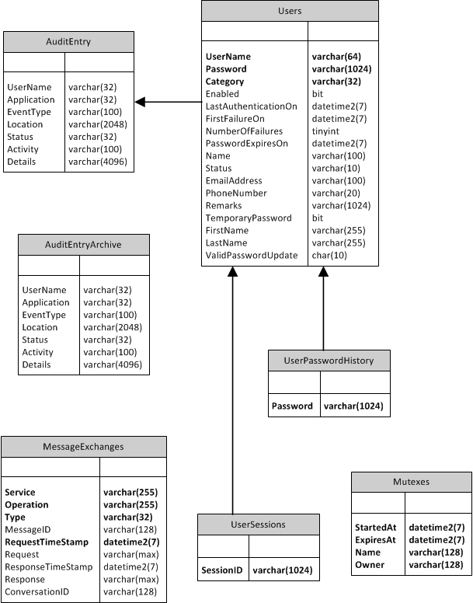

Figure 11 Application Logical Model

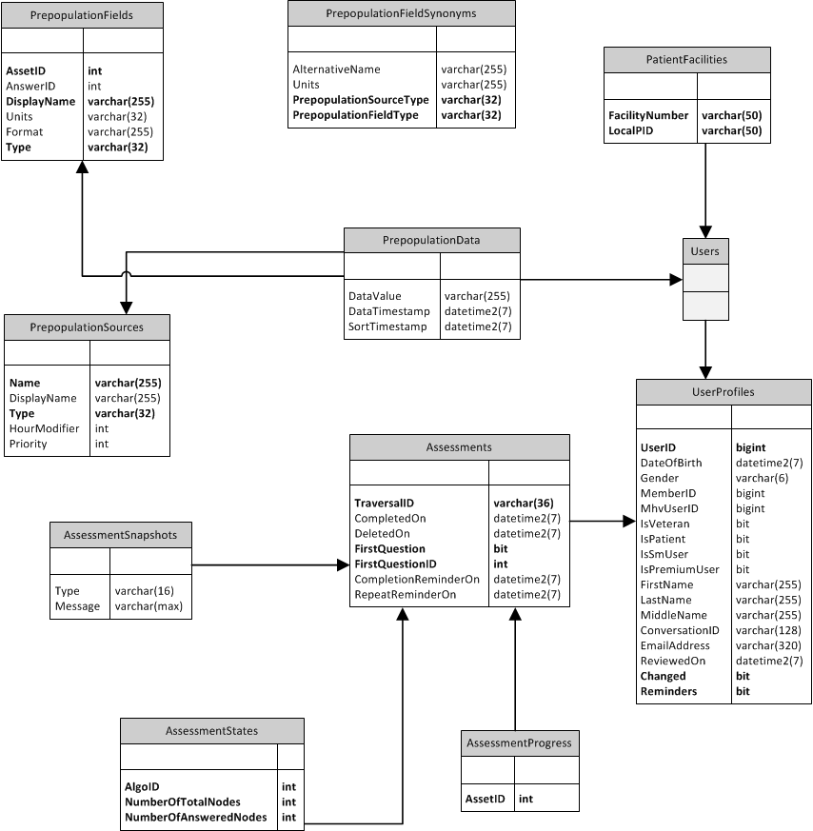

Figure 12 Application Health Care Team Report Logical Model

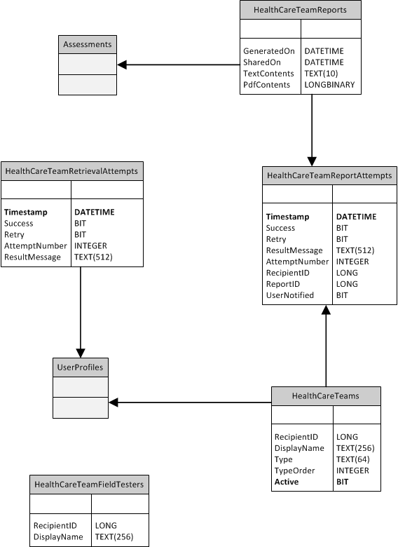

Figure 13 Analytics Main Logical Model

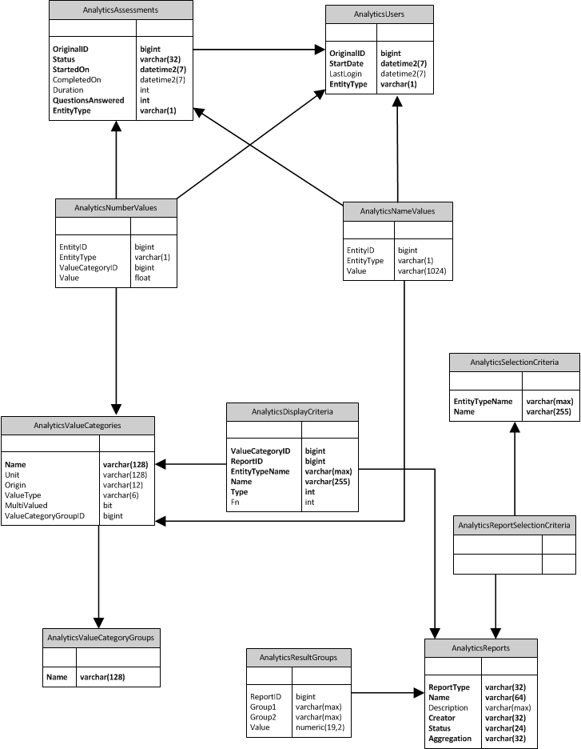

Figure 14 Analytics Selection Criteria Logical Model

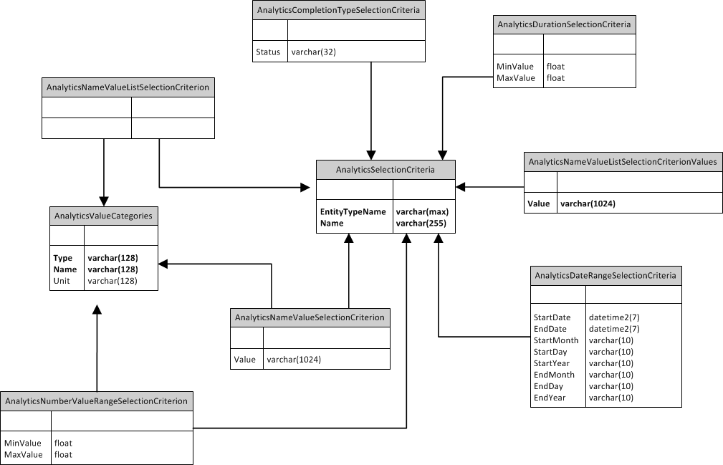

Figure 15 Analytics Synchronization Logical Model

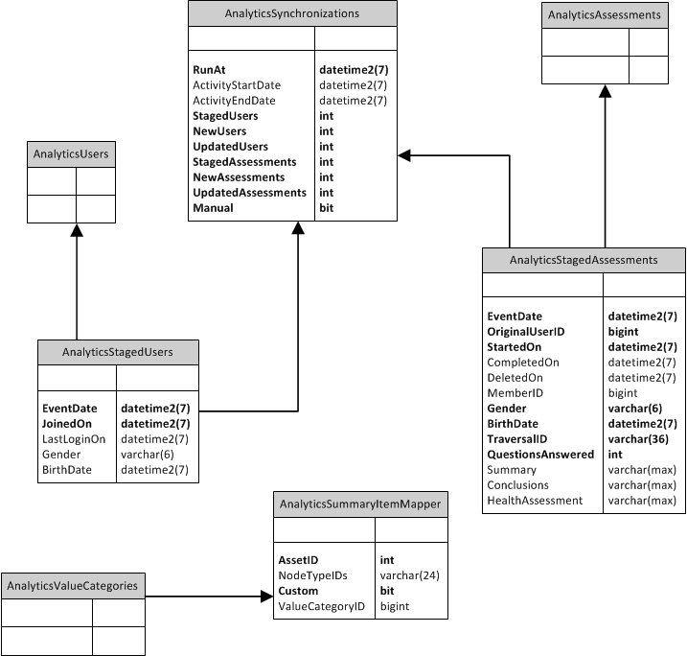

### Physical Database Model

Figure 16 Infrastructure Physical Model

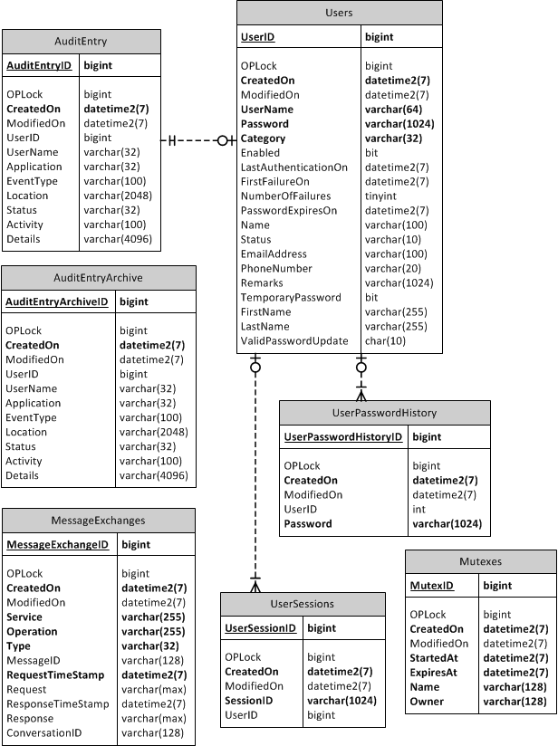

Figure 17 Application Physical Model

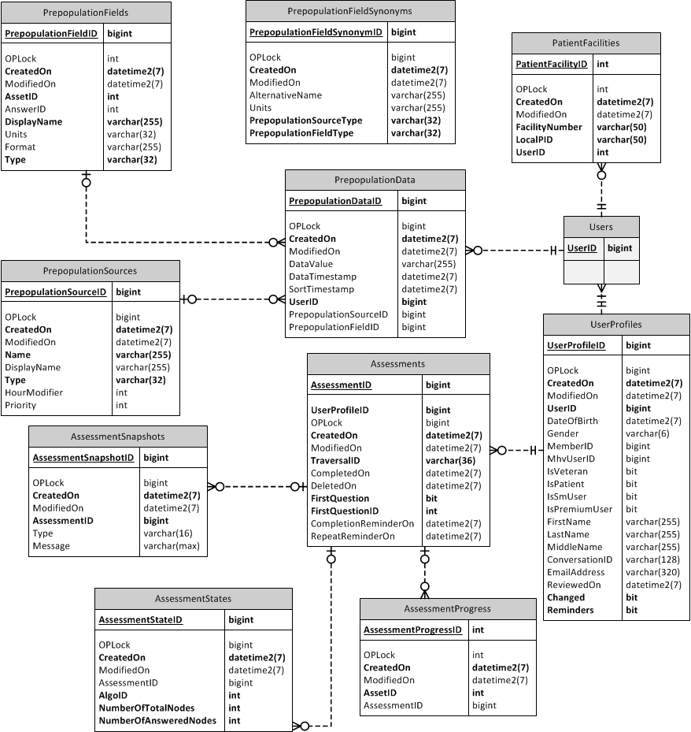

Figure 18 Application Health Care Team Report Physical Model

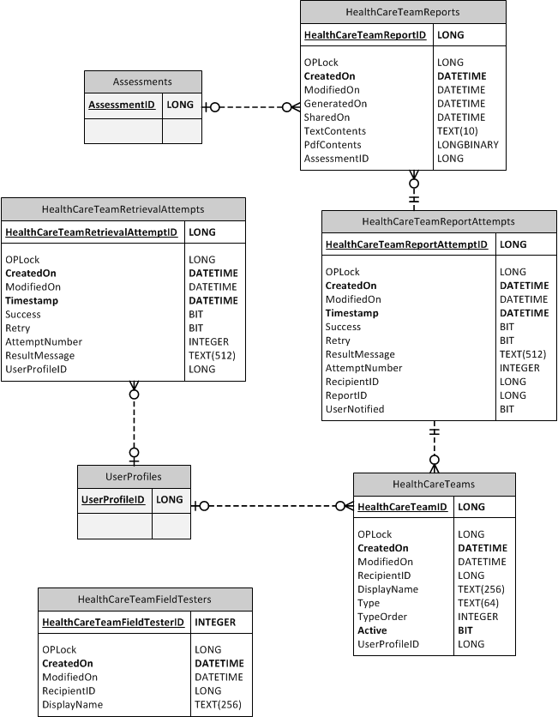

Figure 19 Analytics Selection Criteria Physical Model

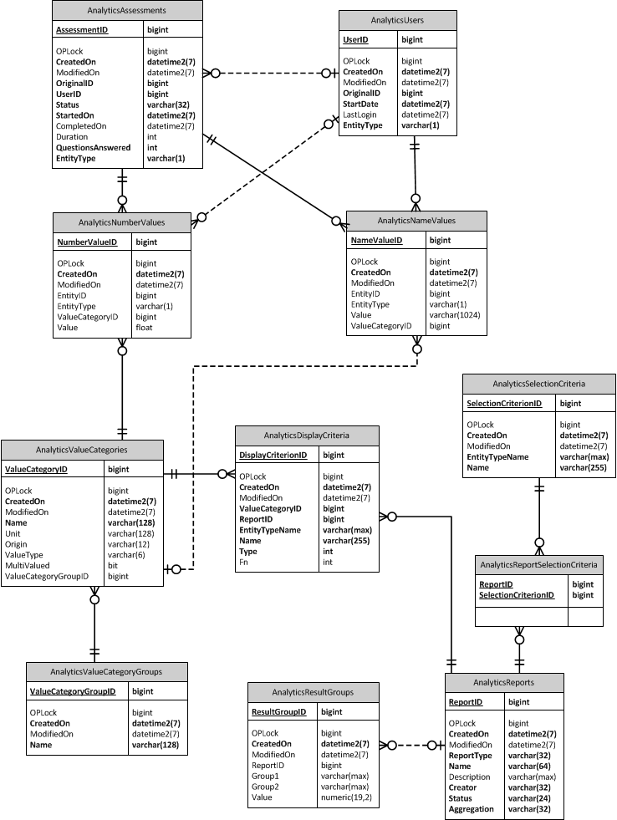

Figure 20 Analytics Synchronization Physical Model

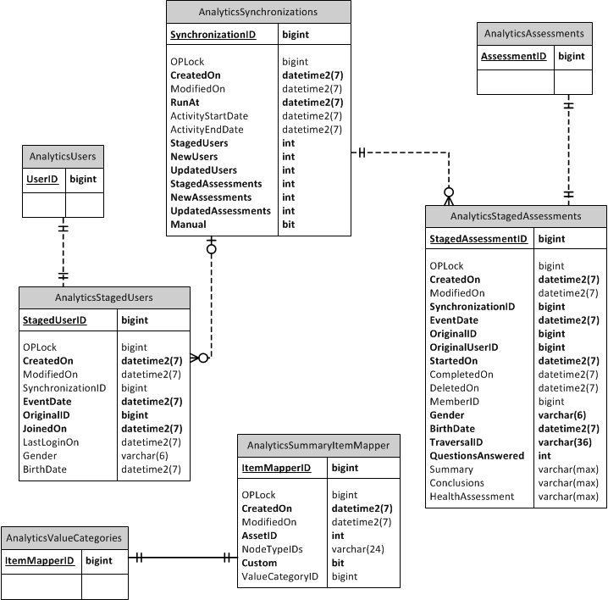

### Database Schema

#### HLA-Infrastructure database schema

**CREATE** **TABLE** Users (

UserID BIGINT IDENTITY,

OPLock BIGINT **DEFAULT** 0,

CreatedOn DATETIME2 **NOT** **NULL**,

ModifiedOn DATETIME2,

UserName **VARCHAR**(64) **NOT** **NULL**,

Password **VARCHAR**(1024) **NOT** **NULL**,

Category **VARCHAR**(32) **NOT** **NULL** **DEFAULT** 'Regular',

Enabled BIT **DEFAULT** 1,

LastAuthenticationOn DATETIME2,

FirstFailureOn DATETIME2,

NumberOfFailures TINYINT **DEFAULT** 0,

PasswordExpiresOn DATETIME2,

Name **VARCHAR**(100),

Status **VARCHAR**(10),

EmailAddress **VARCHAR**(100),

PhoneNumber **VARCHAR**(20),

Remarks **VARCHAR**(1024),

TemporaryPassword BIT **DEFAULT** 0,

FirstName **VARCHAR**(255) **NULL**,

LastName **VARCHAR**(255) **NULL**,

ValidPasswordUpdate BIT **DEFAULT** 0

**PRIMARY** **KEY**(UserID)

);

**CREATE** **UNIQUE** **INDEX** index_Users_UserNames **ON** Users (UserName, Category);

**CREATE** **TABLE** UserSessions (

UserSessionID BIGINT IDENTITY,

OPLock BIGINT **DEFAULT** 0,

CreatedOn DATETIME2 **NOT** **NULL**,

ModifiedOn DATETIME2,

UserID BIGINT **NULL**,

SessionID **VARCHAR**(1024) **NOT** **NULL**

**PRIMARY** **KEY**(UserSessionID),

**CONSTRAINT** fk_UserSessions_Users

**FOREIGN** **KEY** (UserID)

**REFERENCES** Users (UserID)

**ON** **DELETE** **CASCADE**

);

**CREATE** **TABLE** UserPasswordHistory (

UserPasswordHistoryID BIGINT IDENTITY,

OPLock BIGINT **DEFAULT** 0,

CreatedOn DATETIME2 **NOT** **NULL**,

ModifiedOn DATETIME2,

UserID BIGINT **NULL**,

Password **VARCHAR**(1024) **NOT** **NULL**

**PRIMARY** **KEY**(UserPasswordHistoryID),

**CONSTRAINT** fk_UserPasswordHistoryID_Users

**FOREIGN** **KEY** (UserID)

**REFERENCES** Users (UserID)

**ON** **DELETE** **CASCADE**

);

**CREATE** **TABLE** MessageExchanges (

MessageExchangeID BIGINT IDENTITY,

OPLock BIGINT **DEFAULT** 0,

CreatedOn DATETIME2 **NOT** **NULL**,

ModifiedOn DATETIME2,

Service **VARCHAR**(255) **NOT** **NULL**,

Operation **VARCHAR**(255) **NOT** **NULL**,

Type **VARCHAR**(32) **NOT** **NULL**,

MessageID **VARCHAR**(128) **NULL**,

RequestTimeStamp DATETIME2 **NOT** **NULL**,

Request **VARCHAR**(MAX) **NULL**,

ResponseTimeStamp DATETIME2,

Response **VARCHAR**(MAX),

ConversationID **VARCHAR**(128) **NULL**,

**PRIMARY** **KEY**(MessageExchangeID)

);

**CREATE** **TABLE** AuditEntry (

AuditEntryID BIGINT IDENTITY,

OPLock BIGINT **DEFAULT** 0,

CreatedOn DATETIME2 **NOT** **NULL**,

ModifiedOn DATETIME2,

UserID BIGINT **NULL**,

UserName **VARCHAR**(32) **NULL**,

Application **VARCHAR**(32) **NULL**,

EventType **VARCHAR**(100) **NULL**,

Location **VARCHAR**(2048) **NULL**,

Status **VARCHAR**(32) **NULL**,

Activity **VARCHAR**(100) **NULL**,

Details **VARCHAR**(4096) **NULL**,

**PRIMARY** **KEY**(AuditEntryID)

);

**CREATE** **TABLE** AuditEntryArchive (

AuditEntryArchiveID BIGINT IDENTITY,

OPLock BIGINT **DEFAULT** 0,

CreatedOn DATETIME2 **NOT** **NULL**,

ModifiedOn DATETIME2,

UserID BIGINT **NULL**,

UserName **VARCHAR**(32) **NULL**,

Application **VARCHAR**(32) **NULL**,

EventType **VARCHAR**(100) **NULL**,

Location **VARCHAR**(2048) **NULL**,

Status **VARCHAR**(32) **NULL**,

Activity **VARCHAR**(100) **NULL**,

Details **VARCHAR**(4096) **NULL**,

**PRIMARY** **KEY**(AuditEntryArchiveID),

**CONSTRAINT** fk_AuditEntryArchiveID_Users

**FOREIGN** **KEY** (UserID)

**REFERENCES** Users (UserID)

**ON** **DELETE** **CASCADE**

);

**CREATE** **TABLE** Mutexes (

MutexID BIGINT IDENTITY,

OPLock BIGINT **DEFAULT** 0,

CreatedOn DATETIME2 **NOT** **NULL**,

ModifiedOn DATETIME2,

Name **VARCHAR**(128) **NOT** **NULL**,

Owner **VARCHAR**(128) **NOT** **NULL**,

StartedAt DATETIME2 **NOT** **NULL**,

ExpiresAt DATETIME2 **NOT** **NULL**,

**PRIMARY** **KEY**(MutexID)

);

**CREATE** **UNIQUE** **INDEX** index_Mutexes_Name **ON** Mutexes (Name);

#### HLA-Main database schema

**CREATE** **TABLE** UserProfiles (

UserProfileID BIGINT IDENTITY,

OPLock BIGINT **DEFAULT** 0,

CreatedOn DATETIME2 **NOT** **NULL**,

ModifiedOn DATETIME2,

UserID BIGINT **NOT** **NULL**,

DateOfBirth DATETIME2,

Gender **VARCHAR**(6),

MemberID BIGINT **NULL**,

MhvUserID BIGINT **NULL**,

IsVeteran BIT **NULL**,

IsPatient BIT **NULL**,

IsSmUser BIT **NULL,**

IsPremiumUser BIT **NULL,**

FirstName **VARCHAR**(255) **NULL**,

LastName **VARCHAR**(255) **NULL**,

MiddleName **VARCHAR**(255) **NULL**,

ConversationID **VARCHAR**(128) **NULL**,

EmailAddress **VARCHAR**(320) **NULL**,

ReviewedOn DATETIME2(7) **NULL**,

Changed BIT **NOT** **NULL** **DEFAULT** 0,

Reminders BIT **NOT** **NULL** **DEFAULT** 0,

**PRIMARY** **KEY**(UserProfileID)

);

**CREATE** **UNIQUE** **INDEX** index_UserProfile_UserID **ON** UserProfiles (UserID);

**CREATE** **UNIQUE** **INDEX** index_UserProfile_MhvUserID **ON** UserProfiles (MhvUserID)

**WHERE** MhvUserID **IS** **NOT** **NULL**;

**CREATE** **TABLE** Assessments (

AssessmentID BIGINT IDENTITY,

OPLock BIGINT **DEFAULT** 0,

CreatedOn DATETIME2 **NOT** **NULL**,

ModifiedOn DATETIME2,

UserProfileID BIGINT **NOT** **NULL**,

TraversalID **VARCHAR**(36) **NOT** **NULL**,

CompletedOn DATETIME2,

DeletedOn DateTime **NULL**,

FirstQuestion BIT **NOT** **NULL** **DEFAULT** 1,

FirstQuestionID **INT** **NOT** **NULL** **DEFAULT** 0,

CompletionReminderOn DATETIME2 **NULL**,

RepeatReminderOn DATETIME2 **NULL**,

**PRIMARY** **KEY** (AssessmentID),

**CONSTRAINT** fk_Assessments_UserProfiles

**FOREIGN** **KEY** (UserProfileID)

**REFERENCES** UserProfiles (UserProfileID)

);

**CREATE** **INDEX** index_Assessments_UserProfileID **ON** Assessments (UserProfileID);

**CREATE** **INDEX** index_Assessments_TraversalID **ON** Assessments (TraversalID);

**CREATE** **TABLE** AssessmentStates (

AssessmentStateID BIGINT IDENTITY,

OPLock BIGINT **DEFAULT** 0,

CreatedOn DATETIME2 **NOT** **NULL**,

ModifiedOn DATETIME2,

AssessmentID BIGINT **NULL**,

AlgoID **INT** **NOT** **NULL**,

NumberOfTotalNodes **INT** **NOT** **NULL** **DEFAULT** 0,

NumberOfAnsweredNodes **INT** **NOT** **NULL** **DEFAULT** 0,

**PRIMARY** **KEY** (AssessmentStateID),

**CONSTRAINT** fk_AssessmentStates_Assessments

**FOREIGN** **KEY** (AssessmentID)

**REFERENCES** Assessments (AssessmentID)

**ON** **DELETE** **CASCADE**

);

**CREATE** **INDEX** index_AssessmentStates_AssessmentID

**ON** AssessmentStates (AssessmentID);

**CREATE** **TABLE** AssessmentProgress (

AssessmentProgressID BIGINT IDENTITY,

OPLock BIGINT **DEFAULT** 0,

CreatedOn DATETIME2 **NOT** **NULL**,

ModifiedOn DATETIME2,

AssessmentID BIGINT,

AssetID **INT** **NOT** **NULL**,

**PRIMARY** **KEY** (AssessmentProgressID),

**CONSTRAINT** fk_AssessmentProgress_Assessments

**FOREIGN** **KEY** (AssessmentID)

**REFERENCES** Assessments (AssessmentID)

);

**CREATE** **INDEX** index_AssessmentProgress_AssessmentID **ON** AssessmentProgress (AssessmentID);

**CREATE** **UNIQUE** **INDEX** index_AssessmentProgress_Unique **ON** AssessmentProgress (AssessmentID, AssetID);

**CREATE** **TABLE** AssessmentSnapshots (

AssessmentSnapshotID BIGINT IDENTITY,

OPLock BIGINT **DEFAULT** 0,

CreatedOn DATETIME2 **NOT** **NULL**,

ModifiedOn DATETIME2,

AssessmentID BIGINT **NOT** **NULL**,

Type **VARCHAR**(16),

Message **VARCHAR**(MAX),

**PRIMARY** **KEY** (AssessmentSnapshotID),

**CONSTRAINT** fk_AssessmentSnapshots_Assessments

**FOREIGN** **KEY** (AssessmentID)

**REFERENCES** Assessments (AssessmentID)

**ON** **DELETE** **CASCADE**

);

**CREATE** **INDEX** index_AssessmentSnapshots_Assessments **ON** AssessmentSnapshots

(AssessmentID);

**CREATE** **INDEX** index_Assessments_Type **ON** AssessmentSnapshots (Type);

**CREATE** **TABLE** [HLA-APPLICATION].[dbo].[PrepopulationSources](

[PrepopulationSourceID] BIGINT IDENTITY,

[Name] **VARCHAR**(255) **NOT** **NULL**,

[DisplayName] **VARCHAR**(255),

[Type] **VARCHAR**(32) **NOT** **NULL**,

[Priority] **INT**,

[HourModifier] **INT**,

[CreatedOn] DATETIME2 **NOT** **NULL**,

[ModifiedOn] DATETIME2,

[OPLOCK] BIGINT **DEFAULT** 0,

**PRIMARY** **KEY**(PrepopulationSourceID)

);

**INSERT** **INTO** [HLA-APPLICATION].[dbo].[PrepopulationSources]

([Name],[DisplayName],[Type],[Priority],[HourModifier],[CreatedOn])

**VALUES**

('MDWS/VistA Health Records', 'VA records', 'MDWS', 1, 24, GETDATE()),

('MHV Self-Entered Information', 'MHV self-entered information', 'MHV_SEI', 3, **NULL**, GETDATE()),

('MHV Health Records', 'MHV records', 'MHV_RECORDS', 3, **NULL**, GETDATE()),

('Previous Assessment', 'previous assessment', 'ASSESSMENT', 2, **NULL**, GETDATE());

**CREATE** **TABLE** [HLA-APPLICATION].[dbo].[PrepopulationFields](

[PrepopulationFieldID] BIGINT IDENTITY,

[AssetID] **INT** **NOT** **NULL**,

[AnswerID] **INT**,

[DisplayName] **VARCHAR**(255) **NOT** **NULL**,

[Units] **VARCHAR**(32),

[Format] **VARCHAR**(255),

[Type] **VARCHAR**(32) **NOT** **NULL**,

[CreatedOn] DATETIME2 **NOT** **NULL**,

[ModifiedOn] DATETIME2,

[OPLOCK] BIGINT **DEFAULT** 0,

**PRIMARY** **KEY**(PrepopulationFieldID)

);

**INSERT** **INTO** [HLA-APPLICATION].[dbo].[PrepopulationFields]

([AssetID], [AnswerID], [DisplayName], [Units], [Format], [Type], [CreatedOn])

**VALUES**

(-1, **NULL**, 'Field', **NULL**,

'Some answers on this page were populated using data from your %s, dated %d.',

'GeneralField', GETDATE()),

(404, **NULL**, 'Diastolic Blood Pressure', 'mm Hg', **NULL**,

'DiastolicBloodPressure', GETDATE()),

(403, **NULL**, 'Systolic Blood Pressure', 'mm Hg', **NULL**,

'SystolicBloodPressure', GETDATE()),

(213, 1, 'Blood Pressure was last checked', **NULL**,

'According to your %s, your %f on %d.',

'BloodPressureRecent', GETDATE()),

(213, 2, 'Blood Pressure was last checked', **NULL**,

'According to your %s, your %f on %d.',

'BloodPressureOutdated', GETDATE()),

(341, 776, 'Height', 'feet', **NULL**, 'HeightFeetValue', GETDATE()),

(341, 775, 'Height', 'inches', **NULL**, 'HeightInchValue', GETDATE()),

(342, **NULL**, 'Weight', 'pounds', **NULL**, 'Weight', GETDATE()),

(4013, **NULL**, 'HDL Cholesterol', 'mg/dL', **NULL**, 'HdlCholesterol', GETDATE()),

(5154, **NULL**, 'LDL Cholesterol', 'mg/dL', **NULL**, 'LdlCholesterol', GETDATE()),

(436, **NULL**, 'Total Cholesterol', 'mg/dL', **NULL**, 'TotalCholesterol',

GETDATE()),

(12019, 1, 'Served on Active Duty', **NULL**,

'According to your %s, you have %f.', 'Veteran', GETDATE()),

(12019, 2, 'not Served on Active Duty', **NULL**,

'According to your %s, you have %f.', 'NotVeteran', GETDATE()),

(12140, 19404, 'Received some health care from the VA', **NULL**,

'According to your %s, you have %f.', 'Patient', GETDATE()),

(12140, 19405, 'not received health care from the VA', **NULL**,

'According to your %s, you have %f.', 'NotPatient', GETDATE());

**CREATE** **TABLE** [HLA-APPLICATION].[dbo].[PrepopulationData](

[PrepopulationDataID] BIGINT IDENTITY,

[DataValue] **VARCHAR**(255),

[DataTimestamp] DATETIME2,

[SortTimestamp] DATETIME2,

[UserID] BIGINT **NOT** **NULL**,

[PrepopulationSourceID] BIGINT,

[PrepopulationFieldID] BIGINT,

[CreatedOn] DATETIME2 **NOT** **NULL**,

[ModifiedOn] DATETIME2,

[OPLOCK] BIGINT **DEFAULT** 0,

**PRIMARY** **KEY**(PrepopulationDataID),

**CONSTRAINT** fk_PrepopulationData_PrepopulationSources

**FOREIGN** **KEY** (PrepopulationSourceID)

**REFERENCES** [PrepopulationSources] (PrepopulationSourceID),

**CONSTRAINT** fk_HelathData_PrepopulationFields

**FOREIGN** **KEY** ([PrepopulationFieldID])

**REFERENCES** [PrepopulationFields] (PrepopulationFieldID)

);

**CREATE** **TABLE** [HLA-APPLICATION].[dbo].[PatientFacilities](

[PatientFacilityID] BIGINT IDENTITY,

[FacilityNumber] **VARCHAR**(50) **NOT** **NULL**,

[LocalPID] **VARCHAR**(50) **NOT** **NULL**,

[UserID] BIGINT **NOT** **NULL**,

[CreatedOn] DATETIME2 **NOT** **NULL**,

[ModifiedOn] DATETIME2,

[OPLOCK] BIGINT **DEFAULT** 0,

**PRIMARY** **KEY**(PatientFacilityID)

);

**CREATE** **TABLE** [HLA-APPLICATION].[dbo].[PrepopulationFieldSynonyms](

[PrepopulationFieldSynonymID] BIGINT IDENTITY,

[AlternativeName] **VARCHAR**(255),

[Units] **VARCHAR**(255),

[PrepopulationSourceType] **VARCHAR**(32) **NOT** **NULL**,

[PrepopulationFieldType] **VARCHAR**(32) **NOT** **NULL**,

[CreatedOn] DATETIME2 **NOT** **NULL**,

[ModifiedOn] DATETIME2,

[OPLOCK] BIGINT **DEFAULT** 0,

**PRIMARY** **KEY**(PrepopulationFieldSynonymID)

);

**INSERT** **INTO** [PrepopulationFieldSynonyms] (

[AlternativeName],

[Units],

[PrepopulationSourceType],

[PrepopulationFieldType],

[CreatedOn]

) **VALUES**

-- HDL cholesterol

('HDL cholesterol', **NULL**, 'MDWS', 'HdlCholesterol', GETDATE()),

('HDL cholesterol', 'mg/dl', 'MDWS', 'HdlCholesterol', GETDATE()),

('HDL', **NULL**, 'MDWS', 'HdlCholesterol', GETDATE()),

('HDL', 'mg/dl', 'MDWS', 'HdlCholesterol', GETDATE()),

('CHOL/HDL', **NULL**, 'MDWS', 'HdlCholesterol', GETDATE()),

('CHOL/HDL', 'mg/dl', 'MDWS', 'HdlCholesterol', GETDATE()),

-- LDL cholesterol

('LDL cholesterol', **NULL**, 'MDWS', 'LdlCholesterol', GETDATE()),

('LDL cholesterol', 'mg/dl', 'MDWS', 'LdlCholesterol', GETDATE()),

('LDL', **NULL**, 'MDWS', 'LdlCholesterol', GETDATE()),

('LDL', 'mg/dl', 'MDWS', 'LdlCholesterol', GETDATE()),

('CHOL/LDL', **NULL**, 'MDWS', 'LdlCholesterol', GETDATE()),

('CHOL/LDL', 'mg/dl', 'MDWS', 'LdlCholesterol', GETDATE()),

('LDL calculated', **NULL**, 'MDWS', 'LdlCholesterol', GETDATE()),

('LDL calculated', 'mg/dl', 'MDWS', 'LdlCholesterol', GETDATE()),

-- Total cholesterol

('Cholesterol', **NULL**, 'MDWS', 'TotalCholesterol', GETDATE()),

('Cholesterol', 'mg/dl', 'MDWS', 'TotalCholesterol', GETDATE()),

-- Weight

('Weight', **NULL**, 'MDWS', 'Weight', GETDATE()),

('Weight', 'lb', 'MDWS', 'Weight', GETDATE()),

-- Height

('Height', **NULL**, 'MDWS', 'Height', GETDATE()),

('Height', 'in', 'MDWS', 'Height', GETDATE()),

-- Blood pressure (sysotlic + diastolic)

('Blood pressure', **NULL**, 'MDWS', 'BloodPressure', GETDATE());

**CREATE** **TABLE** HealthCareTeams (

HealthCareTeamID BIGINT IDENTITY,

OPLock BIGINT **DEFAULT** 0,

CreatedOn DATETIME2 **NOT** **NULL**,

ModifiedOn DATETIME2,

RecipientID BIGINT,

DisplayName **VARCHAR**(256),

Type **VARCHAR**(64),

TypeOrder INT,

Active BIT **NOT** **NULL**,

UserProfileID BIGINT,

**PRIMARY** **KEY** (HealthCareTeamID),

**CONSTRAINT** fk_HealthCareTeams_UserProfiles

**FOREIGN** **KEY** (UserProfileID)

**REFERENCES** UserProfiles (UserProfileID)

);

**CREATE** **INDEX** index_HealthCareTeams_HealthCareTeamID **ON** HealthCareTeams (HealthCareTeamID);

**CREATE** **INDEX** index_HealthCareTeams_UserProfileID **ON** HealthCareTeams (UserProfileID);

**CREATE** **TABLE** HealthCareTeamReports (

HealthCareTeamReportID BIGINT IDENTITY,

OPLock BIGINT **DEFAULT** 0,

CreatedOn DATETIME2 **NOT** **NULL**,

ModifiedOn DATETIME2,

GeneratedOn DATETIME2,

TextContents **VARCHAR**(max),

PdfContents VARBINARY(max),

SharedOn DATETIME2,

AssessmentID BIGINT,

**PRIMARY** **KEY** (HealthCareTeamReportID),

**CONSTRAINT** fk_HealthCareTeamReports_Assessments

**FOREIGN** **KEY** (AssessmentID)

**REFERENCES** Assessments (AssessmentID)

);

**CREATE** **INDEX** index_HealthCareTeamReports_HealthCareTeamReportID

**ON** HealthCareTeamReports (HealthCareTeamReportID);

**CREATE** **TABLE** HealthCareTeamReportAttempts (

HealthCareTeamReportAttemptID BIGINT IDENTITY,

OPLock BIGINT **DEFAULT** 0,

CreatedOn DATETIME2 **NOT** **NULL**,

ModifiedOn DATETIME2,

Timestamp DATETIME2 **NOT** **NULL**,

Success BIT,

Retry BIT,

ResultMessage **VARCHAR**(512),

AttemptNumber INT,

RecipientID BIGINT,

ReportID BIGINT,

UserNotified BIT,

**PRIMARY** **KEY** (HealthCareTeamReportAttemptID),

**CONSTRAINT** fk_HealthCareTeamReportAttempts_HealthCareTeams

**FOREIGN** **KEY** (RecipientID)

**REFERENCES** HealthCareTeams (HealthCareTeamID),

**CONSTRAINT** fk_HealthCareTeamReportAttempts_HealthCareTeamReports

**FOREIGN** **KEY** (ReportID)

**REFERENCES** HealthCareTeamReports (HealthCareTeamReportID)

);

**CREATE** **INDEX** index_HealthCareTeamReportAttempts_HealthCareTeamReportAttemptID

**ON** HealthCareTeamReportAttempts (HealthCareTeamReportAttemptID);

**CREATE** **TABLE** HealthCareTeamRetrievalAttempts (

HealthCareTeamRetrievalAttemptID BIGINT IDENTITY,

OPLock BIGINT **DEFAULT** 0,

CreatedOn DATETIME2 **NOT** **NULL**,

ModifiedOn DATETIME2,

Timestamp DATETIME2 **NOT** **NULL**,

Success BIT,

Retry BIT,

ResultMessage **VARCHAR**(512),

AttemptNumber INT,

UserProfileID BIGINT,

**PRIMARY** **KEY** (HealthCareTeamRetrievalAttemptID),

**CONSTRAINT** fk_HealthCareTeamRetrievalAttempts_UserProfiles

**FOREIGN** **KEY** (UserProfileID)

**REFERENCES** UserProfiles (UserProfileID)

);

**CREATE** **INDEX** index_HealthCareTeamRetrievalAttempts_HealthCareTeamRetrievalAttemptID

**ON** HealthCareTeamRetrievalAttempts (HealthCareTeamRetrievalAttemptID);

**CREATE** **INDEX** index_HealthCareTeamRetrievalAttempts_UserProfileID

**ON** HealthCareTeamRetrievalAttempts (UserProfileID);

**CREATE** **TABLE** HealthCareTeamFieldTesters (

HealthCareTeamFieldTesterID BIGINT IDENTITY,

OPLock BIGINT **DEFAULT** 0,

CreatedOn DATETIME2 **NOT** **NULL**,

ModifiedOn DATETIME2,

RecipientID BIGINT,

DisplayName **VARCHAR**(256),

**PRIMARY** **KEY** (HealthCareTeamFieldTesterID),

);

#### HLA-Analytics Database Schema

**CREATE** **TABLE** ConfigurationPropertyTypes (

ConfigurationPropertyTypeID BIGINT IDENTITY,

Oplock BIGINT **NOT** **NULL** **DEFAULT** 1,

CreatedOn DATETIME2(7) **NOT** **NULL**,

ModifiedOn DATETIME2(7) **NOT** **NULL**,

Name **VARCHAR**(255) **NOT** **NULL**,

Marshaller **VARCHAR**(1024) **NOT** **NULL**,

**CONSTRAINT** PK_ConfigurationPropertyTypes **PRIMARY** **KEY** CLUSTERED (

ConfigurationPropertyTypeID **ASC**

)

);

**INSERT**

**INTO** ConfigurationPropertyTypes

(CreatedOn, ModifiedOn, Name, Marshaller)

**VALUES** (sysdatetime(), sysdatetime(), 'Text',

'gov.va.HLA.foundation.properties.StringMarshaller');

**CREATE** **TABLE** ConfigurationProperties(

ConfigurationPropertyID BIGINT IDENTITY,

Oplock BIGINT **NOT** **NULL** **DEFAULT** 1,

CreatedOn DATETIME2(7) **NOT** **NULL**,

ModifiedOn DATETIME2(7) **NOT** **NULL**,

GroupName **VARCHAR**(255) **NOT** **NULL**,

Name **VARCHAR**(255) **NOT** **NULL**,

Value **VARCHAR**(MAX),

**CONSTRAINT** PK_ConfigurationProperties **PRIMARY** **KEY** CLUSTERED (

ConfigurationPropertyID **ASC**

)

);

IF OBJECT_ID(N'AnalyticsUsers', N'U') **IS** **NOT** **NULL**

**BEGIN**

**DROP** **TABLE** AnalyticsAssessments;

**DROP** **TABLE** AnalyticsUsers;

**END**

**CREATE** **TABLE** AnalyticsUsers (

UserID BIGINT IDENTITY,

OPLock BIGINT **DEFAULT** 0,

CreatedOn DATETIME2 **NOT** **NULL**,

ModifiedOn DATETIME2,

OriginalID BIGINT **NOT** **NULL**,

StartDate DATETIME2 **NOT** **NULL**,

LastLogin DATETIME2 **NULL**,

EntityType **VARCHAR**(1) **NOT** **NULL** **DEFAULT** 'U',

**PRIMARY** **KEY**(UserID)

);

**CREATE** **TABLE** AnalyticsValueCategoryGroups (

ValueCategoryGroupID BIGINT IDENTITY,

OPLock BIGINT **DEFAULT** 0,

CreatedOn DATETIME2 **NOT** **NULL**,

ModifiedOn DATETIME2,

Name **VARCHAR**(128) **NOT** **NULL**,

**PRIMARY** **KEY** (ValueCategoryGroupID),

);

PRINT '--- Populate AnalyticsValueCategoryGroups --- ';

GO

**INSERT** **INTO** AnalyticsValueCategoryGroups

(Name, CreatedOn, ModifiedOn)

**VALUES** ('MetaData', SYSDATETIME(), SYSDATETIME());

**INSERT** **INTO** AnalyticsValueCategoryGroups

(Name, CreatedOn, ModifiedOn)

**VALUES** ('Demographics (3626)', SYSDATETIME(), SYSDATETIME());

**INSERT** **INTO** AnalyticsValueCategoryGroups

(Name, CreatedOn, ModifiedOn)

**VALUES** ('Fitness (3595)', SYSDATETIME(), SYSDATETIME());

**INSERT** **INTO** AnalyticsValueCategoryGroups

(Name, CreatedOn, ModifiedOn)

**VALUES** ('Habits (3635)', SYSDATETIME(), SYSDATETIME());

**INSERT** **INTO** AnalyticsValueCategoryGroups

(Name, CreatedOn, ModifiedOn)

**VALUES** ('Medical History (3660)', SYSDATETIME(), SYSDATETIME());

**INSERT** **INTO** AnalyticsValueCategoryGroups

(Name, CreatedOn, ModifiedOn)

**VALUES** ('Prevention/Safety (3596)', SYSDATETIME(), SYSDATETIME());

**INSERT** **INTO** AnalyticsValueCategoryGroups

(Name, CreatedOn, ModifiedOn)

**VALUES** ('Reproductive Health (3613)', SYSDATETIME(), SYSDATETIME());

**INSERT** **INTO** AnalyticsValueCategoryGroups

(Name, CreatedOn, ModifiedOn)

**VALUES** ('Key Numbers (3631)', SYSDATETIME(), SYSDATETIME());

**INSERT** **INTO** AnalyticsValueCategoryGroups

(Name, CreatedOn, ModifiedOn)

**VALUES** ('Screening (3612)', SYSDATETIME(), SYSDATETIME());

**INSERT** **INTO** AnalyticsValueCategoryGroups

(Name, CreatedOn, ModifiedOn)

**VALUES** ('Readiness to Change (3634)', SYSDATETIME(), SYSDATETIME());

**INSERT** **INTO** AnalyticsValueCategoryGroups

(Name, CreatedOn, ModifiedOn)

**VALUES** ('Immunizations (3598)', SYSDATETIME(), SYSDATETIME());

**INSERT** **INTO** AnalyticsValueCategoryGroups

(Name, CreatedOn, ModifiedOn)

**VALUES** ('Diet (3652)', SYSDATETIME(), SYSDATETIME());

**INSERT** **INTO** AnalyticsValueCategoryGroups

(Name, CreatedOn, ModifiedOn)

**VALUES** ('Mental Health (3611)', SYSDATETIME(), SYSDATETIME());

**INSERT** **INTO** AnalyticsValueCategoryGroups

(Name, CreatedOn, ModifiedOn)

**VALUES** ('Stress (3632)', SYSDATETIME(), SYSDATETIME());

**CREATE** **TABLE** AnalyticsValueCategories (

ValueCategoryID BIGINT IDENTITY,

OPLock BIGINT **DEFAULT** 0,

CreatedOn DATETIME2 **NOT** **NULL**,

ModifiedOn DATETIME2,

Name **VARCHAR**(128) **NOT** **NULL**,

Unit **VARCHAR**(128),

Origin **VARCHAR**(12) **NOT** **NULL** **DEFAULT** 'Summary',

ValueType **VARCHAR**(6) **NOT** **NULL** **DEFAULT** 'Entity',

MultiValued BIT **NOT** **NULL** **DEFAULT** 0,

ValueCategoryGroupID BIGINT **NOT** **NULL**,

**PRIMARY** **KEY** (ValueCategoryID),

**CONSTRAINT** fk_AnalyticsValueCategories_AnalyticsValueCategoryGroups

**FOREIGN** **KEY** (ValueCategoryGroupID)

**REFERENCES** AnalyticsValueCategoryGroups (ValueCategoryGroupID)

);

**CREATE** **INDEX** index_ValueCategories_Name

**ON** AnalyticsValueCategories (Name);

**INSERT** **INTO** AnalyticsValueCategories

(Type, Name, Unit, CreatedOn, ModifiedOn)

**VALUES** ('HealthNumber', 'Health Age', 'years', SYSDATETIME(), SYSDATETIME());

**INSERT** **INTO** AnalyticsValueCategories

(Type, Name, Unit, CreatedOn, ModifiedOn)

**VALUES** ('HealthNumber', 'Age Differential', 'years', SYSDATETIME(),

SYSDATETIME());

**INSERT** **INTO** AnalyticsValueCategories

(Type, Name, Unit, CreatedOn, ModifiedOn)

**VALUES** ('HealthNumber', 'Algorithm', 'ids', SYSDATETIME(),

SYSDATETIME());

**INSERT** **INTO** AnalyticsValueCategories

(Type, Name, Unit, CreatedOn, ModifiedOn)

**VALUES** ('HealthNumber', 'AlgorithmAnswer', 'ids', SYSDATETIME(),

SYSDATETIME());

**INSERT** **INTO** AnalyticsValueCategories

(Type, Name, Unit, CreatedOn, ModifiedOn)

**VALUES** ('Demographic', 'Age', 'years', SYSDATETIME(), SYSDATETIME());

**INSERT** **INTO** AnalyticsValueCategories

(Type, Name, Unit, CreatedOn, ModifiedOn)

**VALUES** ('Demographic', 'Gender', **null**, SYSDATETIME(), SYSDATETIME());

**INSERT** **INTO** AnalyticsValueCategories

(Type, Name, Unit, CreatedOn, ModifiedOn)

**VALUES** ('Demographic', 'Race', **null**, SYSDATETIME(), SYSDATETIME());

**INSERT** **INTO** AnalyticsValueCategories

(Type, Name, Unit, CreatedOn, ModifiedOn)

**VALUES** ('Demographic', 'Ethnicity', **null**, SYSDATETIME(), SYSDATETIME());

**INSERT** **INTO** AnalyticsValueCategories

(Type, Name, Unit, CreatedOn, ModifiedOn)

**VALUES** ('Demographic', 'MilitaryService', **null**, SYSDATETIME(), SYSDATETIME());

**INSERT** **INTO** AnalyticsValueCategories

(Type, Name, Unit, CreatedOn, ModifiedOn)

**VALUES** ('Demographic', 'AgeGroup', **null**, SYSDATETIME(), SYSDATETIME());

**CREATE** **TABLE** AnalyticsSummaryItemMapper (

ItemMapperID BIGINT IDENTITY,

AssetID **INT** **NOT** **NULL**,

NodeTypeIDs **VARCHAR**(24) **NULL**,

OPLock BIGINT **DEFAULT** 0,

CreatedOn DATETIME2 **NOT** **NULL**,

ModifiedOn DATETIME2,

Custom BIT **NOT** **NULL** **DEFAULT** 0,

ValueCategoryID BIGINT **NULL**,

**PRIMARY** **KEY** (ItemMapperID),

**CONSTRAINT** fk_AnalyticsSummaryItemMapper_AnalyticsValueCategories

**FOREIGN** **KEY** (ValueCategoryID)

**REFERENCES** AnalyticsValueCategories (ValueCategoryID)

**ON** **DELETE** **CASCADE**

);

**CREATE** **PROCEDURE** #AddValueCategory

@Group **VARCHAR**(128),

@Name **VARCHAR**(128),

@AssetID BIGINT = **NULL**,

@NodeTypeIDs **VARCHAR**(24) = **NULL**,

@Origin **VARCHAR**(32) = 'Summary',

@ValueType **VARCHAR**(6) = 'Name',

@Custom BIT = 0,

@Unit **VARCHAR**(128) = **NULL**,

@MultiValued BIT = 0

**AS**

**BEGIN**

**DECLARE** @ValueCategoryID BIGINT = **NULL**,

@ValueCategoryGroupID BIGINT = **NULL**,

@Count **INT** = **NULL**;

**SET** NOCOUNT **ON**;

**SELECT** @ValueCategoryGroupID = ValueCategoryGroupID

**FROM** AnalyticsValueCategoryGroups

**WHERE** Name = @Group;

IF @ValueCategoryGroupID **IS** **NULL**

**BEGIN**

RAISERROR ('ValueCategoryGroup "%s" does NOT EXIST', -1, -1, @Name);

**END**

**SELECT** @ValueCategoryID = ValueCategoryID

**FROM** AnalyticsValueCategories

**WHERE** Name = @Name;

**DELETE**

**FROM** AnalyticsValueCategories

**WHERE** @ValueCategoryID = ValueCategoryID

**DELETE**

**FROM** AnalyticsSummaryItemMapper

**WHERE** ValueCategoryID = @ValueCategoryID;

**INSERT**

**INTO** AnalyticsValueCategories

(Origin, ValueType, Name, MultiValued, Unit, CreatedOn, ModifiedOn,

ValueCategoryGroupID)

**VALUES** (@Origin, @ValueType, @Name, @MultiValued, @Unit,

SYSDATETIME(), SYSDATETIME(), @ValueCategoryGroupID);

**SELECT** @ValueCategoryID = ValueCategoryID

**FROM** AnalyticsValueCategories

**WHERE** Name = @Name;

IF **NOT** @AssetID **IS** **NULL**

**BEGIN**

**INSERT**

**INTO** AnalyticsSummaryItemMapper

(Custom, AssetID, NodeTypeIDs, ValueCategoryID, CreatedOn)

**VALUES** (@Custom, @AssetID, @NodeTypeIDs, @ValueCategoryID,

SYSDATETIME());

**END**

**SELECT** @Count = COUNT(AssetID)

**FROM** AnalyticsSummaryItemMapper

**WHERE** AssetID = @AssetID;

IF @Count > 1

**BEGIN**

PRINT '***** Problem with AssetID [' + CAST(@AssetID **AS** **VARCHAR**) + ']'

RAISERROR ('Too many Mappers with same AssetID', -1, -1);

**END**

**END**

**DECLARE** @G **VARCHAR**(128) = 'Metadata';

EXECUTE #AddValueCategory @Group=@G, @Name='startedOn', @Origin='Application', @ValueType='Entity';

EXECUTE #AddValueCategory @Group=@G, @Name='completedOn', @Origin='Application', @ValueType='Entity';

EXECUTE #AddValueCategory @Group=@G, @Name='status', @Origin='Application', @ValueType='Entity';

EXECUTE #AddValueCategory @Group=@G, @Name='questionsAnswered', @Origin='Application', @ValueType='Entity';

EXECUTE #AddValueCategory @Group=@G, @Name='Algorithm', @Origin='Application', @Unit='ids', @MultiValued=1;

EXECUTE #AddValueCategory @Group=@G, @Name='AlgorithmAnswer', @Origin='Application', @Unit='ids', @MultiValued=1;

**DECLARE** @G **VARCHAR**(128) = 'Demographics (3626)';

EXECUTE #AddValueCategory @Group=@G, @Name='Age', @Origin='Application', @ValueType='Number', @Unit='years';

EXECUTE #AddValueCategory @Group=@G, @AssetID= -1, @Name='AgeGroup', @Origin='Application', @Custom=1;

EXECUTE #AddValueCategory @Group=@G, @Name='Health Age', @Origin='HealthData', @ValueType='Number', @Unit='years';

EXECUTE #AddValueCategory @Group=@G, @Name='Age Differential', @Origin='HealthData', @ValueType='Number', @Unit='years';

EXECUTE #AddValueCategory @Group=@G, @AssetID= -2, @Name='Gender', @Origin='Application';

EXECUTE #AddValueCategory @Group=@G, @AssetID= 11976, @Name='Race', @Multivalued=1;

EXECUTE #AddValueCategory @Group=@G, @AssetID= 11975, @Name='Ethnicity', @Multivalued=1;

EXECUTE #AddValueCategory @Group=@G, @AssetID= 12019, @Name='MilitaryService', @Custom=1;

EXECUTE #AddValueCategory @Group=@G, @AssetID= 12020, @Name='IraqAfghan';

EXECUTE #AddValueCategory @Group=@G, @AssetID= 12140, @Name='VACare', @Multivalued=1;

EXECUTE #AddValueCategory @Group=@G, @AssetID= 3415, @Name='NursingHome';

EXECUTE #AddValueCategory @Group=@G, @AssetID= 3423, @Name='Employment';

EXECUTE #AddValueCategory @Group=@G, @AssetID= 3422, @Name='Unemployment';

**DECLARE** @G **VARCHAR**(128) = 'Fitness (3595)';

EXECUTE #AddValueCategory @Group=@G, @AssetID= 2845, @Name='ActivVig', @ValueType='Number';

EXECUTE #AddValueCategory @Group=@G, @AssetID= 2847, @Name='ActivMod', @ValueType='Number';

EXECUTE #AddValueCategory @Group=@G, @AssetID=11844, @Name='ActVigMin', @ValueType='Number';

EXECUTE #AddValueCategory @Group=@G, @AssetID=11845, @Name='ActModMin', @ValueType='Number';

EXECUTE #AddValueCategory @Group=@G, @AssetID=11846, @Name='CalcVigActivity', @ValueType='Number';

EXECUTE #AddValueCategory @Group=@G, @AssetID=11847, @Name='CalcModActivity', @ValueType='Number';

EXECUTE #AddValueCategory @Group=@G, @AssetID=12063, @Name='CalcMETSFitness', @ValueType='Number';

EXECUTE #AddValueCategory @Group=@G, @AssetID=12164, @Name='CalcActivScore', @ValueType='Number';

**DECLARE** @G **VARCHAR**(128) = 'Habits (3635)';

EXECUTE #AddValueCategory @Group=@G, @AssetID= 333, @Name='Tob', @Multivalued=1;

EXECUTE #AddValueCategory @Group=@G, @AssetID= 508, @Name='TobUse';

EXECUTE #AddValueCategory @Group=@G, @AssetID= 3504, @Name='SmokyEnv';

EXECUTE #AddValueCategory @Group=@G, @AssetID= 4019, @Name='CigSmoked';

EXECUTE #AddValueCategory @Group=@G, @AssetID= 4025, @Name='CigAvg';

EXECUTE #AddValueCategory @Group=@G, @AssetID=11861, @Name='CalcPackYear';

EXECUTE #AddValueCategory @Group=@G, @AssetID=11930, @Name='AlcPastYear';

EXECUTE #AddValueCategory @Group=@G, @AssetID=11931, @Name='AlcTypeDay';

EXECUTE #AddValueCategory @Group=@G, @AssetID=11932, @Name='AlcFreqSix';

EXECUTE #AddValueCategory @Group=@G, @AssetID=11934, @Name='CalcAUDITScore';

EXECUTE #AddValueCategory @Group=@G, @AssetID=11937, @Name='AlcWeekMon';

EXECUTE #AddValueCategory @Group=@G, @AssetID=11938, @Name='AlcWeekTue';

EXECUTE #AddValueCategory @Group=@G, @AssetID=11939, @Name='AlcWeekWed';

EXECUTE #AddValueCategory @Group=@G, @AssetID=11940, @Name='AlcWeekThu';

EXECUTE #AddValueCategory @Group=@G, @AssetID=11941, @Name='AlcWeekFri';

EXECUTE #AddValueCategory @Group=@G, @AssetID=11942, @Name='AlcWeekSat';

EXECUTE #AddValueCategory @Group=@G, @AssetID=11943, @Name='AlcWeekSun';

EXECUTE #AddValueCategory @Group=@G, @AssetID=11944, @Name='CalcTotalWeeklyDrinks';

EXECUTE #AddValueCategory @Group=@G, @AssetID=11946, @Name='Calc%DaysDrinking';

EXECUTE #AddValueCategory @Group=@G, @AssetID=11948, @Name='CalcDrinksPerYear';

EXECUTE #AddValueCategory @Group=@G, @AssetID=11950, @Name='CalcDrinkCostHome';

EXECUTE #AddValueCategory @Group=@G, @AssetID=11961, @Name='CalcDaysDrinkPerWeek';

EXECUTE #AddValueCategory @Group=@G, @AssetID=11963, @Name='CalcAlcCalPerDay';

EXECUTE #AddValueCategory @Group=@G, @AssetID=11966, @Name='CalcHrsPerYear';

EXECUTE #AddValueCategory @Group=@G, @AssetID=11969, @Name='CigAgeStart';

EXECUTE #AddValueCategory @Group=@G, @AssetID=11970, @Name='CigAgeQuit';

EXECUTE #AddValueCategory @Group=@G, @AssetID=11971, @Name='CalcCigYrsSmoked';

EXECUTE #AddValueCategory @Group=@G, @AssetID=11972, @Name='CigNumPerDay';

EXECUTE #AddValueCategory @Group=@G, @AssetID=11973, @Name='CalcCurrentAge';

EXECUTE #AddValueCategory @Group=@G, @AssetID=12080, @Name='CalcYrsSinceQuit';

EXECUTE #AddValueCategory @Group=@G, @AssetID=12082, @Name='CalcDrinksUK';

EXECUTE #AddValueCategory @Group=@G, @AssetID=12118, @Name='CalcAlcAgeCohort';

EXECUTE #AddValueCategory @Group=@G, @AssetID=12119, @Name='CalcAlcDrinkCohort';

EXECUTE #AddValueCategory @Group=@G, @AssetID=12123, @Name='Calc8Items';

EXECUTE #AddValueCategory @Group=@G, @AssetID=12124, @Name='CalcYrlyDrinkCost';

EXECUTE #AddValueCategory @Group=@G, @AssetID=12125, @Name='Calc50Items';

EXECUTE #AddValueCategory @Group=@G, @AssetID=12126, @Name='Calc40Items';

EXECUTE #AddValueCategory @Group=@G, @AssetID=12127, @Name='Calc75Items';

EXECUTE #AddValueCategory @Group=@G, @AssetID=12128, @Name='Calc250Items';

EXECUTE #AddValueCategory @Group=@G, @AssetID=12129, @Name='Calc100Items';

EXECUTE #AddValueCategory @Group=@G, @AssetID=12130, @Name='Calc125Items';

EXECUTE #AddValueCategory @Group=@G, @AssetID=12131, @Name='Calc500Items';

EXECUTE #AddValueCategory @Group=@G, @AssetID=12132, @Name='Calc200Items';

EXECUTE #AddValueCategory @Group=@G, @AssetID=12133, @Name='Calc10Items';

EXECUTE #AddValueCategory @Group=@G, @AssetID=12134, @Name='Calc20Items';

**DECLARE** @G **VARCHAR**(128) = 'Medical History (3660)';

EXECUTE #AddValueCategory @Group=@G, @AssetID= 37, @Name='DifFightInfection';

EXECUTE #AddValueCategory @Group=@G, @AssetID= 224, @Name='Cancer', @Multivalued=1;

EXECUTE #AddValueCategory @Group=@G, @AssetID= 269, @Name='Diabetes', @Multivalued=1;

EXECUTE #AddValueCategory @Group=@G, @AssetID= 271, @Name='Heart', @Multivalued=1;

EXECUTE #AddValueCategory @Group=@G, @AssetID= 290, @Name='Diag1', @Multivalued=1;

EXECUTE #AddValueCategory @Group=@G, @AssetID= 334, @Name='Diag3', @Multivalued=1;

EXECUTE #AddValueCategory @Group=@G, @AssetID= 349, @Name='AgeFirstPeriod';

EXECUTE #AddValueCategory @Group=@G, @AssetID= 350, @Name='AgeFirstChild';

EXECUTE #AddValueCategory @Group=@G, @AssetID= 352, @Name='NumBirths';

EXECUTE #AddValueCategory @Group=@G, @AssetID= 356, @Name='HormoneReplacement';

EXECUTE #AddValueCategory @Group=@G, @AssetID= 405, @Name='Procedure', @Multivalued=1;

EXECUTE #AddValueCategory @Group=@G, @AssetID= 406, @Name='Menopause';

EXECUTE #AddValueCategory @Group=@G, @AssetID= 1508, @Name='GenHealth';

EXECUTE #AddValueCategory @Group=@G, @AssetID= 2824, @Name='HBPMed';

EXECUTE #AddValueCategory @Group=@G, @AssetID= 2850, @Name='BrCan', @Multivalued=1;

EXECUTE #AddValueCategory @Group=@G, @AssetID= 2852, @Name='ColCan', @Multivalued=1;

EXECUTE #AddValueCategory @Group=@G, @AssetID= 2920, @Name='ColCanUnder60';

EXECUTE #AddValueCategory @Group=@G, @AssetID= 3017, @Name='MenAge';

EXECUTE #AddValueCategory @Group=@G, @AssetID= 3253, @Name='DiabParent';

EXECUTE #AddValueCategory @Group=@G, @AssetID= 3243, @Name='DiabAllTests';

EXECUTE #AddValueCategory @Group=@G, @AssetID= 3861, @Name='SterReg';

EXECUTE #AddValueCategory @Group=@G, @AssetID= 4869, @Name='Dialysis';

EXECUTE #AddValueCategory @Group=@G, @AssetID= 5777, @Name='DiagGestDiab';

EXECUTE #AddValueCategory @Group=@G, @AssetID= 6036, @Name='OvCan', @Multivalued=1;

EXECUTE #AddValueCategory @Group=@G, @AssetID=11661, @Name='Lynch';

EXECUTE #AddValueCategory @Group=@G, @AssetID=11804, @Name='DiabMoreOne';

EXECUTE #AddValueCategory @Group=@G, @AssetID=11977, @Name='Ashkenazi';

EXECUTE #AddValueCategory @Group=@G, @AssetID=11985, @Name='Diag2', @Multivalued=1;

EXECUTE #AddValueCategory @Group=@G, @AssetID=12008, @Name='UseAspirinCurrently';

EXECUTE #AddValueCategory @Group=@G, @AssetID=12009, @Name='UseWarfarin';

EXECUTE #AddValueCategory @Group=@G, @AssetID=12010, @Name='UseOtherBlthin';

EXECUTE #AddValueCategory @Group=@G, @AssetID=12014, @Name='BRCATested';

EXECUTE #AddValueCategory @Group=@G, @AssetID=12024, @Name='Hip', @Multivalued=1;

EXECUTE #AddValueCategory @Group=@G, @AssetID=12050, @Name='UseNSAIDS';

EXECUTE #AddValueCategory @Group=@G, @AssetID=12051, @Name='HRControlled';

EXECUTE #AddValueCategory @Group=@G, @AssetID=12058, @Name='TestedHIV';

EXECUTE #AddValueCategory @Group=@G, @AssetID=12060, @Name='ColCanGFamilyMoreOne';

EXECUTE #AddValueCategory @Group=@G, @AssetID=12089, @Name='Colon', @Multivalued=1;

EXECUTE #AddValueCategory @Group=@G, @AssetID=12090, @Name='RetestHIV';

EXECUTE #AddValueCategory @Group=@G, @AssetID=12099, @Name='TestHepBC';

**DECLARE** @G **VARCHAR**(128) = 'Prevention/Safety (3596)';

EXECUTE #AddValueCategory @Group=@G, @AssetID= 420, @Name='Seatbelt';

EXECUTE #AddValueCategory @Group=@G, @AssetID= 429, @Name='DriveInfl';

EXECUTE #AddValueCategory @Group=@G, @AssetID= 3142, @Name='ExposedRadon';

EXECUTE #AddValueCategory @Group=@G, @AssetID= 3413, @Name='ExposedBlood';

EXECUTE #AddValueCategory @Group=@G, @AssetID=11724, @Name='Oc', @Multivalued=1;

EXECUTE #AddValueCategory @Group=@G, @AssetID=11854, @Name='DrivePhone';

EXECUTE #AddValueCategory @Group=@G, @AssetID=11856, @Name='ExposedActive';

EXECUTE #AddValueCategory @Group=@G, @AssetID=11893, @Name='SexAtten';

EXECUTE #AddValueCategory @Group=@G, @AssetID=11894, @Name='SexForce';

EXECUTE #AddValueCategory @Group=@G, @AssetID=11895, @Name='CalcMSTScore';

EXECUTE #AddValueCategory @Group=@G, @AssetID=11981, @Name='Deploy', @Multivalued=1;

EXECUTE #AddValueCategory @Group=@G, @AssetID=11983, @Name='Symp', @Multivalued=1;

EXECUTE #AddValueCategory @Group=@G, @AssetID=11984, @Name='Worse', @Multivalued=1;

EXECUTE #AddValueCategory @Group=@G, @AssetID=12018, @Name='Wk', @Multivalued=1;

EXECUTE #AddValueCategory @Group=@G, @AssetID=12026, @Name='Concern', @Multivalued=1;

**DECLARE** @G **VARCHAR**(128) = 'Reproductive Health (3613)';

EXECUTE #AddValueCategory @Group=@G, @AssetID= 4866, @Name='SexActive';

EXECUTE #AddValueCategory @Group=@G, @AssetID= 3558, @Name='SexSafer';

EXECUTE #AddValueCategory @Group=@G, @AssetID= 6316, @Name='FemBC';

EXECUTE #AddValueCategory @Group=@G, @AssetID= 6527, @Name='PregNextYear';

EXECUTE #AddValueCategory @Group=@G, @AssetID= 9170, @Name='Preference';

EXECUTE #AddValueCategory @Group=@G, @AssetID= 11920, @Name='CurPregnant';

EXECUTE #AddValueCategory @Group=@G, @AssetID= 11923, @Name='MaleBC';

EXECUTE #AddValueCategory @Group=@G, @AssetID= 12110, @Name='CalcSafetyNum', @ValueType='Number';

EXECUTE #AddValueCategory @Group=@G, @AssetID= 12111, @Name='CalcSafetyScore', @ValueType='Number';

**DECLARE** @G **VARCHAR**(128) = 'Key Numbers (3631)';

EXECUTE #AddValueCategory @Group=@G, @AssetID= 213, @Name='BPChecked';

EXECUTE #AddValueCategory @Group=@G, @AssetID= 247, @Name='ColChecked';

EXECUTE #AddValueCategory @Group=@G, @AssetID= 341, @Name='Length', @NodeTypeIDs='81', @ValueType='Number', @Unit='m';

EXECUTE #AddValueCategory @Group=@G, @AssetID= 342, @Name='Weight', @NodeTypeIDs='81', @ValueType='Number', @Unit='kg';

EXECUTE #AddValueCategory @Group=@G, @AssetID= 343, @Name='CalcBMI', @ValueType='Number';

EXECUTE #AddValueCategory @Group=@G, @AssetID= 403, @Name='Systolic', @Unit='SBP mm Hg';

EXECUTE #AddValueCategory @Group=@G, @AssetID= 404, @Name='Diastolic', @Unit='DBP mm Hg';

EXECUTE #AddValueCategory @Group=@G, @AssetID= 436, @Name='CholTotal', @Unit='mg/dL', @NodeTypeIDs='64,83';

EXECUTE #AddValueCategory @Group=@G, @AssetID= 1547, @Name='PondsToBMI25', @ValueType='Number';

EXECUTE #AddValueCategory @Group=@G, @AssetID= 4013, @Name='CholHDL', @Unit='mg/dL', @NodeTypeIDs='64,83';

EXECUTE #AddValueCategory @Group=@G, @AssetID= 4016, @Name='CalcHDLRatio';

EXECUTE #AddValueCategory @Group=@G, @AssetID= 4017, @Name='CalcTotalChol', @ValueType='Number';

EXECUTE #AddValueCategory @Group=@G, @AssetID= 5154, @Name='CholLDL', @Unit='mg/dL', @NodeTypeIDs='64,83';

EXECUTE #AddValueCategory @Group=@G, @AssetID= 11694, @Name='TakeStatin';

EXECUTE #AddValueCategory @Group=@G, @AssetID= 11826, @Name='Calc5Weight', @ValueType='Number';

**DECLARE** @G **VARCHAR**(128) = 'Screening (3612)';

EXECUTE #AddValueCategory @Group=@G, @AssetID= 432, @Name='ScreenMammo';

EXECUTE #AddValueCategory @Group=@G, @AssetID= 434, @Name='Pap';

EXECUTE #AddValueCategory @Group=@G, @AssetID= 437, @Name='CRScreen';

EXECUTE #AddValueCategory @Group=@G, @AssetID= 3533, @Name='PapAB55';

EXECUTE #AddValueCategory @Group=@G, @AssetID= 4864, @Name='CRTest';

EXECUTE #AddValueCategory @Group=@G, @AssetID= 11633, @Name='AAAScreen';

EXECUTE #AddValueCategory @Group=@G, @AssetID= 11866, @Name='Pap3Past55';

EXECUTE #AddValueCategory @Group=@G, @AssetID= 12028, @Name='Stoop';

EXECUTE #AddValueCategory @Group=@G, @AssetID= 12029, @Name='Lifting';

EXECUTE #AddValueCategory @Group=@G, @AssetID= 12030, @Name='Reaching';

EXECUTE #AddValueCategory @Group=@G, @AssetID= 12031, @Name='Writing';

EXECUTE #AddValueCategory @Group=@G, @AssetID= 12032, @Name='Walking';

EXECUTE #AddValueCategory @Group=@G, @AssetID= 12034, @Name='Shopping';

EXECUTE #AddValueCategory @Group=@G, @AssetID= 12035, @Name='Money';

EXECUTE #AddValueCategory @Group=@G, @AssetID= 12036, @Name='WalkingRoom';

EXECUTE #AddValueCategory @Group=@G, @AssetID= 12037, @Name='HouseworkLt';

EXECUTE #AddValueCategory @Group=@G, @AssetID= 12038, @Name='Bathing';

EXECUTE #AddValueCategory @Group=@G, @AssetID= 12039, @Name='CalEldScreenQ1';

EXECUTE #AddValueCategory @Group=@G, @AssetID= 12040, @Name='CalEldScreenQ2';

EXECUTE #AddValueCategory @Group=@G, @AssetID= 12043, @Name='HouseworkHeavy';

EXECUTE #AddValueCategory @Group=@G, @AssetID= 12045, @Name='Fall';

EXECUTE #AddValueCategory @Group=@G, @AssetID= 12046, @Name='BoneDen';

EXECUTE #AddValueCategory @Group=@G, @AssetID= 12047, @Name='CalcFrailScore';

EXECUTE #AddValueCategory @Group=@G, @AssetID= 12095, @Name='CalcFrailScoreTotal';

EXECUTE #AddValueCategory @Group=@G, @AssetID= 12135, @Name='CalcNumScreenTests';

EXECUTE #AddValueCategory @Group=@G, @AssetID= 12136, @Name='CalcScreenConcScore';

EXECUTE #AddValueCategory @Group=@G, @AssetID= 12182, @Name='CalcBirthYr';

EXECUTE #AddValueCategory @Group=@G, @AssetID= 12184, @Name='CalcScreenHepC';

**DECLARE** @G **VARCHAR**(128) = 'Readiness to Change (3634)';

EXECUTE #AddValueCategory @Group=@G, @AssetID= 12067, @Name='HC',@MultiValued=1;

**DECLARE** @G **VARCHAR**(128) = 'Immunizations (3598)';

EXECUTE #AddValueCategory @Group=@G, @AssetID= 11904, @Name='ImFlu';

EXECUTE #AddValueCategory @Group=@G, @AssetID= 11905, @Name='ImPneumonia';

EXECUTE #AddValueCategory @Group=@G, @AssetID= 11906, @Name='ImTetanus';

EXECUTE #AddValueCategory @Group=@G, @AssetID= 11913, @Name='ImPertussus';

EXECUTE #AddValueCategory @Group=@G, @AssetID= 11914, @Name='ImHPV';

EXECUTE #AddValueCategory @Group=@G, @AssetID= 11916, @Name='ImHepA';

EXECUTE #AddValueCategory @Group=@G, @AssetID= 11917, @Name='ImHepB';

EXECUTE #AddValueCategory @Group=@G, @AssetID= 11918, @Name='ImMMR';

EXECUTE #AddValueCategory @Group=@G, @AssetID= 11929, @Name='ImZoster';

EXECUTE #AddValueCategory @Group=@G, @AssetID= 12108, @Name='CalcImNum';

EXECUTE #AddValueCategory @Group=@G, @AssetID= 12109, @Name='CalcImScore';

**DECLARE** @G **VARCHAR**(128) = 'Diet (3652)';

EXECUTE #AddValueCategory @Group=@G, @AssetID= 2827, @Name='DayVeg';

EXECUTE #AddValueCategory @Group=@G, @AssetID= 2828, @Name='DayFruit';

EXECUTE #AddValueCategory @Group=@G, @AssetID= 2829, @Name='WeekNuts';

EXECUTE #AddValueCategory @Group=@G, @AssetID= 2830, @Name='WeekWholeGrains';

EXECUTE #AddValueCategory @Group=@G, @AssetID= 2843, @Name='WeekRedMeat';

EXECUTE #AddValueCategory @Group=@G, @AssetID= 3426, @Name='Salt';

EXECUTE #AddValueCategory @Group=@G, @AssetID=11604, @Name='FattyFish';

EXECUTE #AddValueCategory @Group=@G, @AssetID=11828, @Name='WeakLeanMeat';

EXECUTE #AddValueCategory @Group=@G, @AssetID=11834, @Name='DaySweet';

EXECUTE #AddValueCategory @Group=@G, @AssetID=11835, @Name='UseFats';

EXECUTE #AddValueCategory @Group=@G, @AssetID=12115, @Name='CalcRecCal';

EXECUTE #AddValueCategory @Group=@G, @AssetID=12152, @Name='DayFat';

EXECUTE #AddValueCategory @Group=@G, @AssetID=12153, @Name='DayMilk';

EXECUTE #AddValueCategory @Group=@G, @AssetID=12150, @Name='WeekFish';

EXECUTE #AddValueCategory @Group=@G, @AssetID=12151, @Name='WeekBeans';

EXECUTE #AddValueCategory @Group=@G, @AssetID=12156, @Name='WeekOils';

EXECUTE #AddValueCategory @Group=@G, @AssetID=12155, @Name='ProcFood';

EXECUTE #AddValueCategory @Group=@G, @AssetID=12157, @Name='CalcMeditScore';

EXECUTE #AddValueCategory @Group=@G, @AssetID=12158, @Name='CalcDietScore';

EXECUTE #AddValueCategory @Group=@G, @AssetID=12159, @Name='CalcMeatScore';

EXECUTE #AddValueCategory @Group=@G, @AssetID=12160, @Name='CalcFruitPerWeek';

**DECLARE** @G **VARCHAR**(128) = 'Mental Health (3611)';

EXECUTE #AddValueCategory @Group=@G, @AssetID= 5529, @Name='MHLittleInterest';

EXECUTE #AddValueCategory @Group=@G, @AssetID= 5530, @Name='MHHopeless';

EXECUTE #AddValueCategory @Group=@G, @AssetID=11867, @Name='CalcPHQ-Score';

EXECUTE #AddValueCategory @Group=@G, @AssetID=11884, @Name='MHNightmares';

EXECUTE #AddValueCategory @Group=@G, @AssetID=11885, @Name='MHAvoidance';

EXECUTE #AddValueCategory @Group=@G, @AssetID=11886, @Name='MHDetached';

EXECUTE #AddValueCategory @Group=@G, @AssetID=11887, @Name='CalcPTSDScore';

EXECUTE #AddValueCategory @Group=@G, @AssetID=11891, @Name='MHGuarded';

**DECLARE** @G **VARCHAR**(128) = 'Stress (3632)';

EXECUTE #AddValueCategory @Group=@G, @AssetID= 3407, @Name='Relationship';

EXECUTE #AddValueCategory @Group=@G, @AssetID= 3409, @Name='Support';

EXECUTE #AddValueCategory @Group=@G, @AssetID= 3410, @Name='PtnrFriend';

EXECUTE #AddValueCategory @Group=@G, @AssetID=11924, @Name='7DayStress';

EXECUTE #AddValueCategory @Group=@G, @AssetID=11988, @Name='SleepFall';

EXECUTE #AddValueCategory @Group=@G, @AssetID=11989, @Name='SleepStay';

EXECUTE #AddValueCategory @Group=@G, @AssetID=11990, @Name='SleepWake';

EXECUTE #AddValueCategory @Group=@G, @AssetID=11992, @Name='SleepSatisfaction';

EXECUTE #AddValueCategory @Group=@G, @AssetID=11994, @Name='SleepInterfere';

EXECUTE #AddValueCategory @Group=@G, @AssetID=11995, @Name='SleepNoticeable';

EXECUTE #AddValueCategory @Group=@G, @AssetID=11996, @Name='SleepWorries';

EXECUTE #AddValueCategory @Group=@G, @AssetID=12001, @Name='CalcSIScore';

EXECUTE #AddValueCategory @Group=@G, @AssetID=12088, @Name='CalcStressThermScore';

EXECUTE #AddValueCategory @Group=@G, @AssetID=12102, @Name='Insomnia';

**DROP** **PROCEDURE** #AddValueCategory

**CREATE** **TABLE** AnalyticsNumberValues (

NumberValueID BIGINT IDENTITY,

OPLock BIGINT **DEFAULT** 0,

CreatedOn DATETIME2 **NOT** **NULL**,

ModifiedOn DATETIME2,

EntityID BIGINT **NULL**,

EntityType **VARCHAR**(1) **NULL**,

ValueCategoryID BIGINT **NULL**,

Value **FLOAT**,

**PRIMARY** **KEY** (NumberValueID),

**CONSTRAINT** fk_AnalyticsNumberValues_AnalyticsValueCategories

**FOREIGN** **KEY** (ValueCategoryID)

**REFERENCES** AnalyticsValueCategories (ValueCategoryID)

**ON** **DELETE** **CASCADE**

);

**CREATE** **INDEX** index_AnalyticsNumberValues_NumberValueTypeID

**ON** AnalyticsNumberValues (ValueCategoryID);

**CREATE** **TABLE** AnalyticsNameValues (

NameValueID BIGINT IDENTITY,

OPLock BIGINT **DEFAULT** 0,

CreatedOn DATETIME2 **NOT** **NULL**,

ModifiedOn DATETIME2,

EntityID BIGINT **NULL**,

EntityType **VARCHAR**(1) **NULL**,

ValueCategoryID BIGINT **NULL**,

Value **VARCHAR**(1024),

**PRIMARY** **KEY** (NameValueID),

**CONSTRAINT** fk_AnalyticsNameValues_AnalyticsValueCategories

**FOREIGN** **KEY** (ValueCategoryID)

**REFERENCES** AnalyticsValueCategories (ValueCategoryID)

**ON** **DELETE** **CASCADE**

);

**CREATE** **INDEX** index_AnalyticsNameValues_ValueCategoryID

**ON** AnalyticsNameValues (ValueCategoryID);

IF OBJECT_ID(N'AnalyticsAssessments', N'U') **IS** **NOT** **NULL**

**BEGIN**

**DROP** **TABLE** AnalyticsAssessments;

**END**

**CREATE** **TABLE** AnalyticsAssessments (

AssessmentID BIGINT IDENTITY,

OPLock BIGINT **DEFAULT** 0,

CreatedOn DATETIME2 **NOT** **NULL**,

ModifiedOn DATETIME2,

OriginalID BIGINT **NOT** **NULL**,

UserID BIGINT **NOT** **NULL**,

Status **VARCHAR**(32) **NOT** **NULL**,

StartedOn DATETIME2 **NOT** **NULL**,

CompletedOn DATETIME2,

Duration **INT**,

QuestionsAnswered **INT** **NOT** **NULL** **DEFAULT** 0,

EntityType **VARCHAR**(1) **NOT** **NULL** **DEFAULT** 'A',

**PRIMARY** **KEY** (AssessmentID),

**CONSTRAINT** fk_AnalyticsAssessments_AnalyticsUsers

**FOREIGN** **KEY** (UserID)

**REFERENCES** AnalyticsUsers (UserID)

);

**CREATE** **INDEX** index_AnalyticsAssessments_UserID

**ON** AnalyticsAssessments (UserID);

**CREATE** **TABLE** AnalyticsSelectionCriteria (

SelectionCriterionID BIGINT IDENTITY,

OPLock BIGINT **DEFAULT** 0,

CreatedOn DATETIME2 **NOT** **NULL**,

ModifiedOn DATETIME2,

EntityTypeName **VARCHAR**(MAX) **NOT** **NULL**,

Name **VARCHAR**(255) **NOT** **NULL**,

**PRIMARY** **KEY**(SelectionCriterionID)

);

**CREATE** **TABLE** AnalyticsDateRangeSelectionCriteria (

SelectionCriterionID BIGINT,

StartDate DATETIME2,

EndDate DATETIME2,

StartMonth **VARCHAR**(10),

StartDay **VARCHAR**(10),

StartYear **VARCHAR**(10),

EndMonth **VARCHAR**(10),

EndDay **VARCHAR**(10),

EndYear **VARCHAR**(10),

**PRIMARY** **KEY**(SelectionCriterionID),

**CONSTRAINT** fk_AnalyticsSelectionCriteria_AnalyticsDateRangeSelectionCriteria

**FOREIGN** **KEY** (SelectionCriterionID)

**REFERENCES** AnalyticsSelectionCriteria (SelectionCriterionID)

)

**CREATE** **TABLE** AnalyticsDurationSelectionCriteria (

SelectionCriterionID BIGINT,

MinValue **FLOAT**,

MaxValue **FLOAT**,

**PRIMARY** **KEY**(SelectionCriterionID),

**CONSTRAINT** fk_AnalyticsSelectionCriteria_AnalyticsDurationSelectionCriteria

**FOREIGN** **KEY** (SelectionCriterionID)

**REFERENCES** AnalyticsSelectionCriteria (SelectionCriterionID)

)

**CREATE** **TABLE** AnalyticsCompletionTypeSelectionCriteria (

SelectionCriterionID BIGINT,

Status **VARCHAR**(32),

**PRIMARY** **KEY**(SelectionCriterionID),

**CONSTRAINT** fk_AnalyticsSelectionCriteria_AnalyticsCompletionTypeSelectionCriteria

**FOREIGN** **KEY** (SelectionCriterionID)

**REFERENCES** AnalyticsSelectionCriteria (SelectionCriterionID)

)

**CREATE** **TABLE** AnalyticsNumberValueRangeSelectionCriterion (

SelectionCriterionID BIGINT,

MinValue **FLOAT**,

MaxValue **FLOAT**,

ValueCategoryID bigint **NULL**,

**PRIMARY** **KEY**(SelectionCriterionID),

**CONSTRAINT** fk_AnalyticsSelectionCriteria_AnalyticsNumberValueRangeSelectionCriterion

**FOREIGN** **KEY** (SelectionCriterionID)

**REFERENCES** AnalyticsSelectionCriteria (SelectionCriterionID),

**CONSTRAINT** fk__AnalyticsValueCategories_AnalyticsNumberValueRangeSelectionCriterion

**FOREIGN** **KEY**(ValueCategoryID)

**REFERENCES** AnalyticsValueCategories (ValueCategoryID)

)

**CREATE** **TABLE** AnalyticsNameValueSelectionCriterion (

SelectionCriterionID BIGINT,

Value **varchar**(1024),

ValueCategoryID bigint **NULL**,

**PRIMARY** **KEY**(SelectionCriterionID),

**CONSTRAINT** fk_AnalyticsSelectionCriteria_AnalyticsNameValueSelectionCriterion

**FOREIGN** **KEY** (SelectionCriterionID)

**REFERENCES** AnalyticsSelectionCriteria (SelectionCriterionID),

**CONSTRAINT** fk__AnalyticsValueCategories_AnalyticsNameValueSelectionCriterion

**FOREIGN** **KEY**(ValueCategoryID)

**REFERENCES** AnalyticsValueCategories (ValueCategoryID)

)

**CREATE** **TABLE** AnalyticsNameValueListSelectionCriterion (

SelectionCriterionID BIGINT,

ValueCategoryID bigint **NULL**,

**PRIMARY** **KEY**(SelectionCriterionID),

**CONSTRAINT** fk_AnalyticsSelectionCriteria_AnalyticsNameValueListSelectionCriterion

**FOREIGN** **KEY** (SelectionCriterionID)

**REFERENCES** AnalyticsSelectionCriteria (SelectionCriterionID),

**CONSTRAINT** fk__AnalyticsValueCategories_AnalyticsNameValueListSelectionCriterion

**FOREIGN** **KEY**(ValueCategoryID)

**REFERENCES** AnalyticsValueCategories (ValueCategoryID)

)

**CREATE** **TABLE** AnalyticsNameValueListSelectionCriterionValues (

SelectionCriterionValueID BIGINT IDENTITY,

OPLock BIGINT **DEFAULT** 0,

SelectionCriterionID BIGINT **NOT** **NULL**,

Value **varchar**(1024) **NOT** **NULL**,

**PRIMARY** **KEY**(SelectionCriterionValueID),

**CONSTRAINT** fk_AnalyticsNameValueListSelectionCriterionValues_AnalyticsNameValueListSelectionCriterion

**FOREIGN** **KEY** (SelectionCriterionID)

**REFERENCES** AnalyticsNameValueListSelectionCriterion (SelectionCriterionID),

)

**CREATE** **TABLE** AnalyticsReports (

ReportID BIGINT IDENTITY,

OPLock BIGINT **DEFAULT** 0,

CreatedOn DATETIME2 **NOT** **NULL**,

ModifiedOn DATETIME2,

ReportType **VARCHAR**(32) **NOT** **NULL**,

Name **VARCHAR**(64) **NOT** **NULL**,

Description **VARCHAR**(MAX),

Creator **VARCHAR**(32) **NOT** **NULL**,

Status **VARCHAR**(24) **NOT** **NULL**,

Aggregation **VARCHAR**(32) **NOT** **NULL**,

**PRIMARY** **KEY**(ReportID)

);

**CREATE** **TABLE** AnalyticsResultGroups (

ResultGroupID BIGINT IDENTITY,

OPLock BIGINT **DEFAULT** 0,

CreatedOn DATETIME2 **NOT** **NULL**,

ModifiedOn DATETIME2,

ReportID BIGINT,

Value **NUMERIC**(19,2),

Group1 **VARCHAR**(MAX),

Group2 **VARCHAR**(MAX),

**PRIMARY** **KEY**(ResultGroupID),

**CONSTRAINT** fk_AnalyticsResultGroups_AnalyticsReport

**FOREIGN** **KEY** (ReportID)

**REFERENCES** AnalyticsReports (ReportID)

)

**CREATE** **INDEX** index_AnalyticsResultGroups_ReportID

**ON** AnalyticsResultGroups (ReportID);

**CREATE** **TABLE** AnalyticsDisplayCriteria (

DisplayCriterionID BIGINT IDENTITY,

OPLock BIGINT **DEFAULT** 0,

CreatedOn DATETIME2 **NOT** **NULL**,

ModifiedOn DATETIME2,

ReportID BIGINT,

ValueCategoryID BIGINT **NULL**,

EntityTypeName **VARCHAR**(MAX) **NOT** **NULL**,

Name **VARCHAR**(255) **NOT** **NULL**,

Type **INT** **NOT** **NULL**,

Fn **INT** **NULL**,

**PRIMARY** **KEY**(DisplayCriterionID),

**CONSTRAINT** fk_AnalyticsDisplayCriteria_AnalyticsReport

**FOREIGN** **KEY** (ReportID)

**REFERENCES** AnalyticsReports (ReportID),

**CONSTRAINT** fk_AnalyticsDisplayCriteria_AnalyticsValueCategories

**FOREIGN** **KEY** (ValueCategoryID)

**REFERENCES** AnalyticsValueCategories (ValueCategoryID)

**ON** **DELETE** **CASCADE**

);

**CREATE** **INDEX** index_AnalyticsDisplayCriteria_ReportID

**ON** AnalyticsDisplayCriteria (ReportID);

**CREATE** **INDEX** index_AnalyticsDisplayCriteria_NumberValueTypeID

**ON** AnalyticsDisplayCriteria (ValueCategoryID);

**CREATE** **TABLE** AnalyticsReportSelectionCriteria (

ReportID BIGINT,

SelectionCriterionID BIGINT,

**PRIMARY** **KEY**(ReportID, SelectionCriterionID),

**CONSTRAINT** fk_AnalyticsReportSelectionCriteria_AnalyticsReport

**FOREIGN** **KEY** (ReportID)

**REFERENCES** AnalyticsReports (ReportID),

**CONSTRAINT** fk_AnalyticsReportSelectionCriteria_AnalyticsSelectionCriteria

**FOREIGN** **KEY** (SelectionCriterionID)

**REFERENCES** AnalyticsSelectionCriteria (SelectionCriterionID)

)

IF OBJECT_ID(N'AnalyticsSynchronizations', N'U') **IS** **NOT** **NULL**

**BEGIN**

**DROP** **TABLE** AnalyticsStagedUsers;

**DROP** **TABLE** AnalyticsStagedAssessments;

**DROP** **TABLE** AnalyticsSynchronizations;

**END**

**CREATE** **TABLE** AnalyticsSynchronizations (

SynchronizationID BIGINT IDENTITY **NOT** **NULL**,

Oplock BIGINT **NOT** **NULL** **DEFAULT** 1,

CreatedOn DATETIME2(7) **NOT** **NULL**,

ModifiedOn DATETIME2(7) **NOT** **NULL**,

RunAt DATETIME2(7) **NOT** **NULL**,

ActivityStartDate DATETIME2(7) **NULL**,

ActivityEndDate DATETIME2(7) **NULL**,

StagedUsers **INT** **NOT** **NULL** **DEFAULT** 0,

NewUsers **INT** **NOT** **NULL** **DEFAULT** 0,

UpdatedUsers **INT** **NOT** **NULL** **DEFAULT** 0,

StagedAssessments **INT** **NOT** **NULL** **DEFAULT** 0,

NewAssessments **INT** **NOT** **NULL** **DEFAULT** 0,

UpdatedAssessments **INT** **NOT** **NULL** **DEFAULT** 0,

Manual BIT NOT NULL **DEFAULT** 0,

**CONSTRAINT** PK_AnalyticsSynchronizations **PRIMARY** **KEY** CLUSTERED (

SynchronizationID **ASC**

)

);

IF OBJECT_ID(N'AnalyticsStagedUsers', N'U') **IS** **NOT** **NULL**

**BEGIN**

**DROP** **TABLE** AnalyticsStagedUsers;

**END**

**CREATE** **TABLE** AnalyticsStagedUsers (

StagedUserID BIGINT IDENTITY **NOT** **NULL**,

Oplock BIGINT **NOT** **NULL** **DEFAULT** 1,

CreatedOn DATETIME2(7) **NOT** **NULL**,

ModifiedOn DATETIME2(7) **NOT** **NULL**,

SynchronizationID BIGINT **NOT** **NULL**,

EventDate DATETIME2(7) **NOT** **NULL**,

OriginalID BIGINT **NOT** **NULL**,

JoinedOn DATETIME2(7) **NOT** **NULL**,

LastLoginOn DATETIME2(7) **NULL**,

Gender **VARCHAR**(6) **NULL**,

BirthDate DATETIME2(7) **NULL**,

**CONSTRAINT** pk_AnalyticsStagedUsers **PRIMARY** **KEY** CLUSTERED (

StagedUserID **ASC**

),

**CONSTRAINT** fk_AnalyticsStagedUsers_AnalyticsSynchronizations

**FOREIGN** **KEY** (SynchronizationID)

**REFERENCES** AnalyticsSynchronizations (SynchronizationID)

);

IF OBJECT_ID(N'AnalyticsStagedAssessments', N'U') **IS** **NOT** **NULL**

**BEGIN**

**DROP** **TABLE** AnalyticsStagedAssessments;

**END**

**CREATE** **TABLE** AnalyticsStagedAssessments (

StagedAssessmentID BIGINT IDENTITY **NOT** **NULL**,

Oplock BIGINT **NOT** **NULL** **DEFAULT** 1,

CreatedOn DATETIME2(7) **NOT** **NULL**,

ModifiedOn DATETIME2(7) **NOT** **NULL**,

SynchronizationID BIGINT **NOT** **NULL**,

EventDate DATETIME2(7) **NOT** **NULL**,

OriginalID BIGINT **NOT** **NULL**,

OriginalUserID BIGINT **NOT** **NULL**,

StartedOn DATETIME2(7) **NOT** **NULL**,

CompletedOn DATETIME2(7) **NULL**,

DeletedOn DATETIME2(7) **NULL**,

MemberID BIGINT **NULL**,

Gender **VARCHAR**(6) **NOT** **NULL**,

BirthDate DATETIME2(7) **NOT** **NULL**,

TraversalID **VARCHAR**(36) **NOT** **NULL**,

QuestionsAnswered **INT** **NOT** **NULL**,

Summary **VARCHAR**(MAX) **NULL**,

Conclusions **VARCHAR**(MAX) **NULL**,

HealthAssessment **VARCHAR**(MAX) **NULL**,

**CONSTRAINT** pk_AnalyticsStagedAssessments **PRIMARY** **KEY** CLUSTERED

(StagedAssessmentID **ASC**),

**CONSTRAINT** fk_AnalyticsStagedAssessments_AnalyticsSynchronizations

**FOREIGN** **KEY** (SynchronizationID)

**REFERENCES** AnalyticsSynchronizations (SynchronizationID)

);

IF OBJECT_ID(N'dbo.AnalyticsSynchronize', N'P') **IS** **NOT** **NULL**

**BEGIN**

**DROP** **PROCEDURE** dbo.AnalyticsSynchronize;

**END**

**CREATE** **PROCEDURE** AnalyticsSynchronize

-- @serverName Refers to a linked server, something like

-- <IP Address or HostName>\HLA

@serverName **VARCHAR**(1024) = **NULL**

**AS**

**BEGIN**

**SET** NOCOUNT **ON**;

**DECLARE**

@epoch DATETIME2(7) = '1-1-2013', -- date wll before any possible date

@now DATETIME2(7) = SYSDATETIME(),

@activityStartDate DATETIME2(7),

@userBaseline DATETIME2(7),

@assessmentBaseline DATETIME2(7),

@synchronizationID BIGINT,

@remoteDB **VARCHAR**(1024),

@command **VARCHAR**(2048);

IF @serverName **IS** **NULL**

**BEGIN**

-- Use the 'ApplicationDatbaseServer' property

-- as the remote server name

**SELECT** TOP 1 @serverName = Value

**FROM** ConfigurationProperties

**WHERE** GroupName = 'Analytics'

**AND** Name = 'ApplicationDatabaseServer';

**END**

IF @serverName **IS** **NULL**

**BEGIN**

-- Use the local servername as the remote server name

**SELECT** @serverName = CAST(SERVERPROPERTY('SERVERNAME') **AS** **VARCHAR**);

**END**

**SET** @remoteDB = '[' + @serverName + '].[HLA-APPLICATION].[dbo]';

-- Delete all unprocessed staged user and assessment changes

-- Changes will be incorporated again due to baseline

**DELETE** **FROM** AnalyticsStagedAssessments;

**DELETE** **FROM** AnalyticsStagedUsers;

**SELECT** @activityStartDate = ISNULL(MAX(ActivityEndDate), @epoch)

**FROM** AnalyticsSynchronizations;

**UPDATE** AnalyticsSynchronizations

**SET** StagedUsers = 0, StagedAssessments = 0

**WHERE** SynchronizationID **IN** (

**SELECT** TOP 1 SynchronizationID

**FROM** AnalyticsSynchronizations

**ORDER** **BY** RunAt **DESC**)

-- Record the synchronization results

print 'Logging synchronization results ...';

**INSERT** **INTO** AnalyticsSynchronizations

(CreatedOn, ModifiedOn, RunAt, ActivityStartDate)

**VALUES** (sysdatetime(), sysdatetime(), @now, @activityStartDate);

**SET** @synchronizationID = @@IDENTITY;

print 'Using synchronization ' + CAST(@synchronizationID **AS** **VARCHAR**) +

' with activityStartDate ' + CAST(@activityStartDate **AS** **VARCHAR**);

-- Replicate all Users created or modified since start time

-- into the AnalyticsStagedUsers table

-- Users are sorted by create/modification date

print 'Synchronizing user changes since ' +

CAST(@activityStartDate **AS** **VARCHAR**) + ' ...';

**SET** @command =

'INSERT INTO AnalyticsStagedUsers (CreatedOn, ModifiedOn, ' +

'SynchronizationID, EventDate, OriginalID, JoinedOn, ' +

'LastLoginOn, Gender, BirthDate) ' +

'EXEC ' + @remoteDB + '.[AnalyticsSyncUsers] ' +

'@baseline = ''' + CAST(@activityStartDate **AS** **VARCHAR**) + ''', ' +

'@synchronizationID = ' + CAST(@synchronizationID **AS** **VARCHAR**);

EXEC (@command);

**UPDATE** AnalyticsSynchronizations

**SET** StagedUsers =

(**SELECT** COUNT(StagedUserID) **FROM** AnalyticsStagedUsers)

**WHERE** SynchronizationID = @synchronizationID;

-- Replicate all Assessments created or modified since start time

-- into the AnalyticsStagedAssessments table

-- Users are sorted by create/modification date

print 'Synchronizing assessment changes since ' +

CAST(@activityStartDate **AS** **VARCHAR**) + ' ...';

**SET** @command =

'INSERT INTO AnalyticsStagedAssessments (CreatedOn, ModifiedOn, ' +

'SynchronizationID, EventDate, OriginalID, OriginalUserID, ' +

'MemberID, Gender, BirthDate, TraversalID, StartedOn, ' +

'CompletedOn, DeletedOn, QuestionsAnswered, ' +

'Summary, Conclusions, HealthAssessment) ' +

'EXEC ' + @remoteDB + '.[AnalyticsSyncAssessments] ' +

'@baseline = ''' + CAST(@activityStartDate **AS** **VARCHAR**) + ''', ' +

'@synchronizationID = ' + CAST(@synchronizationID **AS** **VARCHAR**);

print 'Determine Assessments using [' + @command + ']';

EXEC (@command);

**UPDATE** AnalyticsSynchronizations

**SET** StagedAssessments =

(**SELECT** COUNT(StagedAssessmentID) **FROM** AnalyticsStagedAssessments)

**WHERE** SynchronizationID = @synchronizationID;

print 'Returning synchronization results ...';

**SET** NOCOUNT OFF

**SELECT** *

**FROM** AnalyticsSynchronizations

**WHERE** SynchronizationID = @synchronizationID;

**END**

IF OBJECT_ID(N'ToDisplayMonth', N'FN') **IS** **NOT** **NULL**

**BEGIN**

**DROP** FUNCTION ToDisplayMonth;

**END**

**CREATE** FUNCTION ToDisplayMonth (

@date **AS** DATETIME2(7)

) RETURNS **VARCHAR**(10)

**AS**

**BEGIN**

**DECLARE** @year **AS** **VARCHAR**(4) = CAST(DATEPART(yy, DATEADD(m, DATEDIFF(m, 0, @date), 0)) **AS** **VARCHAR**);

**DECLARE** @month **AS** **VARCHAR**(12) = DATENAME(mm, DATEADD(m, DATEDIFF(m, 0, @date), 0));

**DECLARE** @monthAbbr **AS** **VARCHAR**(3) = SUBSTRING(@month, 1, 3);

RETURN @year + '-' + @monthAbbr;

**END**

IF OBJECT_ID(N'CreateDate', N'FN') **IS** **NOT** **NULL**

**BEGIN**

**DROP** FUNCTION CreateDate;

**END**

**CREATE** FUNCTION dbo.CreateDate (

@year **AS** **INT**,

@month **AS** **INT**,

@day **AS** **INT**

) RETURNS DATETIME2(7)

**AS**

**BEGIN**

RETURN CAST(CAST(@month **AS** **VARCHAR**)

+ '-' + CAST(@day **AS** **VARCHAR**)

+ '-' + CAST(@year **AS** **VARCHAR**)

**AS** DATETIME2(7));

**END**

IF OBJECT_ID(N'dbo.BiologicalAge', N'FN') **IS** **NOT** **NULL**

**BEGIN**

**DROP** FUNCTION BiologicalAge;

**END**

**CREATE** FUNCTION BiologicalAge (

@dateOfBirth **AS** DATETIME2(7),

@targetDate **AS** DATETIME2(7)

) RETURNS **INT**

**AS**

**BEGIN**

**DECLARE**

@currentDate DATETIME2(7) = **NULL**,

@birthDate DATETIME2(7) = **NULL**,

@BiologicalAge **INT** = **NULL**;

IF @dateOfBirth **IS** **NOT** **NULL**

**BEGIN**

**SET** @currentDate = dbo.CreateDate(YEAR(@targetDate),

MONTH(@targetDate), DAY(@targetDate));

**SET** @birthDate = dbo.CreateDate(YEAR(@dateOfBirth),

MONTH(@dateOfBirth), DAY(@dateOfBirth));

**SET** @BiologicalAge = DATEDIFF(year, @birthDate, @currentDate);

if DATEPART(DAYOFYEAR, @birthDate) >=

DATEPART(DAYOFYEAR, @currentDate)

**BEGIN**

**SET** @BiologicalAge = @BiologicalAge + 1

**END**

**END**

RETURN @BiologicalAge;

**END**

IF OBJECT_ID(N'dbo.SnapshotType', N'FN') **IS** **NOT** **NULL**

**BEGIN**

**DROP** FUNCTION dbo.SnapshotType;

**END**

**CREATE** FUNCTION SnapshotType (

@biologicalAge **AS** **INT**

) RETURNS **VARCHAR**(16)

**AS**

**BEGIN**

**DECLARE** @targetAge **INT** = **NULL**;

IF (@biologicalAge **IS** **NOT** **NULL**)

**BEGIN**

**SET** @targetAge = @biologicalAge + 20

**END**;

RETURN

CASE

WHEN @targetAge **is** **NULL** **THEN** **NULL**

WHEN @targetAge < 35 **THEN** 'HealthData30'

WHEN 35 <= @targetAge **AND** @targetAge < 45 **THEN** 'HealthData40'

WHEN 45 <= @targetAge **AND** @targetAge < 55 **THEN** 'HealthData50'

WHEN 55 <= @targetAge **AND** @targetAge < 65 **THEN** 'HealthData60'

WHEN 65 <= @targetAge **AND** @targetAge < 75 **THEN** 'HealthData70'

WHEN 75 <= @targetAge **AND** @targetAge < 85 **THEN** 'HealthData80'

ELSE 'HealthData90'

**END**;

**END**

IF OBJECT_ID(N'dbo.AnalyticsSyncUsers', N'P') **IS** **NOT** **NULL**

**BEGIN**

**DROP** **PROCEDURE** dbo.AnalyticsSyncUsers;

**END**

**CREATE** **PROCEDURE** AnalyticsSyncUsers

@baseline DATETIME2(7),

@synchronizationID BIGINT

**AS**

**BEGIN**

**SET** NOCOUNT **ON**;

**DECLARE** @epoch DATETIME2(7) = '1-1-2000',

@now DATETIME2(7) = SYSDATETIME();

IF @baseline **IS** **NULL**

**BEGIN**

**SET** @baseline = @epoch;

**END**

**SELECT** sysdatetime() **AS** CreatedOn,

sysdatetime() **AS** ModifiedOn,

@synchronizationID **AS** SynchronizationID,

CASE

WHEN U.CreatedOn >= @baseline **THEN** U.CreatedOn

ELSE U.ModifiedOn

**END** **AS** EventDate,

U.UserID **AS** OriginalID,

U.CreatedOn **AS** JoinedOn,

U.LastAuthenticationOn **AS** LastLoginOn,

P.Gender **AS** Gender,

P.DateOfBirth **AS** BirthDate

**FROM** [HLA-INFRASTRUCTURE].[dbo].Users **AS** U

**JOIN** [HLA-APPLICATION].[dbo].UserProfiles **AS** P

**ON** U.UserID = P.UserID

**WHERE** Category = 'Regular'

**AND** ((U.CreatedOn **BETWEEN** @baseline **AND** @now)

**OR**

(U.ModifiedOn **BETWEEN** @baseline **AND** @now))

**ORDER** **BY**

CASE

WHEN U.CreatedOn >= @baseline **THEN** U.CreatedOn

ELSE U.ModifiedOn

**END**;

**END**

IF OBJECT_ID(N'dbo.AnalyticsSyncAssessments', N'P') **IS** **NOT** **NULL**

**BEGIN**

**DROP** **PROCEDURE** dbo.AnalyticsSyncAssessments;

**END**

**CREATE** **PROCEDURE** AnalyticsSyncAssessments

@baseline DATETIME2(7),

@synchronizationID BIGINT

**AS**

**BEGIN**

**SET** NOCOUNT **ON**;

**DECLARE** @epoch DATETIME2(7) = '1-1-2000',

@now DATETIME2(7) = SYSDATETIME();

IF @baseline **IS** **NULL**

**BEGIN**

**SET** @baseline = @epoch;

**END**

**SELECT** sysdatetime() **as** CreatedOn,

sysdatetime() **as** ModifiedOn,

@synchronizationID **AS** SynchronizationID,

CASE

WHEN Assessment.CreatedOn >= @baseline **THEN** Assessment.CreatedOn

ELSE Assessment.ModifiedOn

**END** **AS** EventDate,

Assessment.AssessmentID **AS** AsessmentID,

UserProfile.UserID **as** UserID,

UserProfile.MemberID **AS** MemberID,

UserProfile.Gender **AS** Gender,

UserProfile.DateOfBirth **AS** BirthDate,

Assessment.TraversalID **AS** TraversalID,

Assessment.CreatedOn **as** StartedOn,

Assessment.CompletedOn **as** CompletedOn,

Assessment.DeletedOn **as** DeletedOn,

ISNULL((**SELECT** SUM(NumberOfAnsweredNodes)

**FROM** [HLA-APPLICATION].[dbo].[AssessmentStates] **AS** State

**WHERE** State.AssessmentID = Assessment.AssessmentID

**GROUP** **BY** AssessmentID), 0) **as** QuestionsAnswered,

Summary.Message **as** Summary,

Conclusions.Message **as** Conclusions,

HealthData.Message **as** HealthAssessment

**FROM** [HLA-APPLICATION].[dbo].Assessments **AS** Assessment

**JOIN** [HLA-APPLICATION].[dbo].UserProfiles **AS** UserProfile

**ON** Assessment.UserProfileID = UserProfile.UserProfileID

**LEFT** **OUTER** **JOIN** [HLA-APPLICATION].[dbo].AssessmentSnapshots **AS** Summary

**ON** Assessment.AssessmentID = Summary.AssessmentID

**AND** Summary.Type = 'Summary'

**LEFT** **OUTER** **JOIN** [HLA-APPLICATION].[dbo].AssessmentSnapshots **AS** Conclusions

**ON** Assessment.AssessmentID = Conclusions.AssessmentID

**AND** Conclusions.Type = 'Conclusions'

**LEFT** **OUTER** **JOIN** [HLA-APPLICATION].[dbo].AssessmentSnapshots **AS** HealthData

**ON** Assessment.AssessmentID = HealthData.AssessmentID

**AND** HealthData.Type = dbo.SnapshotType(dbo.BiologicalAge(

UserProfile.DateOfBirth, SYSDATETIME()))

**WHERE**

-- Include newly created assessments

(Assessment.CreatedOn **BETWEEN** @baseline **AND** @now)

-- Include modified assessments

**OR** (Assessment.ModifiedOn **BETWEEN** @baseline **AND** @now)

-- Include expired assessments

**OR** ((DATEADD(day, 30, Assessment.CreatedOn) **BETWEEN** @baseline **AND** @now)

**AND** (Assessment.CompletedOn **IS** **NULL**))

**ORDER** **BY**

CASE

WHEN Assessment.CreatedOn >= @baseline **THEN** Assessment.CreatedOn

ELSE Assessment.ModifiedOn

**END**;

**END**

### Database Files

#### Expert-24 Database

[DATABASE-FILES-HOME]/Data/HLA-EXPERT.mdf

[DATABASE-FILES-HOME]/Logs/HLA-EXPERT.ldf

#### Infrastructure Database

[DATABASE-FILES-HOME]/Data/HLA-INFRASTRUCTURE.mdf

[DATABASE-FILES-HOME]/Logs/HLA-INFRASTRUCTURE.ldf

#### Application Database

[DATABASE-FILES-HOME]/Data/HLA-APPLICATION.mdf

[DATABASE-FILES-HOME]/Logs/HLA- APPLICATION.ldf

#### Analytics Database

[DATABASE-FILES-HOME]/Data/HLA-ANALYTICS.mdf

[DATABASE-FILES-HOME]/Logs/HLA-ANALYTICS.ldf

### Database Access

The application database should be accessed only through the JPA defined access layer in the Java EE application(s). The JPA layer provides a Object-Relational Mapping (ORM)

The estimated final database sizes (in 2022) are the following:

HLA-INFRASTRUCTURE database: 2 GB

HLA-APPLICATION database: 3 GB

HLA-ANALYTICS database: 5 GB

HLA-EXPERT database: 5 GB

The update frequency is estimated to be 3.5M (number of users in 2022) x 2 (number of traversals per user per year) = 7M.

## Non-Database Management System Files

### Properties Files

The following files are used to configure the system and are deployed in domain config\properties directory. These files may be changed while the system is running, but changes (typically) do not take effect until the WebLogic container is restarted.

| File Name | Description |
| --- | --- |
| **administration.properties** | Properties for the administration application   |  |  |  | | --- | --- | --- | | **Property** | **Default** | **Description** | | admin.messages.showContent (Boolean) | false | Show the content of exchanged messages, iftrue. | |
| **analytics.**  **properties** | Defines properties related to the Analytics application   |  |  |  | | --- | --- | --- | | **Property** | **Default** | **Description** | | analytics.baseyear | 2014 | HLA deployment year | |
| **authentication.properties** | Properties for user authentication   |  |  |  |  | | --- | --- | --- | --- | | **Property** | | **Default** | **Description** | | authentication.mhv.linkBack | - | Defines the link back to MHV (shown after user ‘closes’ the main application | | authentication.mhv.login | - | If set, defines the URL where the user is redirected when trying to access the HLA main application without a valid session | | authentication. failureBeforeLockout | 3 | Number of consecutive login failures within [authentication. lockoutWindow ] before locking user out of system | | authentication. lockoutWindow | 86400 | Number of seconds for lockout window | | authentication. lockoutPeriod | Integer.*MAX_VALUE* | Lockout period in minutes | | authentication. invalidCredentialsText | The user name or password you have provided is not correct. Please try again | Text displayed for invalid credentials | | authentication. accountLockedText | The number of allowed invalid authentication attempts has been exceeded for this account. This account is unavailable for *N* minutes. Please try again later. | Text displayed for a locked -out user | | authentication. accountLockedIndefinitelyText | The number of allowed invalid authentication attempts has been exceeded for this account. Please contact a system administrator to have the account unlocked. | Text displayed for an account locked -out indefinitely. | | authentication . accountDisabledText | This account has been disabled. Please contact a system administrator to have the account enabled. | Text displayed for an account that has been disabled. | | authentication . credentialsExpiredText | The password for your account has expired. Per the VA policy, password expires every ninety (90) days. Please contact a system administrator to have the password reset. | Text displayed for an account with expired credentials. | |
| **dashboard.properties** | Defines properties related to the Analytics dashboard   |  |  |  | | --- | --- | --- | | **Property** | **Default** | **Description** | | dashboard.numbermonths | 3 | Number of months prior to the current month to  display on the dashboard.  (The current month is also displayed.) | |
| **authentication.properties** | |  |  |  |  | | --- | --- | --- | --- | | **Property** | | **Default** | **Description** | | authentication.sessions.maxExceededText | You have exceeded the maximum number of allowed active sessions. If you no longer have access to you previous session,  please wait at least *n* minutes, until your other session has expired. Note that you lose access to a session when you close all windows of a browser without logging out of the application. It is recommended to always logout, when you are finished using the application. | Text displayed when the maximum number of sessions have been exceeded.. | | authentication.accountDisabledDueToInactivityText | The maximum ninety (90) days of inactivity period has been exceeded. Per the VA policy, your account has been disabled. Please contact a system administrator to have your account enabled. | Text displayed for an account that has been inactive for 90 days. | | authentication. regularUserMax | 1 | Maximum number of sessions allowed per regular user. | | authentication. administrationUserMax | 3 | Maximum number of sessions allowed per administrative user. | | authentication. analyticsUserMax | 1 | Maximum number of sessions allowed per analytics user. | |
| **extract.properties** | Properties for the health care team report   |  |  |  | | --- | --- | --- | | **Property** | **Default** | **Description** | | extracts.numberResults | 100000 | Maximum number of rows returned in an extract | |
| **hctr.properties** | Properties for the health care team report   |  |  |  | | --- | --- | --- | | **Property** | **Default** | **Description** | | HLA.hctr.enableSharing | true | If true, users are able to share their health care team reports | | HLA.hctr.reportAccessibleInInterface | false | If true, user is able to view their health care team report from the History page | | HLA.hctr.healthCareTeamRestriction | NONE | Controls which health care teams users are able to send reports to; one of the values from HealthCareTeamRestriction enumeration.  Possible values:  §  NONE: no restrictions  §  FIELD_TESTERS_BY_ID: only teams in the HealthCareTeamFieldTesters table, match on the ID values only  §  FIELD_TESTERS_BY_NAME: only teams in the HealthCareTeamFieldTesters table, match on the name values only  §  FIELD_TESTERS_BY_NAME_AND_ID: only teams in the HealthCareTeamFieldTesters table, match on name and ID values | | HLA.hctr.showOnlyPrimaryTeams | false | If true, show only the patient’s primary health care teams on the “Share” page. | | HLA.hctr.showPrimaryTeamsFirst | true | If true, show the patient’s primary health care teams before other health care teams on the “Share” page. | |
| **hctreport.properties** | Properties for the health care team report data   |  |  |  | | --- | --- | --- | | **Property** | **Default** | **Description** | | hcteamreport.healthage.faqquestion | What is health age? | FAQ question text for health age explanation | | hcteamreport.healthage.explanation | TBD | FAQ URL for health age explanation | | hcteamreport.risk.faqquestion | Why is the Framingham risk different than the HLA-generated risk? | FAQ question text for Framingham risks explanation | | hcteamreport.risk.explanation | TBD | FAQ URL for Framingham risks explanation | | hcteamreport.recommendations.limit | 5 | Determines the maximum number of recommendations to display on the report | |
| **hctr-sm-integration.properties** | Properties for secure messaging integration   |  |  |  | | --- | --- | --- | | **Property** | **Default** | **Description** | | hctr.share.messageSubject | Shared health care team report | Text to use as the subject when sharing reports through SM | | hctr.share.messageCategory | Other | Default category in SM to assign shared reports | | hctr.share.pdfName | HealthCareTeamReport.pdf | Name to use for the for the PDF attachment file in SM | | hctr.share.failureMbean | com.bea:Name=HLAHctrShareReportQueue,Type=weblogic.j2ee.descriptor.wl.DeliveryFailureParamsBean,Parent=[HLA]/JMSSystemResources[HLAJMSModule],Path=JMSResource[HLAJMSModule]/Queues[HLAHctrShareReportQueue]/DeliveryFailureParams | The default path to the MBean for the health care team retrieval queue delivery failure parameters, which is used to determine the number of times the container will retry to get the health care teams after a failure. | | hctr.retrieve.failureMbean | com.bea:Name=HLAHctrRetrieveTeamsQueue,Type=weblogic.j2ee.descriptor.wl.DeliveryFailureParamsBean,Parent=[HLA]/JMSSystemResources[HLAJMSModule],Path=JMSResource[HLAJMSModule]/Queues[HLAHctrRetrieveTeamsQueue]/DeliveryFailureParams | The default path to the MBean for the health care team share queue delivery failure parameters, which is used to determine the number of times the container will retry to share the health care team report after a failure. | |
| **help.**  **properties** | Defines properties related to the Help.   |  |  |  | | --- | --- | --- | | **Property** | **Default** | **Description** | | help-topics.browser | https://www.myhealth.va.gov/mhv-portal-web/resources/jsp/help.jsp?helpDirectRequest=browser_compatibility.htm | Link to browser compatibility help | | help-topics.accessibility | https://www.myhealth.va.gov/mhv-portal-web/resources/jsp/help.jsp?helpDirectRequest=duplicated_global/accessibility.htm | Link to accessibility (508) help | | help-topics.privacy | https://www.myhealth.va.gov/mhv-portal-web/resources/jsp/help.jsp?helpDirectRequest=duplicated_global/privacy_policy.htm | Link to MHV privacy policy | | help-topics.conditions | https://www.myhealth.va.gov/mhv-portal-web/resources/jsp/help.jsp?helpDirectRequest=duplicated_global/terms_conditions.htm | Link to MHV terms and conditions | | help-topics.enable-javascript | https://www.myhealth.va.gov/mhv-portal-web/resources/jsp/help.jsp? helpDirectRequest=enable-js.htm | URL of help page instructing a user on how to enable javascript for their browser. (Only displayed if javascript is disabled.) | |
| **keep-alive.**  **properties** | |  |  |  | | --- | --- | --- | | **Property** | **Default** | **Description** | | keep-alive.url | https://www.myhealth.va.gov/mhv-portal-web/mhv.portal?nfpb=true&_pageLabel=mhvHome | URL of the MHV page that HLA will “ping” in order to keep the MHV user’s session alive. | | keep-alive.delay-in-seconds | 10 | Number of seconds to delay the keep-alive “ping” after a page load. | |
| **mdws-integration. properties** | Properties for integration with MDWS   |  |  |  | | --- | --- | --- | | **Property** | **Default** | **Description** | | mdws.url | - | The base URL of the MDWS server to connect to. | | mdws.visit.userSitecode | - | The site code corresponding to the “home site” of the VistA user that HLA passes to MDWS in order to visit other VistA facilities. | | mdws.visit.userName | - | The name of the VistA user that HLA passes to MDWS in order to visit other VistA facilities. | | mdws.visit.userDUZ | - | The user number (DUZ) of the VistA user that HLA passes to MDWS in order to visit other VistA facilities. | | mdws.visit.userSSN | - | The social security number (SSN) of the VistA user that HLA passes to MDWS in order to visit other VistA facilities. | | mdws.applicationPassword | - | The application password that HLA passes to MDWS in order to visit VistA facilities. | | mdws.context | - | The default context that HLA passes to MDWS to determine the necessary permissions required on remote VistA systems. This controls what data the HLA can access. | | mdws.emrsvc.name | EmrSvc | The name of the remote MDWS service to connect to. | | mdws.emrsvc.path | /EmrSvc.asmx | The path to the remote MDWS service; appended to **mdws.url** to generate the full URL to the remote service. | | mdws.emrsvc.namespaceURI | http://mdws.medora.va.gov/EmrSvc | The namespace URI used in the SOAP results from MDWS. | | mdws.ignoreSites | - | A list of VistA facilities to which HLA should not try to connect. | | mdws.error.recordFatal | false | If true, fatal errors from MDWS are recorded in the audit log. | | mdws.error.recordWarning | true | If true, control if non-fatal errors from MDWS are recorded in the audit log | | mdws.timeoutInSeconds | 60 | Number of seconds to hold before timing out when connecting to or reading from a MDWS service. | |
| **mhv-integration.**  **properties** | Properties for integration with MHV   |  |  |  | | --- | --- | --- | | **Property** | **Default** | **Description** | | mhv.enableMVI | true | If true, HLA will connect to MVI when a premium user logs in. | | mhv.enableMDWS | true | If true, HLA will connect to MDWS to get values from the user’s EHR. If **enableMVI** is false, HLA will not connect to MDWS because there would be no facilities for the user. | | mhv.tokenExpirationInMinutes | 5 | Number of minutes before a token expires. Every time a user logs in through MHV, they are given a temporary token that actually logs them into the HLA application. | |
|  |  |
| **mvi-integration. properties** | Properties for integration with MVI   |  |  |  | | --- | --- | --- | | **Property** | **Default** | **Description** | | mvi.mhvSourceID | 200MH | Defines the correlation source ID of the MHV. | | mvi.remoteURL | - | Required . Defines the URL used to connect to the MVI/VAAFI system | |
| **sm-integration.properties** | Properties for integration with secure messaging   |  |  |  | | --- | --- | --- | | **Property** | **Default** | **Description** | | HLA.sm.baseUrl | <https://sm.myhealth.va.gov/mhv-sm-api> | Server endpoint for the SM service | | HLA.sm.servicePath | /patient/v1 | Path to the patient service in SM | | HLA.sm.applicationID | - | The unique application ID for the HLA application, as assigned by SM | | HLA.sm.readTimeout | 60 | Number of seconds to wait before timing out when reading from SM | | HLA.sm.connectTimeout | 60 | Number of seconds to wait before timing out when connecting to SM | |
| **synchronization.properties** | Properties for the synchronization functionality of the Analytics application   |  |  |  | | --- | --- | --- | | **Property** | **Default** | **Description** | | synchronization.scheduled.maxDuration | 600 | Maximum allowed duration (in seconds) for a scheduled synchronization | | synchronization.scheduled.batchSize | 1000 | Maximum allowed number of records that can be processed in a single transaction for a scheduled synchronization | | synchronization.scheduled.maxPerDay | 1 | Maximum allowed number of synchronizations that can be done per day for a scheduled synchronization | | synchronization.manual.maxDuration | 60 | Maximum allowed duration (in seconds) for a manual synchronization | | synchronization. manual.batchSize | 100 | Maximum allowed number of records that can be processed in a single transaction for a manual synchronization | | synchronization. manual.maxPerDay | 1 | Maximum allowed number of synchronizations that can be done per day for a manual synchronization | |
| **traversal.**  **properties** | Defines properties related to the Expert-24 data service.   |  |  |  | | --- | --- | --- | | **Property** | **Default** | **Description** | | traversal.remotehost | localhost | The host where the Expert-24 data service is located. | | traversal.startAlgoID | 1 | The starting algorithm for assessment traversals. | | traversal.numberOfQuestions | -1 | The number of questions answered so far in the traversal | | traversal. daysToCompleteAssessment | 30 | Number of days to complete an assessment. | | traversal.algos | 3626, 3630, 3631, 3595, 3594, 3596, 3635, 3632, 3611, 3612, 3613, 3598, 3634 | List of algorithms used by the content in the traversal | | traversal.clickableIDs | 1,2,4,6,9,10,11,12 | List of IDs used to determine the list of clickable conclusion IDs. | | traversal.silentConclusionIDs | null | List of conclusion IDs that must be ignored when determining if a conclusion must be shown as a checkable conclusion | | traversal.prepopulateQuestions | false | Flag used to indicate whether or not to prepopulate answers. | | traversal.logMessageExchange | false | Flag used to indicate whether or not to log message exchanges. | | traversal.logMessageContents | false | Flag used to indicate whether or not to log message contents. | |
| **userprofile.**  **properties** | Defines properties related to UserProfiles.   |  |  |  | | --- | --- | --- | | **Property** | **Default** | **Description** | | HLA.user.minAge | 18 | Minimum age for a user. | | HLA.user.maxAge | 90 | Maximum age for a user. | |
| **welcome-page.**  **properties** | |  |  |  |  |  | | --- | --- | --- | --- | --- | | **Property** | | **Default** | | **Description** | | welcome-page.daily-message | | - | When set, defines a message shown on the welcome page of the application. | | welcome-page.show-message | | true | If true, shows welcome page daily message. | | welcome-page.video.embedded-url | | - | URL of embedded video on welcome page. | | welcome-page.video.link-url | | - | URL of video on welcome page. | | welcome-page.javascript-help-link | | https://www.myhealth.va.gov/mhv-portal-web/resources/jsp/help.jsp?helpDirectRequest=enable-js.htm | URL of help page instructing a user on how to enable javascript for their browser. (Only displayed if javascript is disabled.) | | welcome-page.video.text | |  | Text accompanying video. | | welcome-page.video.length | | “15-30 second” |  | | welcome-page.video.height | | 360 | Welcome page video window height in pixels | | welcome-page.video.width | | 640 | Welcome page video window width in pixels | |

### Log Files

#### Configuration File Specification

The configuration file is a log4j XML configuration file. Typically the configuration file will be similar to the following example:

<?xml version="1.0" encoding="UTF-8" ?>

<!DOCTYPE log4j:configuration SYSTEM "log4j.dtd">

<log4j:configuration xmlns:log4j="http://jakarta.apache.org/log4j/">

<appender name="console" class="org.apache.log4j.ConsoleAppender">

<param name="Target" value="System.out"/>

<layout class="org.apache.log4j.PatternLayout">

<param name="ConversionPattern" value="%-5p %c{1} - %m%n"/>

</layout>

<filter class="org.apache.log4j.varia.LevelRangeFilter">

<param name="levelMin" value="FATAL" />

<param name="levelMax" value="WARN" />

</filter>

</appender>

<appender name="domainlog" class="org.apache.log4j.RollingFileAppender">

<param name="file" value=

"${HLA_DOMAIN_HOME}/domains/HLA/servers/AdminServer/logs/ domain.log"/>

<param name="maxFileSize" value="8192KB"/>

<param name="maxBackupIndex" value="4"/>

<layout class="org.apache.log4j.PatternLayout">

<param name="ConversionPattern" value="%d %-5p %t %-15.30c{3} - %m%n"/>

</layout>

</appender>

<appender name="dataservicelog" class="org.apache.log4j.RollingFileAppender">

<param name="file" value=

"${PROJECT_HOME}/domains/HLA/servers/AdminServer/logs/dataservice.log"/>

<param name="maxFileSize" value="8192KB"/>

<param name="maxBackupIndex" value="4"/>

<layout class="org.apache.log4j.PatternLayout">

<param name="ConversionPattern" value="%d %-5p %t %-15.30c{3} - %m%n"/>

</layout>

</appender>

<root>

<priority value ="warn" />

<appender-ref ref="domainlog" />

</root>

</log4j:configuration>

More specific information can be found in <http://logging.apache.org/log4j/1.2/manual.html>

#### Log Files

Log files will use the following format (as specified in the previous section):

<date> <level> <thread name> <logger name> <text>

E.g.

2012-05-14 10:56:33,491 DEBUG [ACTIVE] ExecuteThread: '3' for queue: 'weblogic.kernel.Default (self-tuning)' web.servlet.DispatcherServlet - Successfully completed request

# Detailed Design

1. Every design item should map back to the Functional Requirements Document. These should be captured in the Requirements Traceability Matrix.

## Hardware Detailed Design

Following are the hardware specifications for all environments. In a Production or Production-identical environments the required size of a cluster is 2 (or more) nodes to provide fail-over in.

Other environments may use single-node clusters (1 node per cluster). These other environments may also use local storage, rather than a SAN, when using a single node (1 node) Database cluster. Additionally, the HLA Engine cluster instance and the Database instance may be combined into a single Windows Server system on these environments.

All environments may be virtualized. Also environments may be partially virtualized. However, nodes in the same cluster must be on different physical machines in order to preserve fail-over capability.

The recommended configuration (with 2 nodes per cluster) is expected to be able to handle loads of 150 concurrent users (see also 2.5.1 Design Assumptions - System Load Assumptions). However, this *must be confirmed with performance testing*. Please note that if clusters are not in close proximity the performance of the system will be adversely affected.

Once the number of users grows and a usage profile (specifically peak loads) can be established, the system may need to be properly scaled. The system can be scaled up by increasing the number of nodes per cluster and/or increasing resources (e.g. RAM) on the existing cluster nodes. The storage space of the SAN may also need to be increased. Performance testing must be used to confirm hardware configuration changes will support estimate loads before changing the production hardware.

#### Load Balancer

Virtual Terremark load balancers. Pass-thorugh of SSL connections.

#### Application Servers

Table 4 – Application Server specifications

|  | Production and Production-Identical Environments | Other environments (minimum) |
| --- | --- | --- |
| Platform | Intel x86, 64-bits | Intel x86, 64-bits |
| Processor | 2 GHz | 1.5 GHz |
| RAM | 2GB per core, with total minimum of 4GB | 512 GB per core, with total minimum of 2GB |
| HDD | 300 GB, 10K rpm, 16MB cache | 200 GB, 7.2K rpm, 8MB cache |

#### HLA COTS Servers

Table 5 - HLA COTS server specifications

|  | Production and Production-Identical Environments | Other environments (minimum) |
| --- | --- | --- |
| Platform | Intel x86, 64-bits | Intel x86, 64-bits |
| Processor | 2 GHz | 1.5 GHz |
| RAM | 2GB per core, with total minimum of 4GB | Minimum: 512MB per core, with total minimum of 2GB |
| HDD | 100 GB, 10K rpm, 16MB cache | 50 GB, 7.2K rpm, 8MB cache |

#### Main Database Servers

Table 6 - Database server specifications

|  | Production and Production-Identical Environments | Other environments (minimum) |
| --- | --- | --- |
| Platform | Intel x86, 64-bits | Intel x86, 64-bits |
| Processor | 2.67 GHz, 16MB L3 cache, 2MB L2 Cache | 2 GHz, 8MB L3 cache, 1MB L2 Cache |
| RAM | 2GB per core, 10 GB total minimum | Minimum: 1GB per core, with total minimum of 6 GB |
| HDD | 300 GB, 10K rpm, 16MB cache | 200 GB, 7.2K rpm, 12MB cache |

In environments that do not need to be identical to production and have a single-node database cluster, local disk space may be used. Add 300GB to the (minimum) HDD requirement.

#### Reporting Database Server

Table 7 – Reporting database server specifications

|  | Production and Production-Identical Environments | Other environments (minimum) |
| --- | --- | --- |
| Platform | Intel x86, 64-bits | Intel x86, 64-bits |
| Processor | 2.67 GHz, 16MB L3 cache, 2MB L2 Cache | 2 GHz, 8MB L3 cache, 1MB L2 Cache |
| RAM | 2GB per core, 10 GB total minimum | Minimum: 1GB per core, with total minimum of 6 GB |
| HDD | 300 GB, 10K rpm, 16MB cache | 200 GB, 7.2K rpm, 12MB cache |

In environments that do not need to be identical to production and have a single-node database cluster, local disk space may be used. Add 300GB to the (minimum) HDD requirement. Furthermore, the reporting database may be hosted on the same database server.

## Software Detailed Design

There are several modules that make up the HLA system: the main, administration, analytics application, integration and static content applications, and the Expert-24 data service. There are also 2 generic modules that are used by the various applications: The application framework and the user authentication module.

### Genereric Components

| Sub-module | Description |
| --- | --- |
| Framework | Provides functionality for the framework used by the other sub-modules. For details, refer to the “HLA Framework Subsystem Design” document. |
| User Authentication | Provides functionality for authenticating users. For details, refer to the “User Authentication Subsystem Design” document. |

### Main Application

The application is comprised of the following major sub-modules:

| Sub-module | Description |
| --- | --- |
| Assessment | Provides functionality for taking assessments and viewing, deleting and continuing assessments. For details, refer to the “HLA Assess Health Risk Subsystem Design” document. |
| Reports | Provides functionality for viewing, printing, and saving reports. For details, refer to the “Summary Report Subsystem Design”, “Full Report Subsystem Design”, “Health Care Team Report Subsystem Design” and “HLA PDF Report Generation Subsystem Design” documents. |

### Integration Application

The application is comprised of the following major sub-modules:

| Sub-module | Description |
| --- | --- |
| Integration | Provides functionality for the system to integrate with other systems (MHV, MVI, MDWS, and SM). For details, refer to the “HLA Integration Subsystem Design” documents. |

### Administration Application

The application is comprised of the following major sub-modules:

| Sub-module | Description |
| --- | --- |
| User Management | Provides functionality for managing organizational users (i.e. users of the Administration and Analytics applications). For details, refer to the “HLA User Management Subsystem Design” documents. |
| Auditing | Provides functionality for recording and viewing auditable events in the system. For details, refer to the “HLA Audit Subsystem Design” documents. |

### Analytics Application

The application is comprised of the following major sub-modules:

| Sub-module | Description |
| --- | --- |
| Analytics | Provides functionality for performing population-based analysis of the assessment and user activities in the main application. For details, refer to the “HLA Analytics Subsystem Design” document. |

### Static Content Application

The static content is simply comprised of non-executable content such as images.

### Expert-24 Data Service

#### Processing

The Expert-24 data service provides the API to the survey engine. The API consists of a web service.

#### Web Service Interface Specification

| Operation | getData |
| --- | --- |
| **Description** | The getData method is a generic method for returning any allowable stored procedure call to the database and returning the resultset back as well formed xml. This is the main method of retrieving data outside of the processQuestion method. It has two parameters:- procedure and args. The procedure parameter is the name of the SQL Server stored procedure and the args parameter is a string array listing the parameter names and values in an alternating sequence. |
| **Parameters** | |  |  |  | | --- | --- | --- | | *procedure* | String | The name of the SQL stored procedure, one of:   * wsp_CreateMember * dsp_Summary4 * dsp_Conclusions * aah_GetCheckableConclusions | | *args* | String[] | Parameter names and values in an alternating sequence. | |
| **Request format** | POST /webbuilder/data.asmx HTTP/1.1  Host: somewhere.com  Content-Type: text/xml; charset=utf-8  Content-Length: length  SOAPAction: "http://tempuri.org/getData"  <?xml version="1.0" encoding="utf-8"?>  <soap:Envelope  xmlns:xsi="http://www.w3.org/2001/XMLSchema-instance"  xmlns:xsd="http://www.w3.org/2001/XMLSchema"  xmlns:soap="http://schemas.xmlsoap.org/soap/envelope/">    <soap:Body>      <getData xmlns="http://tempuri.org/">        <procedure>string</procedure>        <args>          <string>string</string>          <string>string</string>        </args>      </getData>    </soap:Body>  </soap:Envelope> |
| **Response Format** | HTTP/1.1 200 OK  Content-Type: text/xml; charset=utf-8  Content-Length: **length**  <?xml version="1.0" encoding="utf-8"?>  <soap:Envelope  xmlns:xsi="http://www.w3.org/2001/XMLSchema-instance"  xmlns:xsd="http://www.w3.org/2001/XMLSchema"  xmlns:soap="http://schemas.xmlsoap.org/soap/envelope/">    <soap:Body>      <getDataResponse xmlns="http://tempuri.org/">        <getDataResult>xml</getDataResult>      </getDataResponse>    </soap:Body>  </soap:Envelope> |
| **Sample** | In this sample request a call is made to procedure wsp_CreateMember which returns the new MemberID and a new TraversalID.  <?xml version="1.0" encoding="utf-8"?>  <soap:Envelope  xmlns:xsi="http://www.w3.org/2001/XMLSchema-instance"  xmlns:xsd="http://www.w3.org/2001/XMLSchema"  xmlns:soap="http://schemas.xmlsoap.org/soap/envelope/">    <soap:Body>      <getData xmlns="http://tempuri.org/">        <procedure>wsp_CreateMember</procedure>        <args>          <string>@Surname</string>          <string>Thompson</string>          <string>@FirstName</string>          <string>Mike</string>          <string>@Gender</string>          <string>M</string>          <string>@DOB</string>          <string>1970-12-19</string>          <string>@UserType</string>          <string>21</string>        </args>      </getData>    </soap:Body>  </soap:Envelope>  The XML produced by the getData method is entirely dictated by the recordsets returned by the SQL server.  <?xml version="1.0" encoding="utf-8"?>  <NewDataSet ReturnValue="1460072" DOB="6575.00000003392" Gender="F" Self="False">  <Table>  <MemberID>1460073</MemberID>  <TraversalID>cb8e4fe4-133e-40b4-a061-93f5733537c1</TraversalID>  </Table>  </NewDataSet>  This is the equivalent to the stored procedure call  Exec wsp_CreateMember @Surname = ‘Thompson’, @FirstName = ‘Mike’ , @Gender = ‘M’, @DOB = ‘1970-12-29’, @UserType = 21  This is equivalent to the SQL recordset   | **MemberID** | **TraversalID** | | --- | --- | | 1460073 | CB8E4FE4-133E-40B4-A061-93F5733537C1 | |
| **Possible Errors** | There are a number of possible errors that can occur when calling any stored procedure. There are also some errors that can occur as a result of the WebBuilder service failing in some way. An errors returned by the WebBuilder will have an Error document returned instead of a NewDataSet document. The Error document will contain details of the error and potentially this can lead to a simple fix of the problem. Forbidden procedure <?xml version="1.0" encoding="utf-8"?>  <Error ReturnValue="0">    <![CDATA[  -------------------------------------------------------------  -----              Exception 1                         ------  -------------------------------------------------------------    An attempt was made to call forbidden procedure wsp_CreateMember!    An error has occurred. Error details to follow:    Workstation   : SHELLEY  Date          : 09/11/2011 12:03:30  Error Source  : App_Code.zr-blyhj  Error Message : An attempt was made to call forbidden procedure wsp_CreateMember!  Stack Trace   :     at Data.getData(String procedure, String[] args) in c:\inetpub\E24_APPS\WebBuilderE24\App_Code\Data.cs:line 865      ]]><Command><![CDATA[Exec [wsp_CreateMember] @Surname = 'Thompson', @FirstName = 'Mike', @Gender = 'M', @DOB = '1970-12-29', @UserType = '21']]></Command><Request>      <![CDATA[  User :  Host     : 62.255.195.62  IP       : 62.255.195.62  URL      : http://apps.expert-24.com/webbuilder/Data.asmx/getData?procedure=wsp_CreateMember&args=@Surname&args=Thompson&args=@FirstName&args=Mike&args=@Gender&args=M&args=@DOB&args=1970-12-29&args=@UserType&args=21  Agent    : Mozilla/5.0 (compatible; MSIE 9.0; Windows NT 6.1; WOW64; Trident/5.0)  Language : en-GB  ]]>    </Request>  </Error> General WebBuilder error <?xml version="1.0" encoding="utf-8"?>  <Error ReturnValue="0">    <![CDATA[  -------------------------------------------------------------  -----              Exception 1                         ------  -------------------------------------------------------------    String was not recognized as a valid Boolean.    An error has occurred. Error details to follow:    Workstation   : SHELLEY  Date          : 09/11/2011 13:17:34  Error Source  : mscorlib  Error Message : String was not recognized as a valid Boolean.  Stack Trace   :     at System.Boolean.Parse(String value)     at Data.getData(String procedure, String[] args) in c:\inetpub\E24_APPS\WebBuilderE24\App_Code\Data.cs:line 861      ]]><Command><![CDATA[Exec [wsp_CreateMember] @Surname = 'Thompson', @FirstName = 'Mike', @Gender = 'M', @DOB = '1970-12-29', @UserType = 'undefined', Self = 'wibble']]></Command><Request>      <![CDATA[  User :  Host     : 62.255.195.62  IP       : 62.255.195.62  URL      : http://apps.expert-24.com/webbuilder/Data.asmx/getData?procedure=wsp_CreateMember&&args=@Surname&args=Thompson&args=@FirstName&args=Mike&args=@Gender&args=M&args=@DOB&args=1970-12-29&args=@UserType&args=undefined&args=Self&args=wibble  Agent    : Mozilla/5.0 (compatible; MSIE 9.0; Windows NT 6.1; WOW64; Trident/5.0)  Language : en-GB  ]]>    </Request>  </Error> Procedure not found <?xml version="1.0" encoding="utf-8"?>  <Error ReturnValue="0">    <![CDATA[  -------------------------------------------------------------  -----              Exception 1                         ------  -------------------------------------------------------------    Could not find stored procedure 'wsp_CreateMember'.    An error has occurred. Error details to follow:    Workstation   : SHELLEY  Date          : 09/11/2011 12:08:02  Error Source  : .Net SqlClient Data Provider  Error Message : Could not find stored procedure 'wsp_CreateMember'.  Stack Trace   :     at System.Data.SqlClient.SqlConnection.OnError(SqlException exception, Boolean breakConnection)  …     at Data.getData(String procedure, String[] args) in c:\inetpub\E24_APPS\WebBuilderE24\App_Code\Data.cs:line 893      ]]><Command><![CDATA[Exec [wsp_CreateMember] @Surname = 'Thompson', @FirstName = 'Mike', @Gender = 'M', @DOB = '1970-12-29', @UserType = '21']]></Command><Request>      <![CDATA[  User :  Host     : 62.255.195.62  IP       : 62.255.195.62  URL      : http://apps.expert-24.com/webbuilder/Data.asmx/getData?procedure=wsp_CreateMember&&args=@Surname&args=Thompson&args=@FirstName&args=Mike&args=@Gender&args=M&args=@DOB&args=1970-12-29&args=@UserType&args=21  Agent    : Mozilla/5.0 (compatible; MSIE 9.0; Windows NT 6.1; WOW64; Trident/5.0)  Language : en-GB  ]]>    </Request>  </Error> General SQL server error <?xml version="1.0" encoding="utf-8"?>  <Error ReturnValue="0">    <![CDATA[  -------------------------------------------------------------  -----              Exception 1                         ------  -------------------------------------------------------------    Error converting data type nvarchar to int.    An error has occurred. Error details to follow:    Workstation   : SHELLEY  Date          : 09/11/2011 12:13:21  Error Source  : .Net SqlClient Data Provider  Error Message : Error converting data type nvarchar to int.  Stack Trace   :     at System.Data.SqlClient.SqlConnection.OnError(SqlException exception, Boolean breakConnection)  …     at Data.getData(String procedure, String[] args) in c:\inetpub\E24_APPS\WebBuilderE24\App_Code\Data.cs:line 893      ]]><Command><![CDATA[Exec [wsp_CreateMember] @Surname = 'Thompson', @FirstName = 'Mike', @Gender = 'M', @DOB = '1970-12-29', @UserType = 'undefined']]></Command><Request>      <![CDATA[  User :  Host     : 62.255.195.62  IP       : 62.255.195.62  URL      : http://apps.expert-24.com/webbuilder/Data.asmx/getData?procedure=wsp_CreateMember&&args=@Surname&args=Thompson&args=@FirstName&args=Mike&args=@Gender&args=M&args=@DOB&args=1970-12-29&args=@UserType&args=undefined  Agent    : Mozilla/5.0 (compatible; MSIE 9.0; Windows NT 6.1; WOW64; Trident/5.0)  Language : en-GB  ]]>    </Request>  </Error> |

| Operation | processQuestion |
| --- | --- |
| **Description** | This method is the main method for processing and retrieving questions from the traversal engine. The XML returned is slightly more compact than the getData method for non-traversal procedures. There are several parameters used to enable the engine to process the questions data correctly. |
| **Parameters** | |  |  |  | | --- | --- | --- | | rerender | bool | If true the engine will always return the current node. | | currentNode | xml | This is the XML as returned by the previous processQuestion call. If this is the first call then this is a small XML document with AlgoID and member details. | | Form xml | xml | This represents the user input. | | TraversalID | String | The GUID associated with the current traversal. | | MemberID | int | The current member. | | CallID | int | A system property used to group traversals. | | NonExclusive TableNone | bool | If true the system will validate multiple select table questions by requiring at least one input that can include a ‘None’ option. | | WriteProcessed | bool | This tells the system to output the processed XML on the WebBuilder server for debugging purposes. | |
| **Request format** | POST /webbuilder/Data.asmx HTTP/1.1  Host: apps.expert-24.com  Content-Type: text/xml; charset=utf-8  Content-Length: **length**  SOAPAction: "http://tempuri.org/processQuestion"    <?xml version="1.0" encoding="utf-8"?>  <soap:Envelope  xmlns:xsi="http://www.w3.org/2001/XMLSchema-instance"  xmlns:xsd="<http://www.w3.org/2001/XMLSchema>"  xmlns:soap="http://schemas.xmlsoap.org/soap/envelope/">    <soap:Body>      <processQuestion xmlns="http://tempuri.org/">        <rerender>boolean</rerender>        <currentNode>xml</currentNode>        <Form>xml</Form>        <TraversalID>string</TraversalID>        <MemberID>int</MemberID>        <CallID>int</CallID>        <NonExclusiveTableNone>boolean</NonExclusiveTableNone>        <WriteProcessed>boolean</WriteProcessed>      </processQuestion>    </soap:Body>  </soap:Envelope> |
| **Response Format** | HTTP/1.1 200 OK  Content-Type: text/xml; charset=utf-8  Content-Length: **length**    <?xml version="1.0" encoding="utf-8"?>  <soap:Envelope   xmlns:xsi="http://www.w3.org/2001/XMLSchema-instance"  xmlns:xsd=<http://www.w3.org/2001/XMLSchema>   xmlns:soap="http://schemas.xmlsoap.org/soap/envelope/">    <soap:Body>      <processQuestionResponse xmlns="http://tempuri.org/">        <processQuestionResult>xml</processQuestionResult>      </processQuestionResponse>    </soap:Body>  </soap:Envelope> |
| **Sample** | In this sample request the processQuestion method is called with a StartAlgoID, Gender and Self attributes. This represents getting the first question in AlgoID 1.  <?xml version="1.0" encoding="utf-8"?>  <soap:Envelope  xmlns:xsi="http://www.w3.org/2001/XMLSchema-instance"   xmlns:xsd="http://www.w3.org/2001/XMLSchema"  xmlns:soap="http://schemas.xmlsoap.org/soap/envelope/">    <soap:Body>      <processQuestion xmlns="http://tempuri.org/">        <rerender>false</rerender>        <currentNode>          <root StartAlgoID="1" Gender="M" Self="true"/>        </currentNode>        <Form></Form>        <TraversalID>CB8E4FE4-133E-40B4-A061-93F5733537C1  </TraversalID>        <MemberID>1460073</MemberID>        <CallID>116</CallID>        <NonExclusiveTableNone>false</NonExclusiveTableNone>        <WriteProcessed>false</WriteProcessed>      </processQuestion>    </soap:Body>  </soap:Envelope>  The XML returned is based on the recordsets returned by SQL server. The resulting XML is matched against a XSD schema  <soap:Envelope  xmlns:soap="http://schemas.xmlsoap.org/soap/envelope/"    xmlns:xsi="http://www.w3.org/2001/XMLSchema-instance"  xmlns:xsd="http://www.w3.org/2001/XMLSchema">    <soap:Body>      <processQuestionResponse xmlns="http://tempuri.org/">        <processQuestionResult>          <NewDataSet ReturnValue="1" DOB="6575.00000009031"  Gender="M" Self="True" xmlns="">            <Table AlgoID="1" NodeID="11" AssetID="77"  NextNodeID="0" NodeTypeID="32" Problem="" Algo=""  Counter="0" Detail="156" Comments="0">              <DisplayText>What kind of problem is this?  </DisplayText>              <Title>Problem Type:</Title>              <ImageSource/>              <Algo_Name>Symptom Assessment</Algo_Name>              <DisplayOrder>7744</DisplayOrder>              <Assessment>0</Assessment>              <Question_State>5</Question_State>            </Table>            <Table1 AlgoID="1" NodeID="11" AssetID="234"  NextNodeID="148" NodeTypeID="65" StoreIfNeg="true"    Counter="0" MinValue="0" MaxValue="0" Detail="269"   QuestionID="77">              <DisplayText>Illness / Medical concern</DisplayText>            </Table1>            <Table1 AlgoID="1" NodeID="11" AssetID="376"  NextNodeID="156" NodeTypeID="65" StoreIfNeg="true"  Counter="0" MinValue="0" MaxValue="0" Detail="494"  QuestionID="77">              <DisplayText>Injury / Bite / Sting / Burn / Wound /  Scar</DisplayText>            </Table1>            <Table1 AlgoID="1" NodeID="11" AssetID="4517"  NextNodeID="148" NodeTypeID="65" StoreIfNeg="true"  Counter="0" MinValue="0" MaxValue="0" Detail="0"  QuestionID="77">              <DisplayText>Skin problem</DisplayText>            </Table1>            <Table1 AlgoID="1" NodeID="11" AssetID="235"  NextNodeID="41" NodeTypeID="65" StoreIfNeg="true"  Counter="0" MinValue="0" MaxValue="0" Detail="176"  QuestionID="77">              <DisplayText>Mood / Behaviour / Thinking</DisplayText>            </Table1>            <InfoMessage>NodeType : 34 , Algo : 1 , Node : 2 ,  Asset : 70 , AnswerID : 88</InfoMessage>          </NewDataSet>        </processQuestionResult>      </processQuestionResponse>    </soap:Body>  </soap:Envelope>  This is equivalent to the SQL recordset   | **Algo ID** | **Node ID** | **Asset ID** | **Next Node ID** | **Node ID Type** | **DisplayText** | **Store If Neg** | **Counter** | **Min Value** | **Max Value** | **Detail** | **Question ID** | | --- | --- | --- | --- | --- | --- | --- | --- | --- | --- | --- | --- | | 1 | 11 | 234 | 148 | 65 | Illness / Medical Concern | 1 | 0 | 0 | 0 | 269 | 77 | | 1 | 11 | 376 | 156 | 65 | Injury / Bite / Sting/ Burn / Wound / Scar | 1 | 0 | 0 | 0 | 494 | 77 | | 1 | 11 | 4517 | 148 | 65 | Skin problem | 1 | 0 | 0 | 0 | 0 | 77 | | 1 | 11 | 235 | 41 | 65 | Nood / behavior / Thinking | 1 | 0 | 0 | 0 | 176 | 77 | |
| **Possible Errors** | <soap:Envelope  xmlns:soap="http://schemas.xmlsoap.org/soap/envelope/"  xmlns:xsi="http://www.w3.org/2001/XMLSchema-instance"  xmlns:xsd="http://www.w3.org/2001/XMLSchema">    <soap:Body>      <soap:Fault>        <faultcode>soap:Server</faultcode>        <faultstring>          System.Web.Services.Protocols.SoapException: Server was  unable to process request. ---&gt;  System.NullReferenceException: Object reference not set  to an instance of an object.          at Data.processQuestion(Boolean rerender, XmlDocument  currentNode, XmlDocument Form, String TraversalID,  Int32 MemberID, Int32 CallID,  Boolean NonExclusiveTableNone, Boolean WriteProcessed)  in c:\inetpub\E24_APPS\WebBuilderE24\App_Code\Data.  process.cs:line 63          --- End of inner exception stack trace ---        </faultstring>        <detail/>      </soap:Fault>    </soap:Body>  </soap:Envelope> |

| Operation | getHealthAssessmentData |
| --- | --- |
| **Description** | This method is the retrieves the health risk and wellbeing result values for a given traversal. |
| **Parameters** | |  |  |  | | --- | --- | --- | | TraversalID | string | The TraversalID of the HLA assessment. | | RiskForAge | int | This is the age that the calculation engine will assess risks up to. | | Conclusions | int | This is an array of conclusion ids that the user can work on to see the potential improvements in the risks. | |
| **Request format** | POST /webbuilder/data.asmx HTTP/1.1  Host: apps.expert-24.com  Content-Type: text/xml; charset=utf-8  Content-Length: **length**  SOAPAction: "http://tempuri.org/getHealthAssessmentData"  <?xml version="1.0" encoding="utf-8"?>  <soap:Envelope  xmlns:xsi=”http://www.w3.org/2001/XMLSchema-instance”  xmlns:xsd="http://www.w3.org/2001/XMLSchema"  xmlns:soap="http://schemas.xmlsoap.org/soap/envelope/">  <soap:Body>  <getHealthAssessmentData xmlns="http://tempuri.org/">  <TraversalID>string</TraversalID>  <RiskForAge>int</RiskForAge>  <Conclusions>  <int>int</int>  <int>int</int>  </Conclusions>  </getHealthAssessmentData>  </soap:Body>  </soap:Envelope> |
| **Response Format** | HTTP/1.1 200 OK  Content-Type: text/xml; charset=utf-8  Content-Length: **length**  <?xml version="1.0" encoding="utf-8"?>  <soap:Envelope  xmlns:xsi="http://www.w3.org/2001/XMLSchema-instance"  xmlns:xsd="http://www.w3.org/2001/XMLSchema"  xmlns:soap="http://schemas.xmlsoap.org/soap/envelope/">  <soap:Body>  <getHealthAssessmentDataResponse  xmlns="http://tempuri.org/">  <getHealthAssessmentDataResult>xml  </getHealthAssessmentDataResult>  </getHealthAssessmentDataResponse>  </soap:Body>  </soap:Envelope> |
| **Sample** | In this sample request the risk calculation engine is invoked for an HLA traversal  <?xml version="1.0" encoding="utf-8"?>  <soap:Envelope xmlns:xsi="http://www.w3.org/2001/XMLSchema-instance" xmlns:xsd="http://www.w3.org/2001/XMLSchema" xmlns:soap="http://schemas.xmlsoap.org/soap/envelope/">  <soap:Body>  <getHealthAssessmentData xmlns="http://tempuri.org/">  <TraversalID>8f44112e-5c24-4452-9d53-60a0e63f4618</TraversalID>  <RiskForAge>90</RiskForAge>  <Conclusions />  </getHealthAssessmentData>  </soap:Body>  </soap:Envelope>  Theis results in the following response:  <soap:Envelope xmlns:soap="http://schemas.xmlsoap.org/soap/envelope/" xmlns:xsi="http://www.w3.org/2001/XMLSchema-instance" xmlns:xsd="http://www.w3.org/2001/XMLSchema">  <soap:Body>  <getHealthAssessmentDataResponse  xmlns="http://tempuri.org/">  <getHealthAssessmentDataResult>  <Items xmlns="">  <RiskItems>  <Risk ID="2" Name="Bowel cancer"  Min="0.186200585925266"  Current="0.39947582154955" Order="5"/>  <Risk ID="3" Name="Death"  Min="0.87941041848932" Current="1"  Order="7" HealthAge="63" AgeAtDeath="54"  MinHealthAge="37" MinAgeAtDeath="80"  MinSwing="-12" MaxSwing="34" Age="40"  LifeExpectancy="77"/>  <Risk ID="5" Name="Heart disease"  Min="0.237950922839696"  Current="0.883305967575096" Order="1"/>  <Risk ID="6" Name="Lung cancer"  Min="0.00929927926469198"  Current="0.00929927926469198" Order="4"/>  <Risk ID="7" Name="Prostate cancer"  Min="0.178634388546241"  Current="0.384658680228187" Order="6"/>  <Risk ID="8" Name="Stroke"  Min="0.45467723010887"  Current="0.97755150644114" Order="3"/>  </RiskItems>  <WellbeingItems>  <Wellbeing ID="1" Name="Diet"  Current="0.15"/>  <Wellbeing ID="2" Name="Stress"  Current="0.2"/>  <Wellbeing ID="3" Name="Habits"  Current="0.67"/>  <Wellbeing ID="4" Name="Fitness"  Current="0.01"/>  <Wellbeing ID="5" Name="Prevention"  Current="0.05"/>  <Wellbeing ID="6" Name="Screening"  Current="0.15"/>  <Wellbeing ID="7" Name="Overall Wellbeing"  Current="0.39"/>  </WellbeingItems>  </Items>  </getHealthAssessmentDataResult>  </getHealthAssessmentDataResponse>  </soap:Body>  </soap:Envelope> |

#### Local data structures

N/A

## Communications Detailed Design

End users communicate via browsers on a secure HTTPS connection with the custom HLA web application. HTTPS requests and responses are sent from a browser through a firewall to the web application. The HLA web application sends and receives XML as http requests and responses to and from the Expert-24 HLA Web Service. The web application communicates with the HLA-APPLICATION database using the JDBC (Java Database Connectivity) protocol. The Web Service uses the ODBC (Open Database Connectivity) protocol to communicate with the HLA-EXPERT database..

# External Interface Design

The system has interfaces with MHV, MVI and MDWS

## Interface Architecture

All communication uses SOAP-based messages. All messages are routed through the JAX-WS (Java API for XML Web Services) services provided by the JAX-WS runtime in the WebLogic container. All services provided by the application (web service interface to MHV) and service accessed outside the system (VAAFI/MVI and MDWS/VistA) utilize the framework provided by the JAX-WS specification. This includes making and accepting web service calls, and listening to messages to track the message exchanges and capture errors. The WebLogic container provides access points for any JAX-WS published in a web application (WAR).

Figure 21 System-to-System Interface Architecture Overview



## Interface Detailed Design

For each service that HLA exposes, a WSDL (Web Service Description Language) file must created. Likewise, for each service that HLA calls, a WSDL file must provided by the system that exposes the service. These specification are used to generate code that integrates the JAX-WS services, but abstracts the details of the mechanics of how JAX-WS runtime processes message calls to provide a higher-level interface.

To add listeners to incoming calls, a listener must be defined in an XML-based handler-chain specification file. E.g

<?xml version=*"1.0"* encoding=*"UTF-8"*?>

<handler-chains xmlns=*"http://java.sun.com/xml/ns/javaee"*>

<handler-chain>

<handler>

<handler-class>

gov.va.HLA.integration.mhv.ws.listener.MessageLogHandler

</handler-class>

</handler>

</handler-chain>

</handler-chains>

This file must be associated with the service using JAX-WS @HandlerChain annotation on generated service class. E.g.

@WebService(portName = "MyWebServicePort",

serviceName = "MyWebService",

targetNamespace = "http://mywebservice.HLA.va.gov/",

wsdlLocation = "/wsdls/MyWebService.wsdl",

endpointInterface = "gov.va.HLA.integration.myservice.ws.MyService"

)

@BindingType("http://www.w3.org/2003/05/soap/bindings/HTTP/")

@HandlerChain(file="handler-chain.xml")

**public** **class** MyServiceImpl **extends** WebServiceImpl

The generated service class will implement the logic to respond to calls.

For outgoing calls the handler instantiated and must be set on the generated client class. E.g.

**final** TheirWebService service = **new** TheirWebService (

**new** URL(url),

**new** QName("http://vaww.oed.oit.va.gov", "TheirWebService"));

service.setHandlerResolver(handlerResolver);

**return** service.getTheirWebServicePort();

# Human-Machine Interface

Users access the custom HLA web application via a compatible browser.

## Interface Design Rules

The application is fully section 508-compliant. Tabbing and screen readers are fully supported as means to navigate.The application has been designed to work with or without JavaScript. However, enabling JavaScript allows the user to take full advantage of the application’s functionality.

## Inputs

For the main application, user input consists of forms for the user profile and traversal answers. For the analytics application, input consists of forms for generating reports and data extracts and synchronizing the analytics database from the main application database. For the administration application, input consists of forms for managing user accounts, viewing the audit and message exchange logs.

## Outputs

For the main application, outputs include summary and full reports, assessment history, and the review answers page. For the analytics application, outputs include a dashboard page, assessment and user reports in both view page and spreadsheet form, report history, data extract spreadsheet results, and synchronization history and detail. For the administration application, outputs include listings of user accounts, audit log and message exchange history and clinical model information,

## Navigation Hierarchy

### Main Application: Welcome Page

The welcome page is the initial landing page the user sees after logging in. Depending on the state of the user’s assessments, it provides controls for starting, continuing, deleting, and viewing history of assessments.

#### Controls

| Name | When | Description |
| --- | --- | --- |
| Start New Assessment | Always | If clicked, allows the user to start a new assessment, discarding any existing incomplete assessment. |
| View History | If user has started or completed one or more assessments | If clicked, takes the user to the assessment history page. |
| Please start a new assessment | If the user’s incomplete assessment has expired | If clicked, allows the user to start a new assessment, |
| Complete Assessment | If the user has an incomplete assessment | If clicked, allows the user to continue the incomplete assessment, |
| Session  Timeout Warning | Always | If clicked, takes the user to a page providing information about the user can be notified that the session is about to expire. |
| Tips for Taking Your Health Assessment | Always | If clicked, takes the user to a page providing tips for new users for how to take an assessment. |

#### When the user has no assessments.



#### When the user has at least one completed assessment.



#### When the user has an incomplete assessment.



#### When the user has an expired assessment.

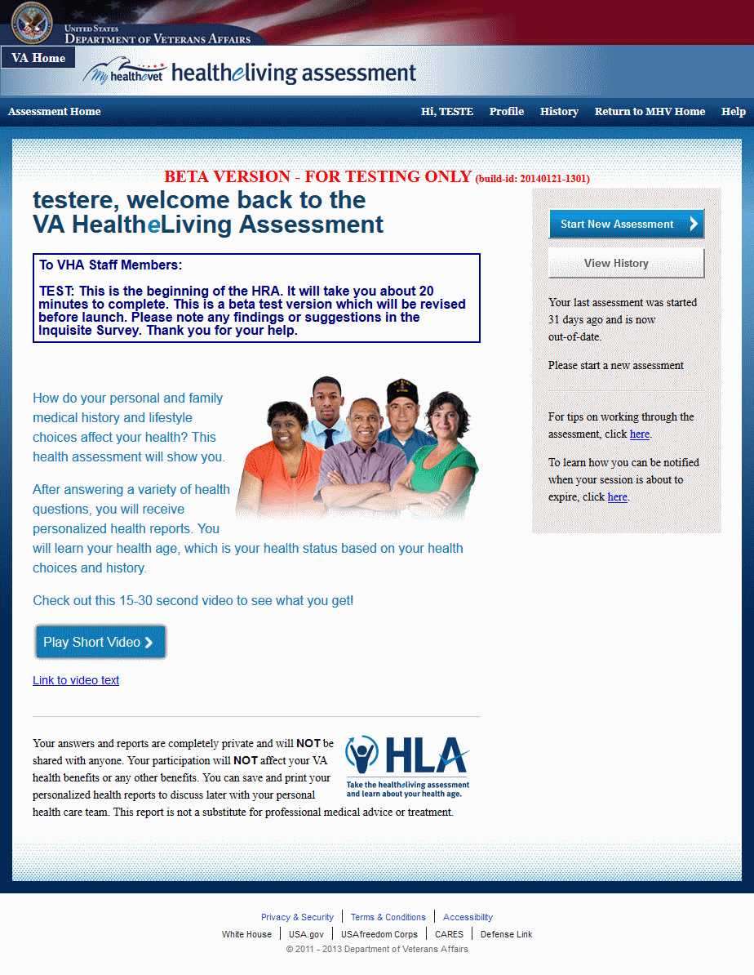

### Main Application: Privacy Reminder Page

#### Controls

| Name | When | Description |
| --- | --- | --- |
| Continue | Always | If clicked, allows the user to begin a new assessment or complete an incomplete assessment. |

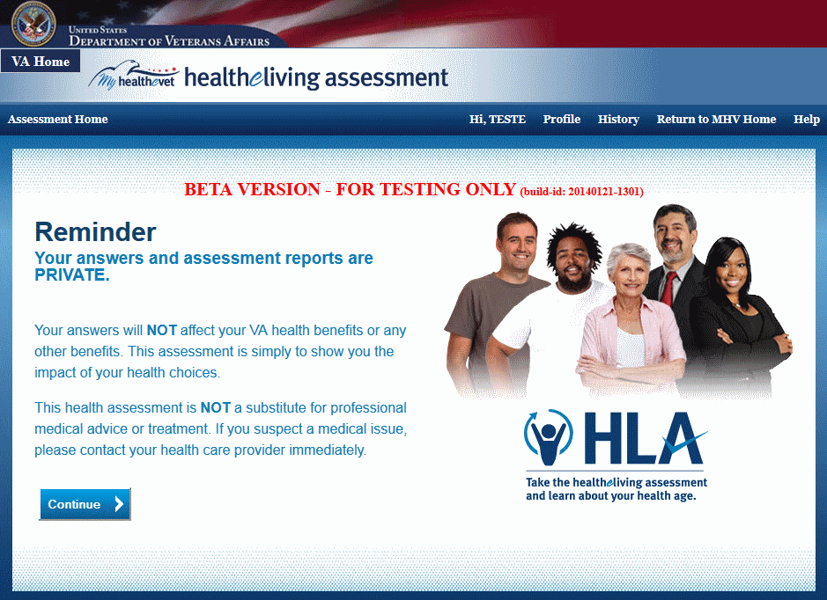

### Main Application: User Profile Page

The user profile page allows the user to update his profile.

#### Controls

| Name | When | Description |
| --- | --- | --- |
| Save | Always | Allows the user to save his updated profile. |
| Cancel | Always | Allows the user to cancel his update. |
| Reminders | Always | If clicked, displays information regarding receiving email reminders to take an annual health assessment and complete incomplete assessments. |

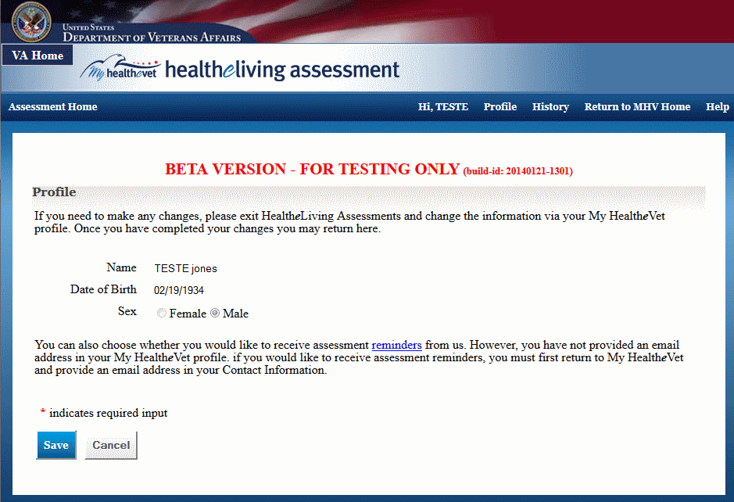

### Main Application: Assessment History Page

The assessment history page displays a history of a user’s assessments.

It also allows the user to start a new assessment and delete an incomplete assessment. The user can view, print, and save both summary and full reports. Finally, the user can share an assessment with health care teams.

#### Controls

| Name | When | Description |
| --- | --- | --- |
| Complete Assessment | An incomplete assessment exists | Allows the user to complete an existing incomplete assessment |
| Start New Assessment | Always | Allows the user to start a new assessment, discarding any existing incomplete assessment. |
| Delete Assessment | An incomplete assessment exist | Allows the user to discard the existing incomplete assessment. |
| View Summary Report  (One per completed assessment) | A complete assessment exists | Allows the user to view the summary report of the completed assessment |
| Print Summary Report  (One per completed assessment) | A complete assessment exists | Allows the user to view a printer-friendly version of the summary report of the completed assessment |
| Save Summary Report  (One per completed assessment) | A complete assessment exists | Allows the user to save the summary report of the completed assessment |
| View Full Report  (One per completed assessment) | A complete assessment exists | Allows the user to view the full report of the completed assessment |
| Print Full Report  (One per completed assessment) | A complete assessment exists | Allows the user to view a printer-friendly version of the full report of the completed assessment |
| Save Full Report  (One per completed assessment) | A complete assessment exists | Allows the user to save the full report of the completed assessment |
| Share Health Care Team Report | The assessment has not yet been shared | Allows the user to share the completed assessment information |

#### When no assessment exists

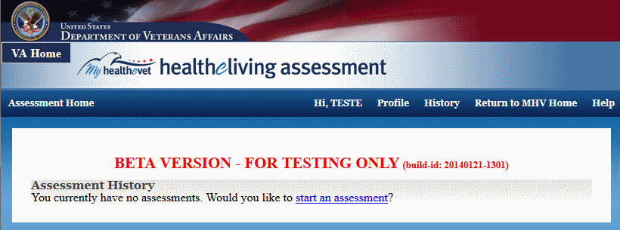

#### When an incomplete assessment exists

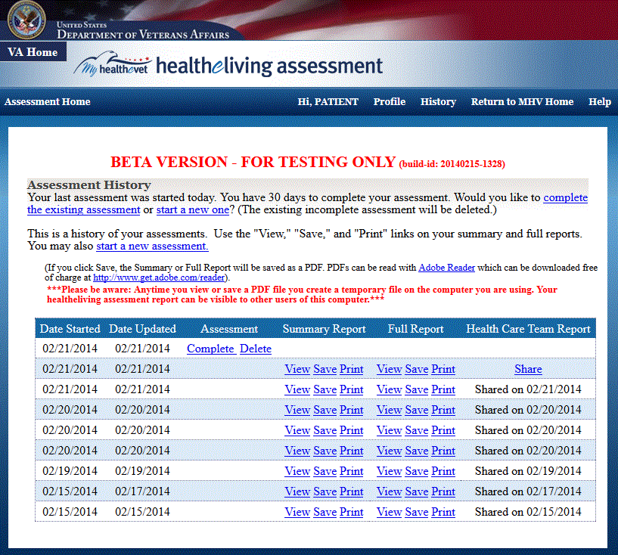

#### When only completed assessments exist

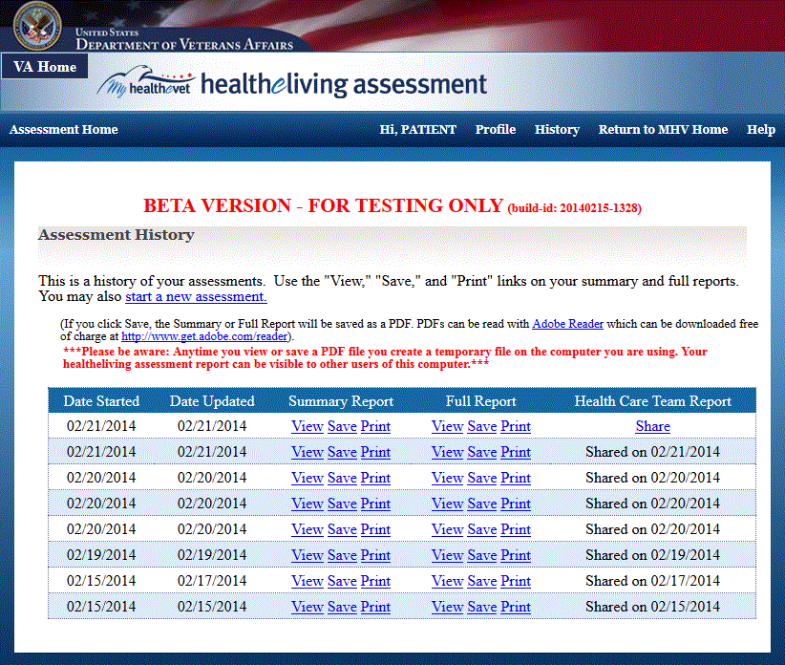

### Main Application: Answer Questions Pages

The answer questions pages allows the user to answer the assessment questions. Questions take several different formats: single and multiple answer, user input, and exclusive and non-exclusive table answers,

#### Controls

| Name | When | Description |
| --- | --- | --- |
| Save & Continue | Always | When clicked, saves the answer and takes the user to the next question. |
| Back | Always | When clicked, takes the user to the previous question. |
| Save & Exit | Always | When clicked, the user is prompted if he really wants to save the assessment or not. If he clicks ‘Yes’, the assessment is saved and exits to the assessment history page. |
| More Info | When information exists for a question | When info icon is clicked, displays information regarding the item |

#### Question Type: Single answer

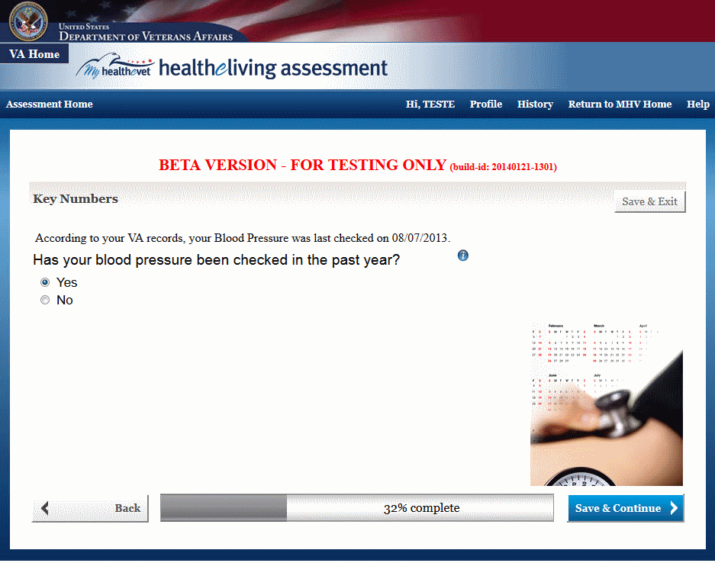

#### Question Type: Multiple answer

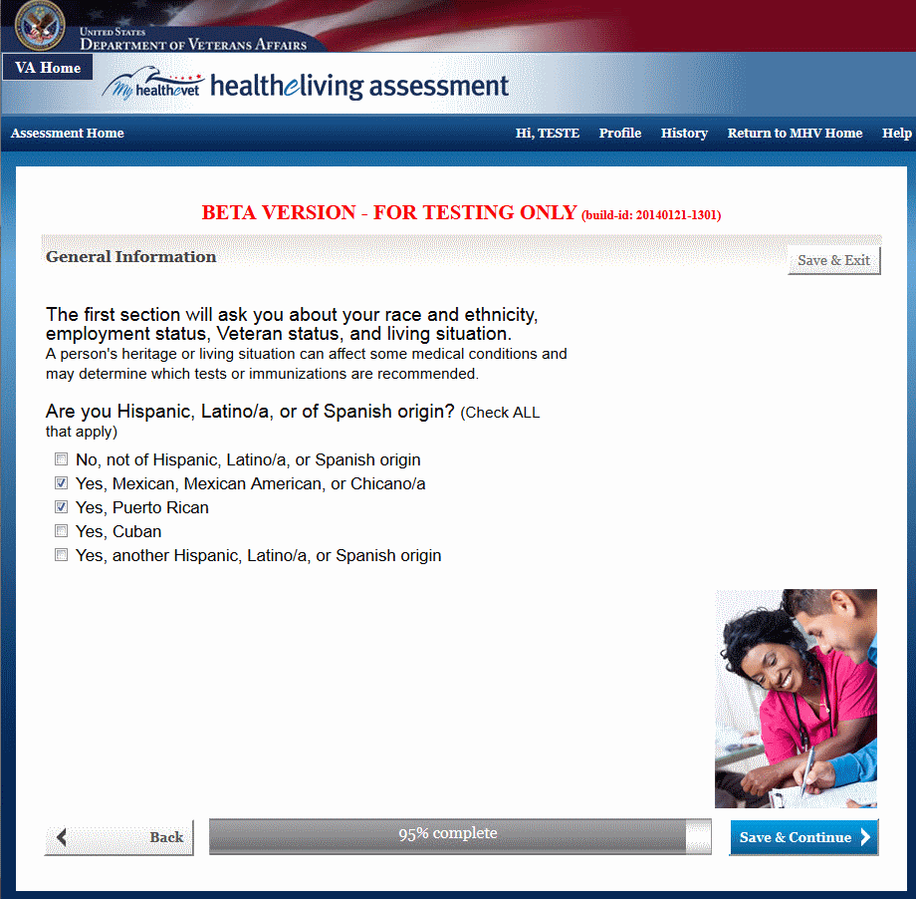

#### Question Type: User Input

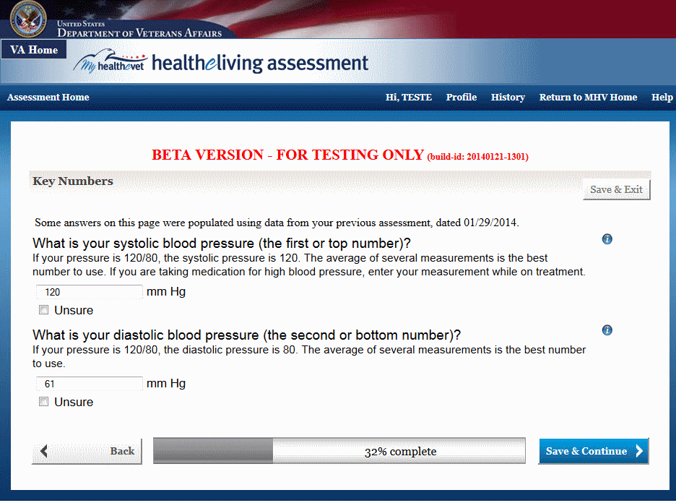

#### Question Type: Exclusive Table

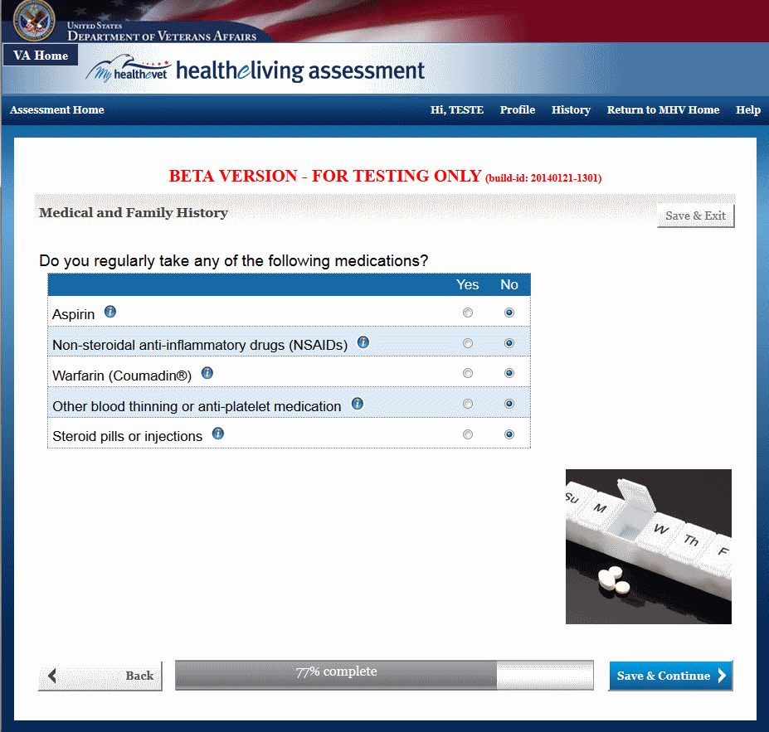

#### Question Type: Non-Exclusive Table

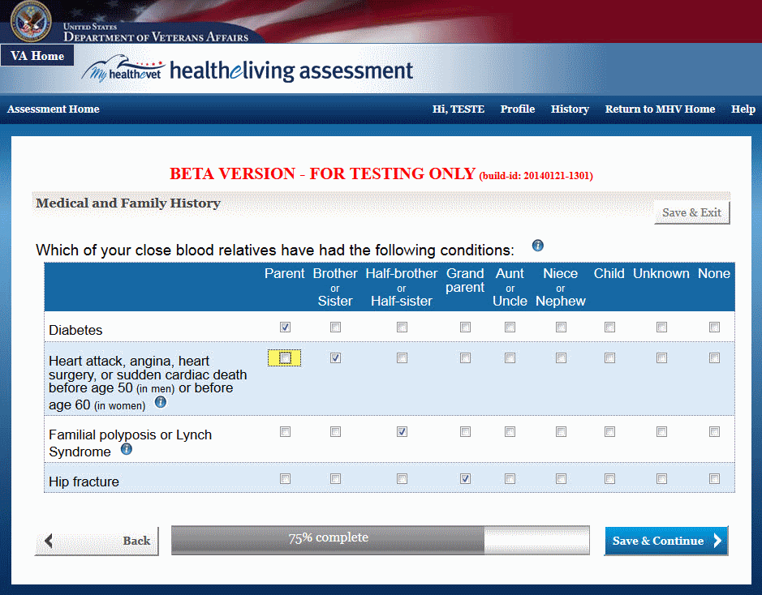

#### Question Type: Error Message

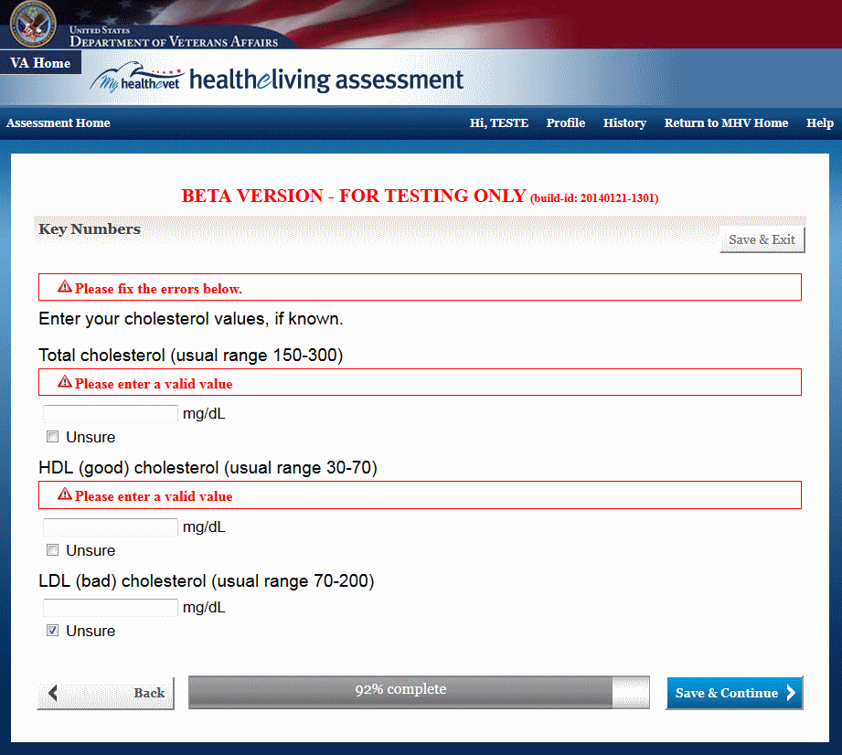

#### Informational Message

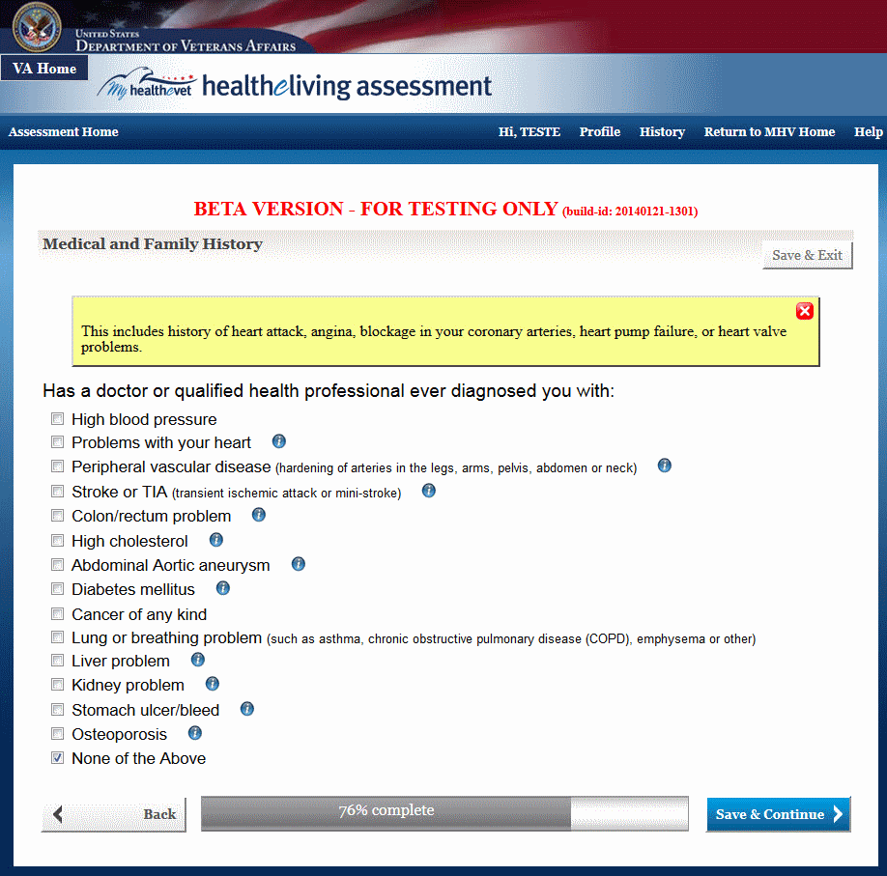

### Main Application: Review Answers Page

The review answers page allows the user to review the answers of an incomplete assessment after no more questions remain. The user can select any answer listed in order to change the answer. When the answer is changed, the user may need to answer more questions (depending on the new answer) before finally ending up on the review answers page. Once the user is satisfied with the answers, the user finalizes the assessment by clicking the Submit button to confirm the answers.

#### Controls

| Name | When | Description |
| --- | --- | --- |
| Answer (for each answer given during the assessment) | Always | Allows the user to change the previously given answer |
| Submit | Always | Allows the user to confim all answers and complete the assessment |

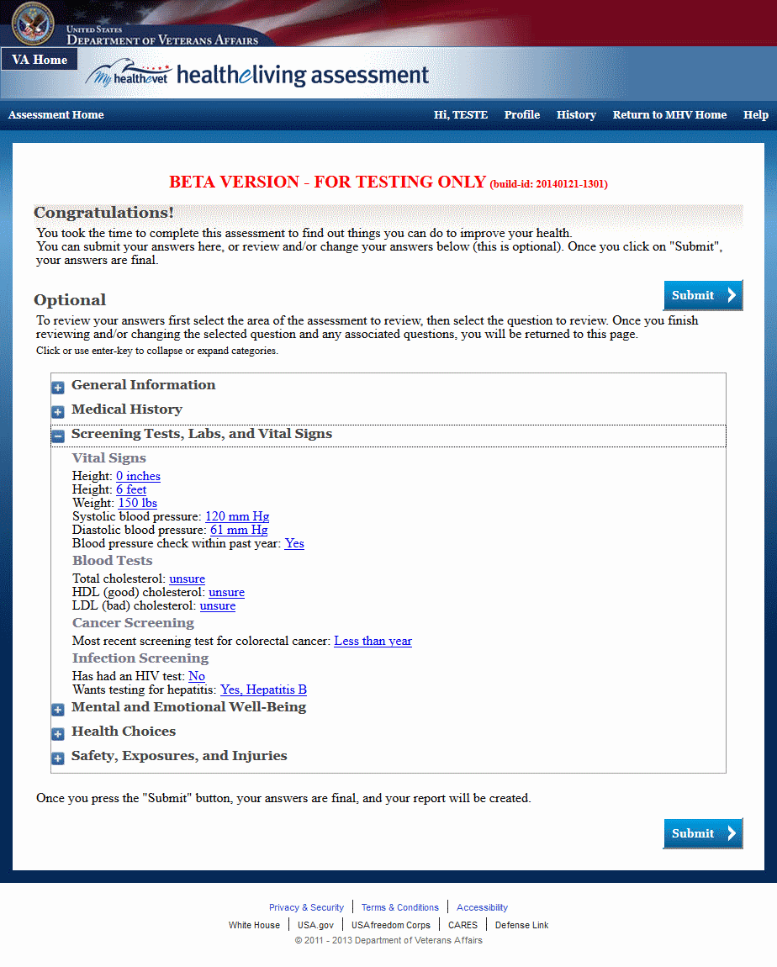

### Main Application: Share Assessment Page

When the user clicks the submit button on the Review Answers page, the share assessment page is displayed. It allows the user to choose whether or not to share assessment information with one or more health care teams. The user also can specify which health care teams to share the information with. If the user elects not to share, a share link for the assessment will show up on the Assessment History page (see Main Application: Assessment History Page) that allows the user to share at a later time.

#### Controls

| Name | When | Description |
| --- | --- | --- |
| Health Care Team radio buttons | Always | Allows the user to select one or more Health Care Teams to share the assessment information with |
| Yes share with my health care team | Always | Allows the user to choose to share the assessment information with selected Health Care Teams |
| No do not share with my health care team | Always | Allows the user to choose not to share the assessment information with selected Health Care Teams |
| OK | Always | Submits the form |

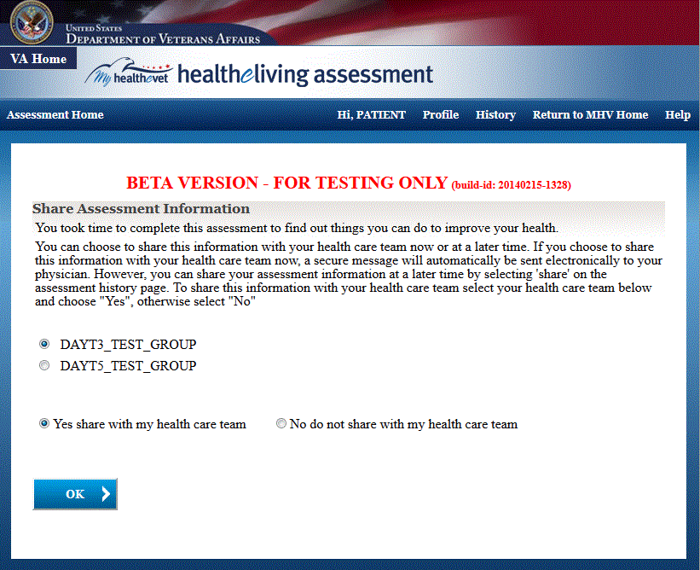

### Main Application: Summary Report Page

The summary report page provides a summary of the user’s completed assessment. It includes the user’s health age, any screenings and vaccines now due, health choice scores, health risk scores, recommendations, more actions that can be taken and what the user is doing well. The recommendations can be selected and used to recalculate the health age interactively on the report page. The user can change the age at which his health risks are scored and then recalculate the risks on the page. Both recalculation settings can be reset to their original values. The summary report can be printed and saved. The user can also go to the Review Answers and full report pages. Finally, the user can exit the summary report page and land on the assessment history page.

#### Controls

| Name | When | Description |
| --- | --- | --- |
| Print | Always | Print the summary report |
| Save | Always | Save the summary report |
| Review Answers | Always | Go to Review Answers page |
| Go to Full Report | Always | Go to Full Report page |
| Exit | Always | Exit the Summary Report page and go to the Assessment History page. |
| Health Choice links (Diet, Physical Activity, Stress, Tobacco, Alcohol, and Safety) | Always | Clicking each link displays information inline on the summary report page pertaining to the selected health choice. |
| Health Risk links (Heart Disease, Diabetes, Stroke, Lung Cancer, Colon Cancer, and Breast Cancer) | Always | Clicking each link displays information inline on the summary report page pertaining to the selected health risk. |
| Recommendation check boxes and Recalculate | Always | One or more check boxes may be selected and then the Recalculate button may be clicked to recalculate and redisplay the user’s updated health choice and risk scores. |
| “Risks before the age of” and Recalculate | Always | User may select a new age before which to recalculate his health risks percentages and redisplay the updated risks. |
| Reset (for Recommendations and Health Risk age) | Always | Reset and display the original health choice and risk scores. |
| What You Are Doing Well list | Always | User can select to view a list of things he is already doing well. |
| More Info | Always | Clicking on information icons (for example, those icons displayed next to the recommendation check boxes) displays detailed information for that item |

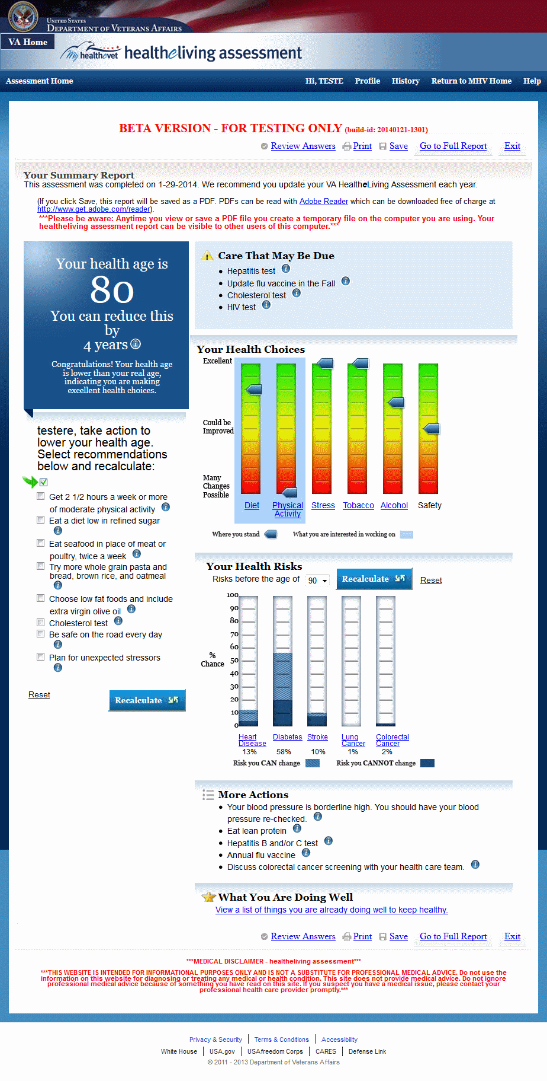

### Main Application: Full Report Page

The full report page provides a full accounting of the user’s completed assessment. It provides more detail than the summary report. The top of the page provides a “table of contents”, with links to detailed information for health age, health choices, health risks, critical numbers (BMI, blood pressure, and cholesterol), and what the user is doing well. The full report can be printed and saved. The user can also go to the Review Answers and summary report pages. Finally, the user can exit the full report page and land on the assessment history page.

#### Controls

| Name | When | Description |
| --- | --- | --- |
| Print | Always | Print the full report |
| Save | Always | Save the full report |
| Review Answers | Always | Go to Review Answers page |
| Go to Summary Report | Always | Go to Summary Report page |
| Exit | Always | Exit the Full Report page and go to the Assessment History page. |
| Health Age | Always | Clicking this link takes the user to health age information below the table of contents on the full report page. |
| Your Numbers | Always | Clicking each link takes the user to information for that health number below the table of contents on the full report page. |
| What You Are Doing Well | Always | Clicking this link takes the user to information about what the user has been doing well below the table of contents on the full report page. |
| Health Choice links (Diet, Physical Activity, Stress, , Alcohol, Tobacco, Safety Immunizations, and Screening) | Always | Clicking each link takes the user to information below the table of contents on the full report page pertaining to the selected health choice. |
| Health Risk links (Heart Disease, Diabetes, Stroke, Lung Cancer, Colon Cancer, and Breast Cancer) | Always | Clicking each link takes the user to information below the table of contents on the full report page pertaining to the selected health risk. |

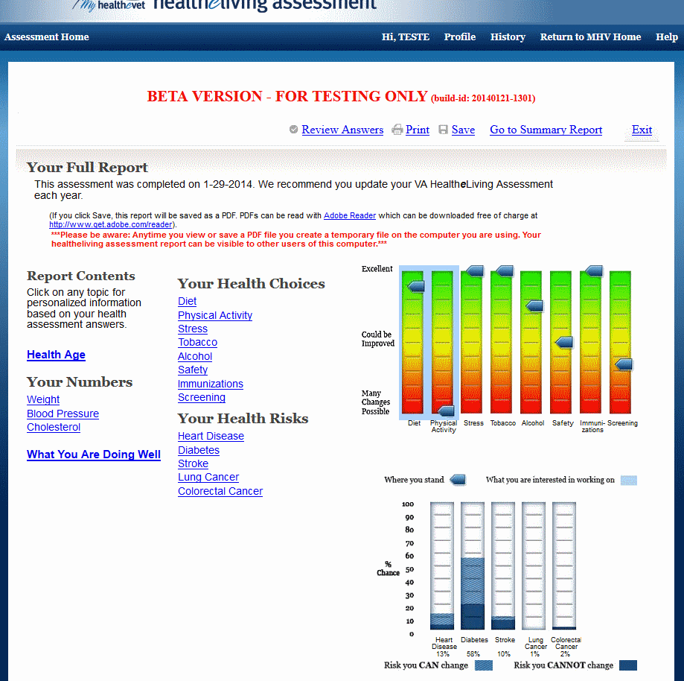

#### Controls

| Name | When | Description |
| --- | --- | --- |
| Back to Top | Always | Clicking this link takes the user back to the top of the full report page |
| View your USDA caloric, vitamin and mineral recommendations | Always | Clicking this link takes the user to another page in a new tab or window. This page displays diet recommendations. |

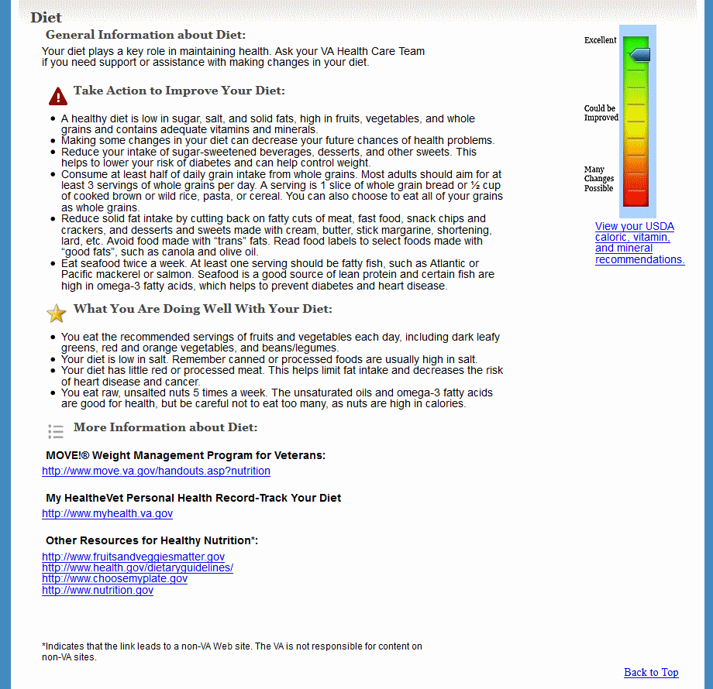

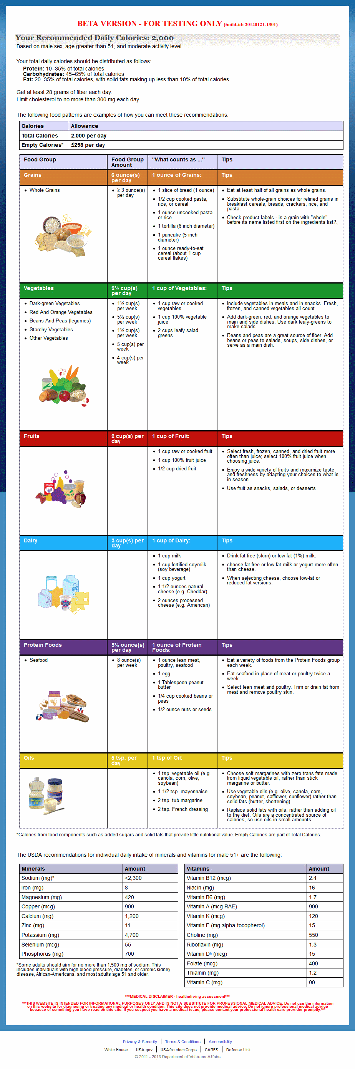

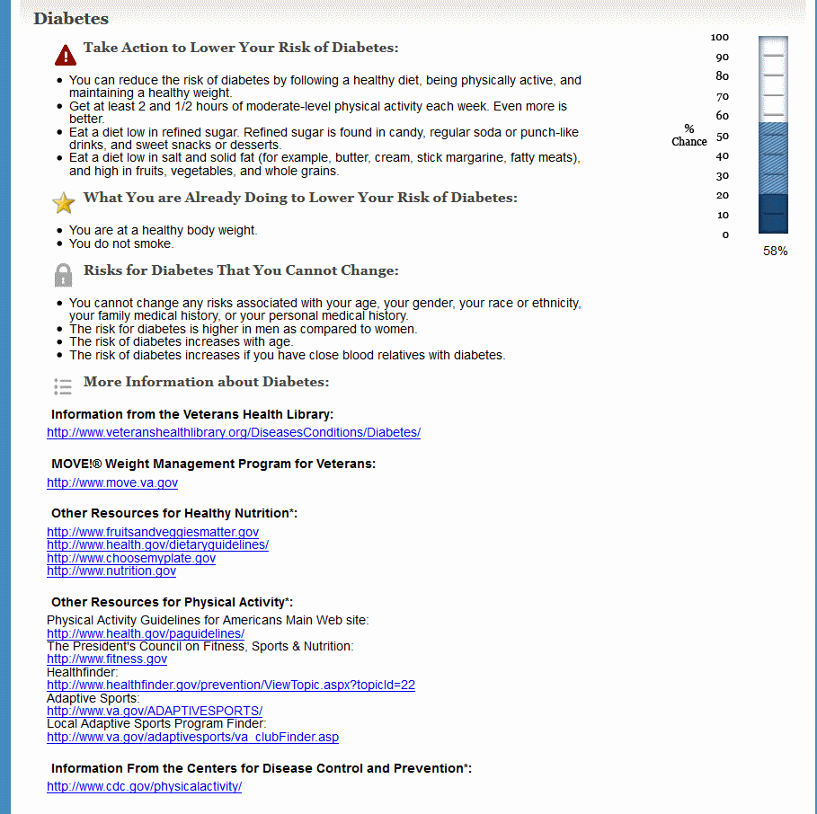

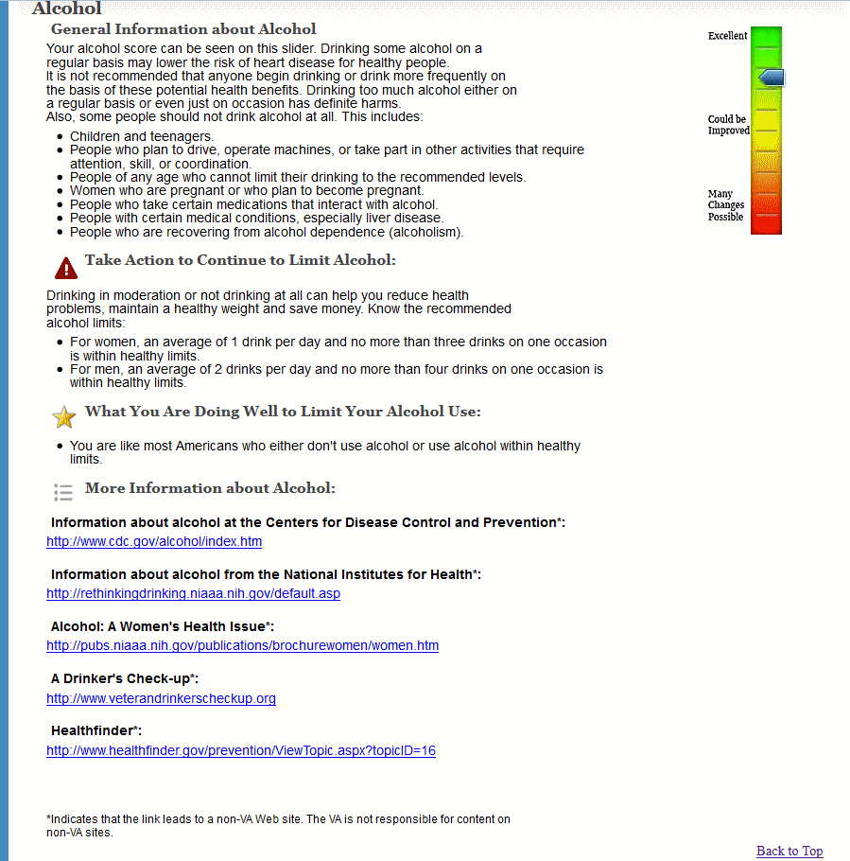

### Main Application: Help Topics Page

The help topics page provides help on general topics associated with the HLA web application. These topics include browser compatibility, accessibility, the privacy statement, terms and conditions, registration, and personal information. The page is accessible from the Help drop-down menu in the main navigation header.

#### Controls

| Name | When | Description |
| --- | --- | --- |
| Browser Compatibility | Always | Clicking this link takes the user to a new page that provides information regarding browsers that are compatible and recommended with viewing the application. |
| Accessibility | Always | Clicking this link takes the user to a new page that provides information regarding accessibility options and section 508. |
| Privacy Statement | Always | Clicking this link takes the user to a new page that provides the MHV privacy statement. |
| Terms and Conditions | Always | Clicking this link takes the user to a new page that provides the MHV terms and conditions. |

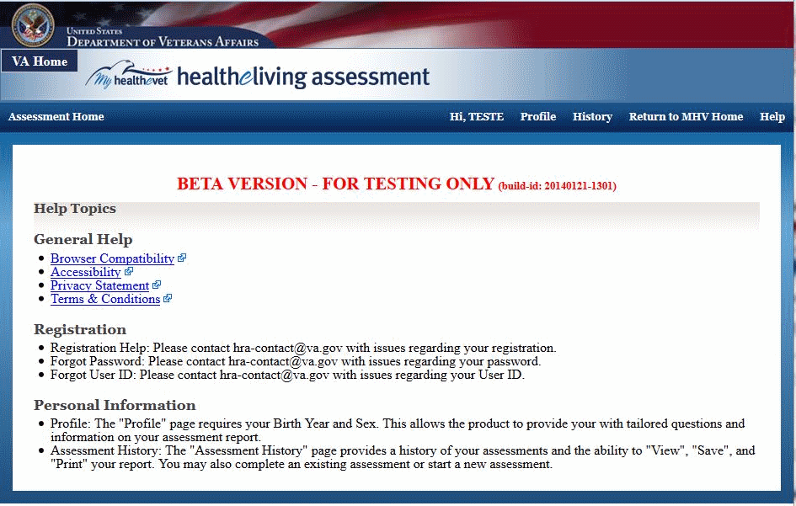

### Main Application: Frequently Asked Questions (FAQs) Page

The FAQs page provides answers to questions frequently asked about the HLA application.

Question topics include new users, issues using the HLA application, and the benefits of using javascript. The page is accessible from the Help drop-down menu in the main navigation header.

#### Controls

| Name | When | Description |
| --- | --- | --- |
| New Users questions | Always | Clicking these links takes the user to locations within the FAQs page that provide answers to questions regarding new users. |
| Issues Using the HealtheLiving Assessment | Always | Clicking these links takes the user to locations within the FAQs page that provide answers to questions regarding using the HLA. |
| Benefits of enabling JavaScript  in the HealtheLiving Assessment | Always | Clicking these links takes the user to locations within the FAQs page that provide answers to questions regarding enabling JavaScript. |
| Back to Top | Link has been clicked. | Takes the user back to the top of the FAQs page. |
| Back to Assessment Home | Always | Takes the user back to the welcome page. |

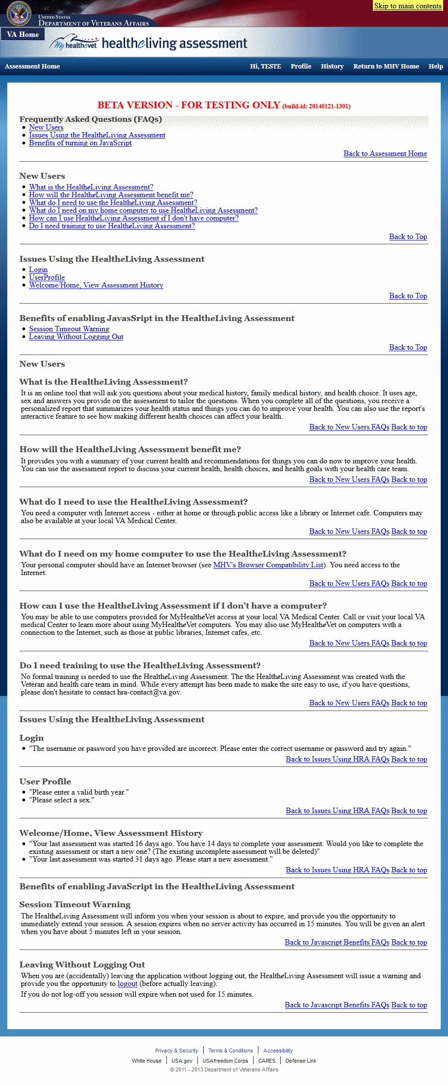

### Main Application: Tips Page

The tips page provides tips for new users for how to take an assessment. The page is accessible from the Help drop-down menu in the main navigation header.

#### Controls

| Name | When | Description |
| --- | --- | --- |
| Start New Assessment | Always | Clicking this button allows the user to start taking an assessment. |

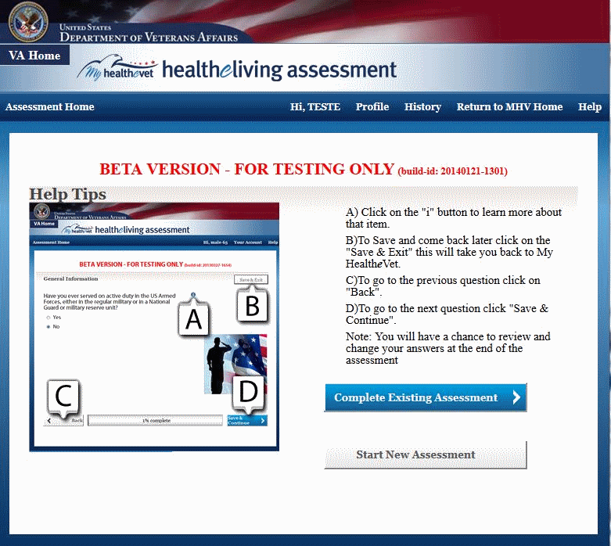

### Analytics Application: Login Page

The login page allows a user to access the application. It requires a valid user name and password, specific to the Analytics application.

#### Controls

| Name | When | Description |
| --- | --- | --- |
| Login | Always | If clicked, allows the user enter the application, redirecting the user to the welcome page. |

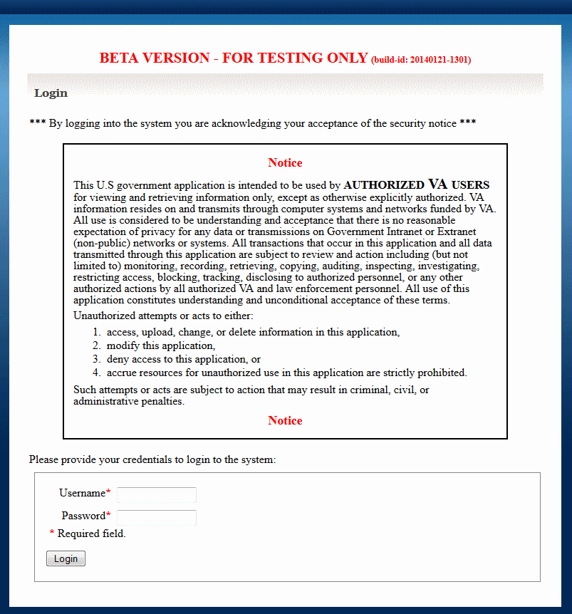

### Analytics Application: Welcome Page

The welcome page is the initial landing page the user sees after logging in. It shall show a dashboard with some analytics information.

#### Controls

| Name | When | Description |
| --- | --- | --- |
| Create Report | Always | Allows the user to start a new User or Assessment Report |
| Reports History | Always | Allows to user to view an overview of all previously created reports |

#### Welcome Page – no synchronization yet

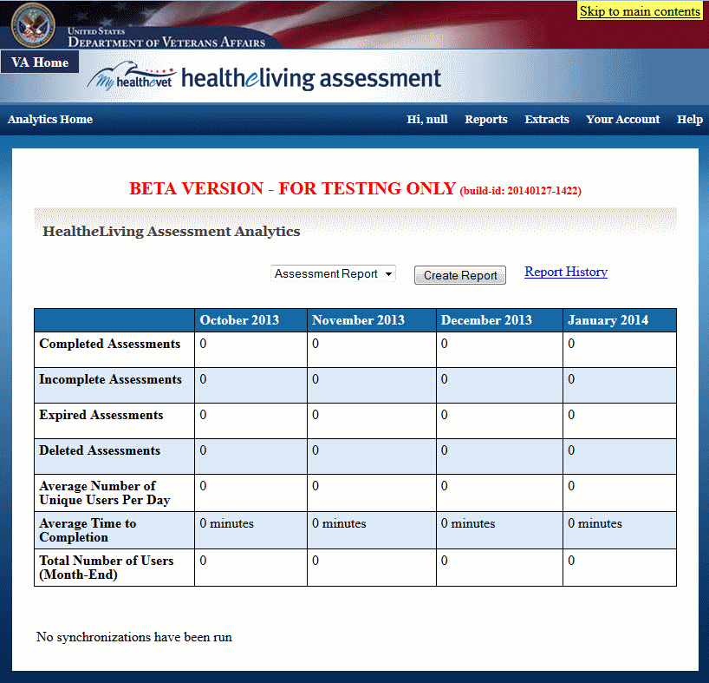

#### Welcome Page – after synchronization

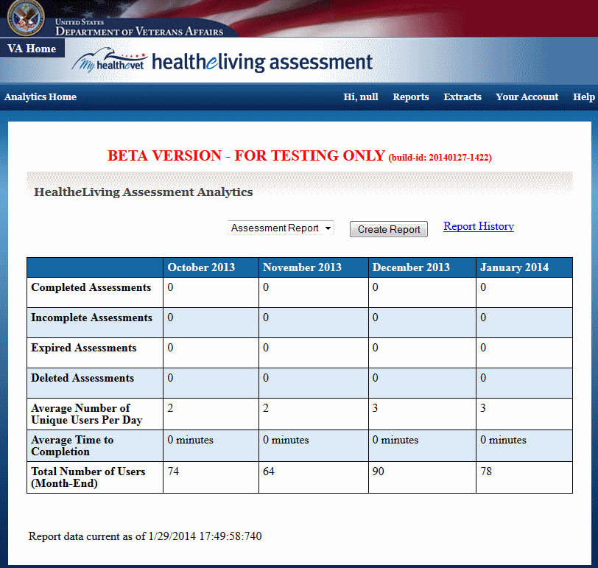

### Analytics Application: Synchronization Page

#### Controls

| Name | When | Description |
| --- | --- | --- |
| Synchronize Now | Always | Synchronizes Analytics database with anonymized assessment and user data from main application database. |

#### Synchronization Page – before synchronization

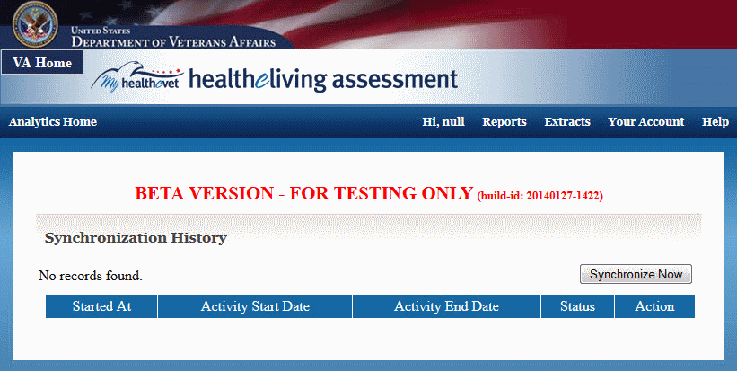

#### Synchronization Page – after synchronization

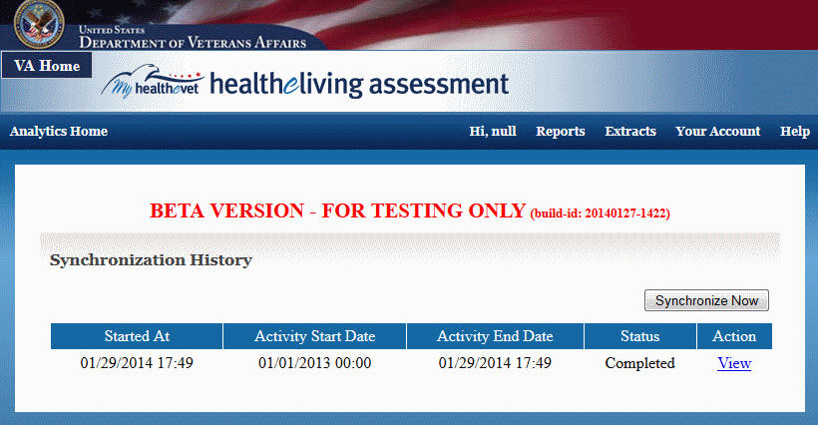

### Analytics Application: View Report History Page

The View History page allows the user to view a liste of all previous created reports (that have not been deleted).

#### Controls

| Name | When | Description |
| --- | --- | --- |
| Go to Dashboard | Always | Returns the user to the welcome page |
| Report Type | Always | Shows a list of possible report types (Assessment, User) |
| Create New Report | Always | Creates a new report of the type selected in the Report Type control |
| Recreate Report | For each listed report | Creates a report similar to the selected report; Opens the Create Report page with all values and criteria of the selected report pre-populated |
| View Report | For each listed report | Views the results of the selected report; Opens the View Report page for that report. |
| Delete Report | For each listed report | Removes the selected report |
| Export Report | For each listed report | Exports the report selected to a CSV file |
| Print Report | For each listed report | Opens a printer-firendly page for the selected report |

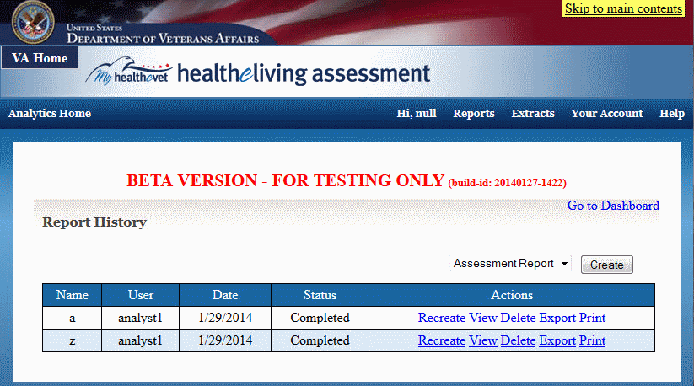

### Analytics Application: Create Report Page

The Create Report page allows the Analyst to create a User or Assessment report (the user choose the type before opening the page).

#### Controls

| Name | When | Description |
| --- | --- | --- |
| Name field | Always | A short description of the report that will be shown in the report listing |
| Description Field | Always | A longer description of the report |
| Criteria Selection | Always | A list of criteria types that allow the Analyst to pick which criteria are used to limit which assessment are to be included in the report |
| Add Criterion | Always | Adds a select criterion to the list of actual selection criteria. |
| Row Display Selection | Always | A list of values that defines the first (mandatory) grouping of the assessments in the report |
| Column Display Selection | Always | A list of values that defines the (optional) second grouping of the assessments in the report |
| Create Report | Always | Creates the report with all the values and criteria as specified. |
| Cancel | Always | Cancels the report |

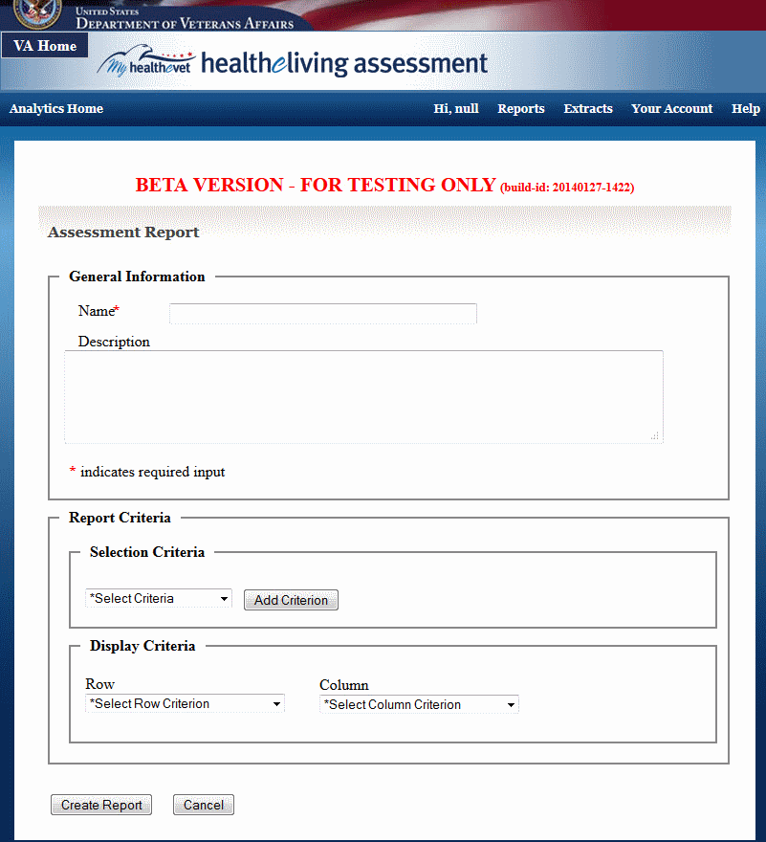

### Analytics Application: View Report Page

The View Report page shows the user the report information, name, description, creator name, creation date, description of the selection and display criteria and a table containing the report results

#### Controls

| Name | When | Description |
| --- | --- | --- |
| Create Similar Report | Always | Open the Create Reort page with the parameters (name, description, selection and display criteria) prepopulated with the values of the currently viewed report. |
| Export to CSV | Always | Export the information on the current page to a CSV file |
| Printer Friendly | Always | Show a fprinter-friendly version of the current page |

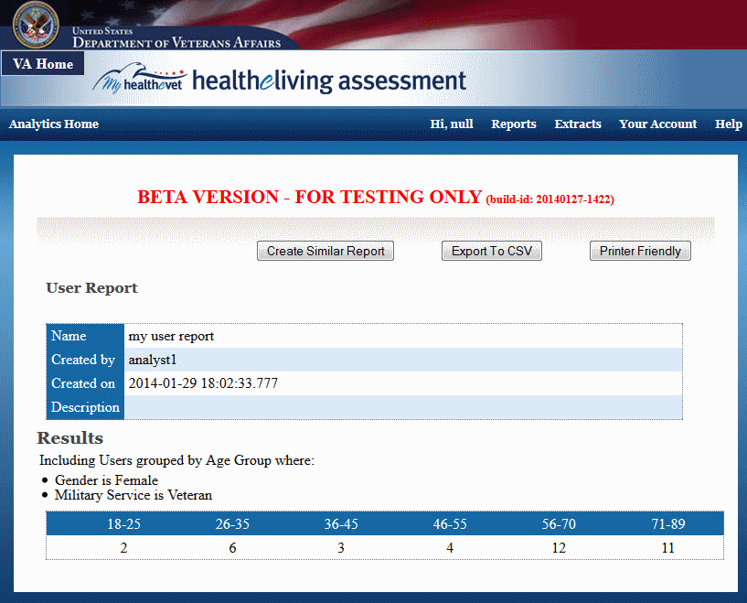

### Analytics Application: Printer-friendly View Report Page

The Printer-friendly report view page page provides user with a printer-friendly view of the View Report page. Header and footer information will be suppressed.

#### Controls

| Name | When | Description |
| --- | --- | --- |
| Print | When Javascript is enabled | Allows the user to print the the page |
| Back | Always | Return the user to previous page |

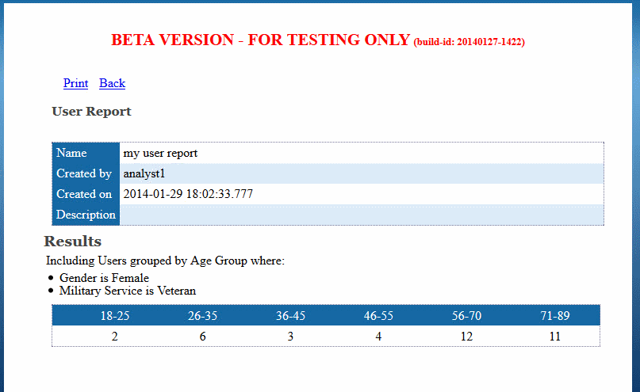

### Analytics Application: Create Extract Page

The Create Extract page allows the Analyst to create a User or Assessment data extract (the user chooses the type before opening the page).

#### Controls

| Name | When | Description |
| --- | --- | --- |
| Selection Criteria | Always | Two (optional) date range criteria that allow the Analyst to limit which assessments (or users) are to be included in the extract . |
| Extract Categories | Always | Categories of data that are selected for extraction. Each category corresponds to multiple values that show up in the extract (spreadsheet). At least one category must be selected. |
| Extract | Always | Creates the extract with all the categories and criteria as specified. |
| Cancel | Always | Cancels the extract |

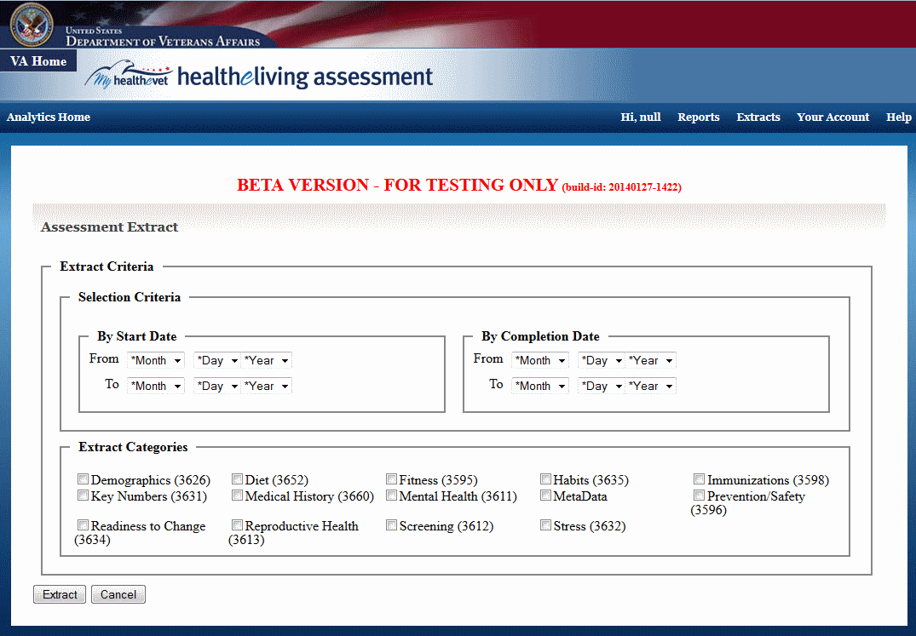

### Administration Application: Login Page

The login page allows a user to access the application. It requires a valid user name and password, specific to the Administrationapplication.

#### Controls

| Name | When | Description |
| --- | --- | --- |
| Login | Always | If clicked, allows the user enter the application, redirecting the user to the welcome page. |

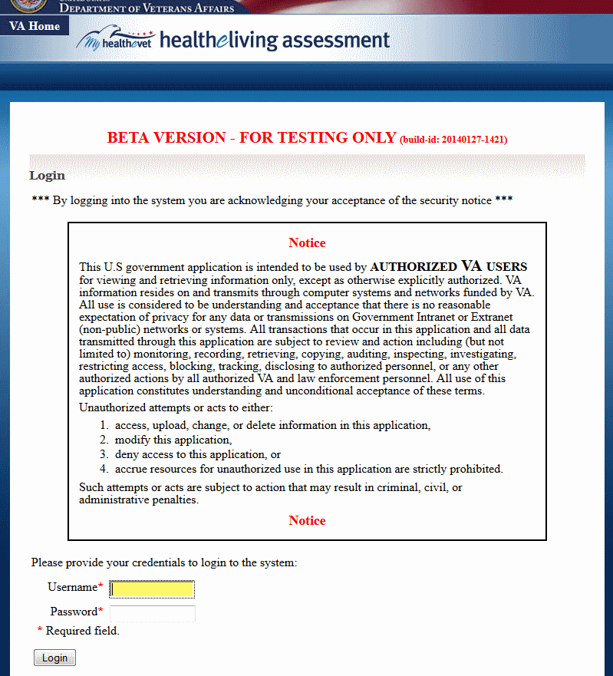

### Administration Application: Welcome Page

The welcome page is the initial landing page the user sees after logging in. It shall show a a list of tasks the administrator can perform

#### Controls

| Name | When | Description |
| --- | --- | --- |
| Manage Users | Always | Manage user accounts. Review Veteran-type users; create and manage Administrator and Analyst users |
| View Audit Log | Always | View the log of audit entries containing information such as errors, authentication successes an failures. |
| View Message Log | Always | View the log of messages exchanged with internal and external systems |
| View Clinical Model Information | Always | Shows a read-only page with information about the linical model (for verification purposes). |

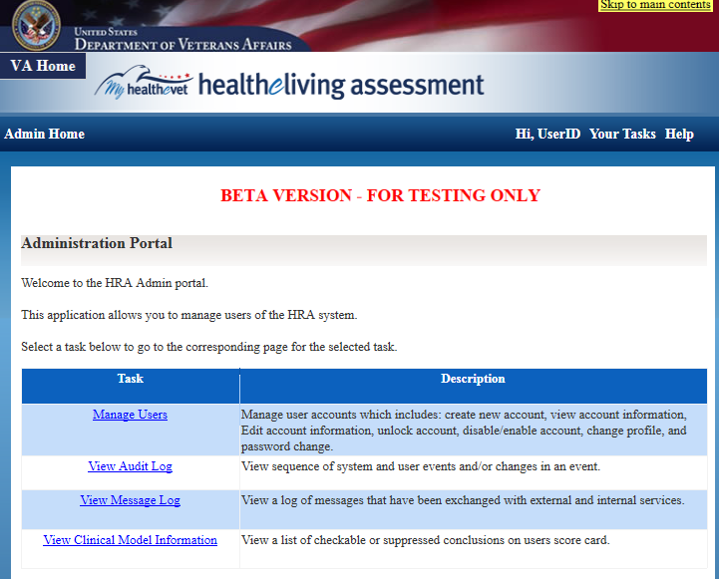

### Administration Application: User Account List Page

#### Controls

| Name | When | Description |
| --- | --- | --- |
| Create Account | Always | OOPens the Create Account page to enable the Administrator to create a new Administrator or Analyst user account |
| Apply Filter | Always | Resfreshed the page while applying the current values of the filter fields to determine which user accounts to show |
| Reset | Always | Resets the filter fields to the original values |
| Edit | Always, one per listed account | Opens the Edit Account Information page for the account |
| Disable | One per listed account that is currently enabled | Disables the currently enabled account |
| Enable | One per listed account that is currently disabled | Enables the currently disabled account |
| Unlock | One per listed account that is currently locked | Unlocks the currently locked account |

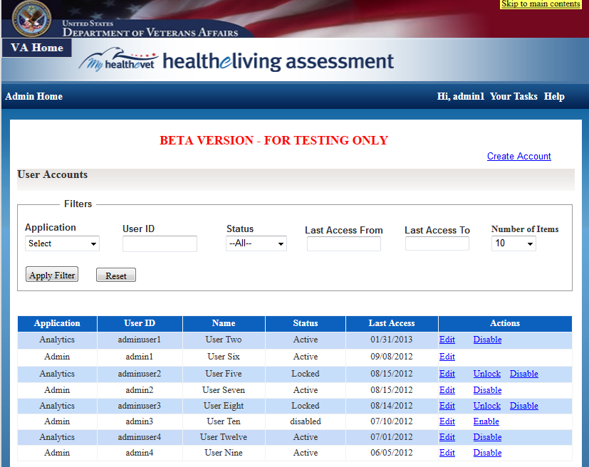

### Administration Application: User Account Creation Page

The User Account Creation page enables an Administrator to create a new Administrator or Analyst account.

#### Controls

| Name | When | Description |
| --- | --- | --- |
| Submit | Always | Submit the values submitted and create a new account |
| Cancel | Always | Cancel creating a new account and return to the account listing. |

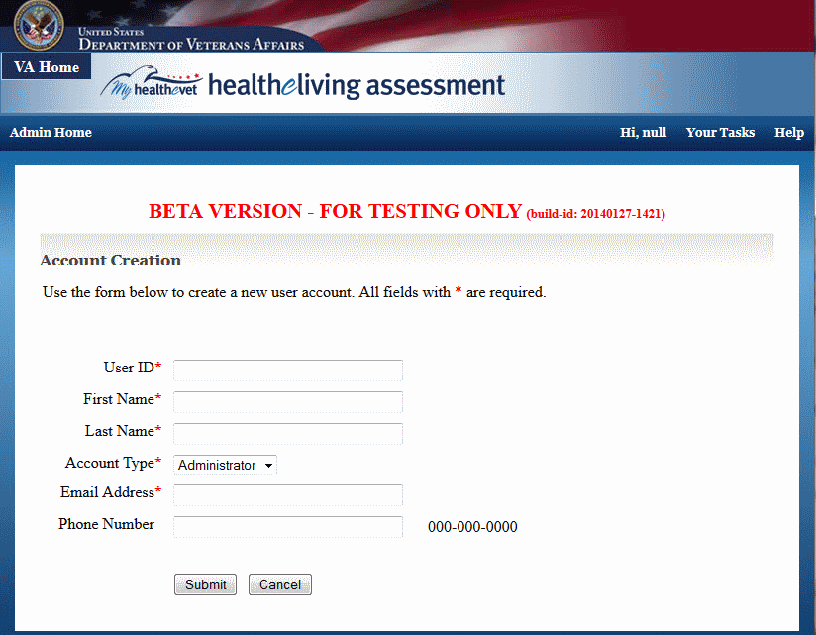

### Administration Application: Change Password Page

The change password page is shown when the user selects to change her password. Theuser must provide the old and new password.

#### Controls

| Name | When | Description |
| --- | --- | --- |
| Change Password | Always | Submits the changed password |
| Cancel | Always | Cancels changing th epassword |

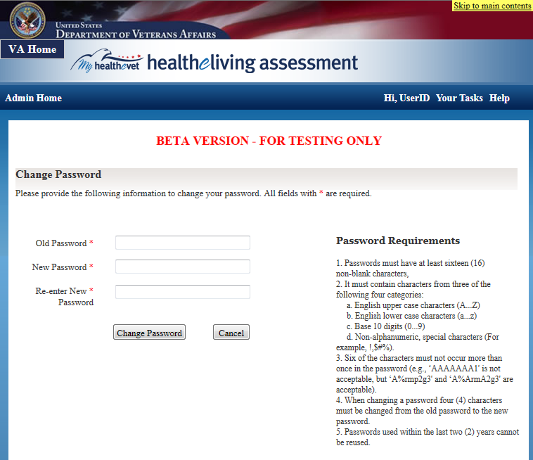

### Administration Application: Change Temporary Page

The temporary change password page is shown to the user when an Administrator reset the password and provided a temporary password. The user must change the password upon first logon. The user must provide the new password. The old password does not bneed to be provided as the user just provided it during login.

#### Controls

| Name | When | Description |
| --- | --- | --- |
| Change Password | Always | Submits the changed password |
| Cancel | Always | Cancels changing th epassword |

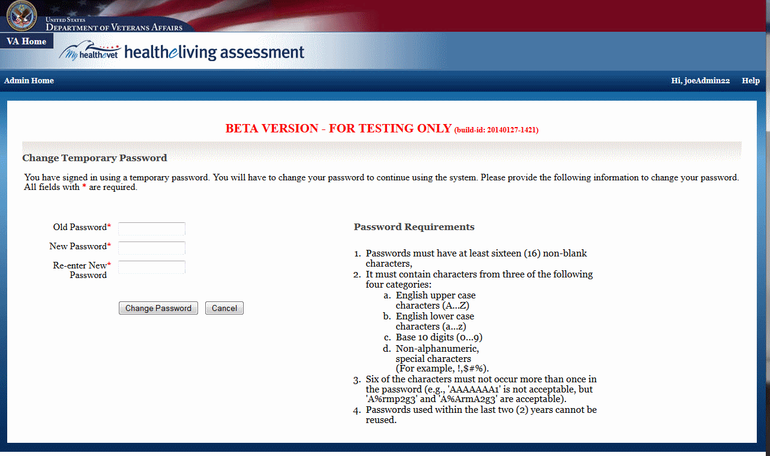

### Administration Application: Change Profile Page

The change profile page allows the user to change her name and contact information. Note the information is only used to contact the user (if necessary).

#### Controls

| Name | When | Description |
| --- | --- | --- |
| Save | Always | Save the changes made |
| Cancel | Always | Cancel the changes |

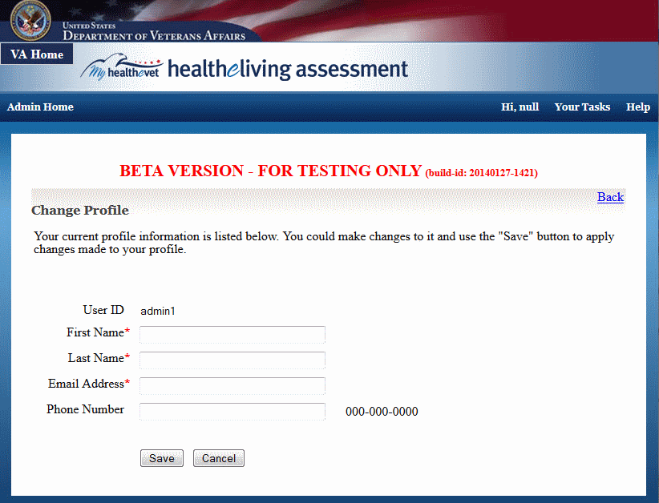

### Administration Application: Edit Account Information Page

The Edit Account Information allows an Administrator to review and change account information (in the case of Administrator and Analyst accounts), add remarks to any account, and unlock or enable/disable any account. Note that locking happens automatically (when too many invalid login attempts occur) and cannot be performed by an Administrator

#### Controls

| Name | When | Description |
| --- | --- | --- |
| Back | Always | Return to the account listing |
| Save | Always | Save any changes made |
| Unlock | When user account is currently locked | Unlocks the user account, such that the user may login again. |
| Enable | When user account is currently disabled | Enables the user account, such that the user may login again. |
| Disable | When user account is currently enabled | Disables the user account, such that the user may no longer login. |

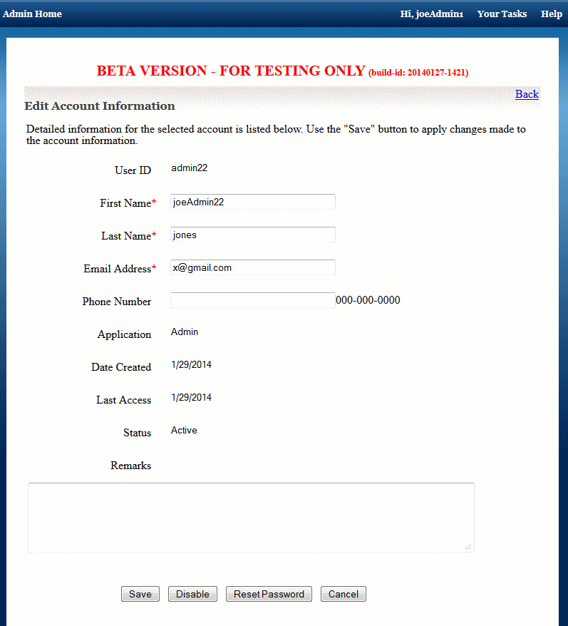

### Administration Application: Audit Log Page

The audit Log page allows an Administrator to review the auditable events that occurred in the system

#### Controls

| Name | When | Description |
| --- | --- | --- |
| Export | Always | Exports the list of entries to an CSV file |
| Print | Always | Prints the list of entries |
| Apply Filter | Always | Refreshes the page using the filter fields to determine wheich audit entries to show |
| Reset | Always | Resets the filter fields to the original values |
| View entry | Per listed account, always | The control is enabled on the activity name and enables the user to review all details of the audit log entry |

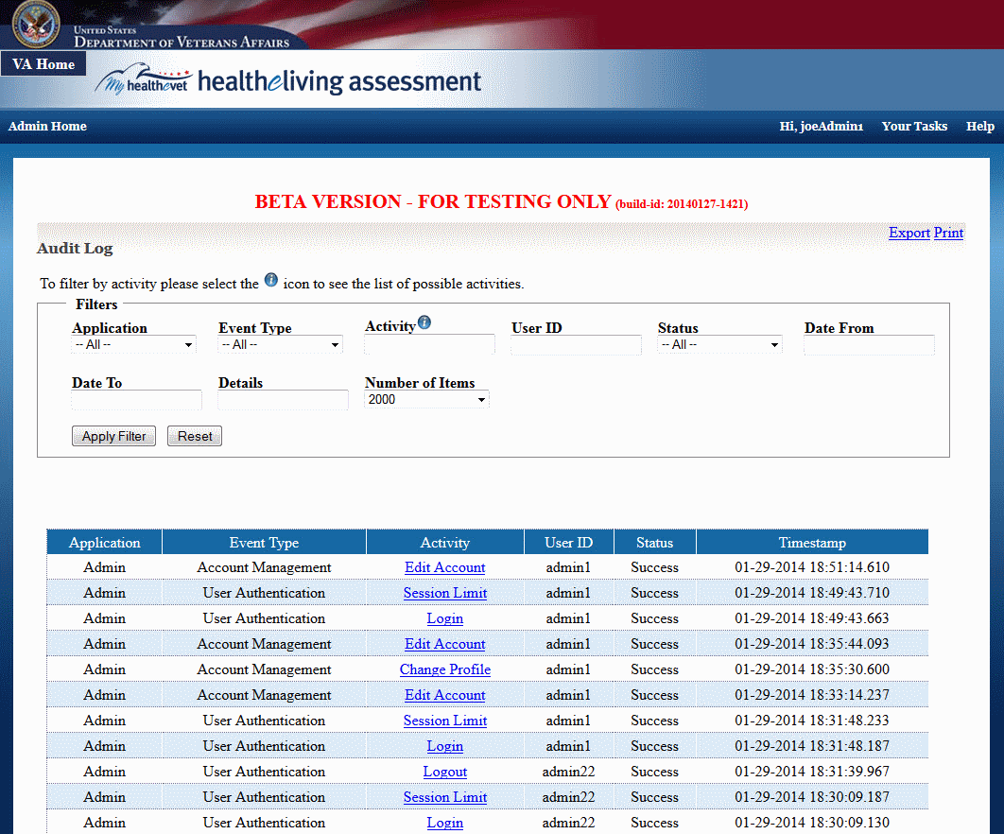

### Administration Application: View Audit Details Page

The View Audit Details Page enables an Administrator to review the details of a single audit log entry.

#### Controls

| Name | When | Description |
| --- | --- | --- |
| Back | Always | Returns the user to the audit log listing |
| Print | Always | Prints the current audit entry |

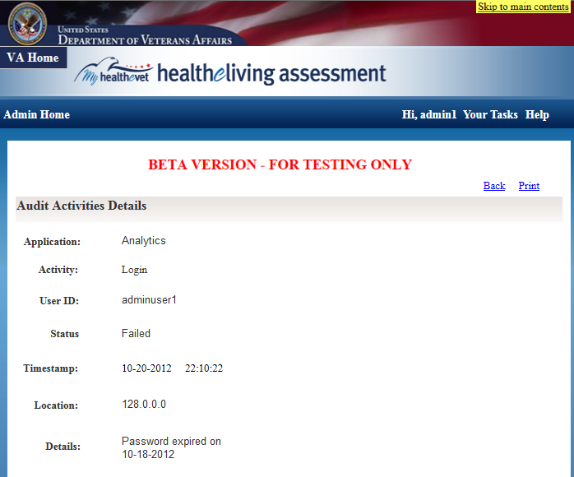

### Administration Application: Message Log Listing Page

The Message Log Listing page allows an Administrator to review messages being exchanged with other internal and external systems.

#### Controls

| Name | When | Description |
| --- | --- | --- |
| Apply Filter | Always | Resfreshes the pages while applying the current filter fields |
| Reset | Always | Resets the filter fields to the original values |
| View | Always, one per message | View the contents of the message |
| Save | Always, one per message | Save the contents of the message to and XML formatted file |
| Conversation | Always, one per message | Refreshes the page and filter on all messages in the same conversation (message thread) |
| Save Conversation | Always, one per message | Saves the entire message thread to an XML formatted file |

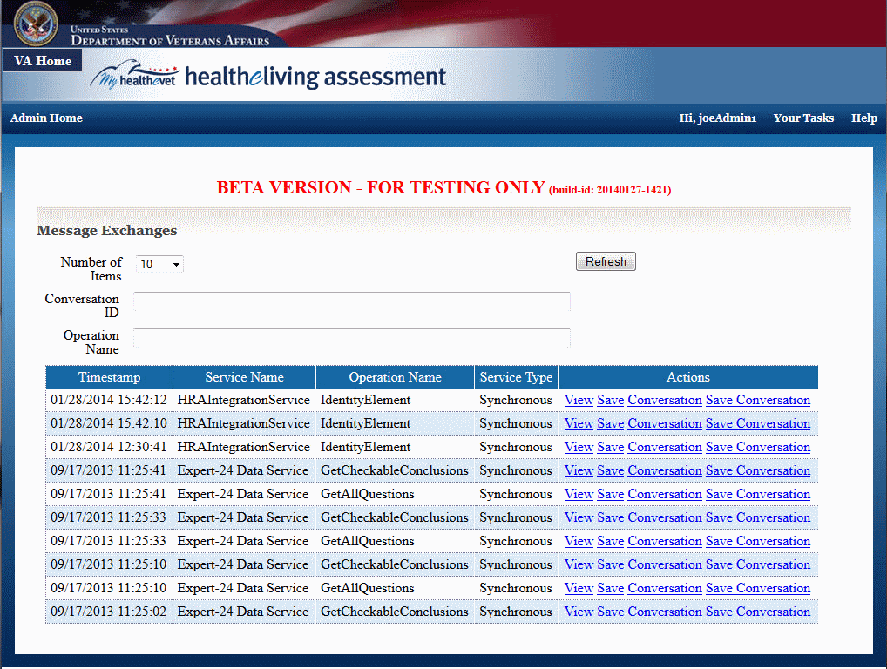

### Administration Application: Clinical Model Information Page

The Clinical Model Information page shows the user the list of checkable conclusions (as published by the Expert-24 product), as well as the list of conclusions that are configured to be suppressed. The configuration of suppressed conclusions happens through a configuration file. This page allows an Administrator to review that configuration.

#### Controls

| Name | When | Description |
| --- | --- | --- |
| ** none ** | | |

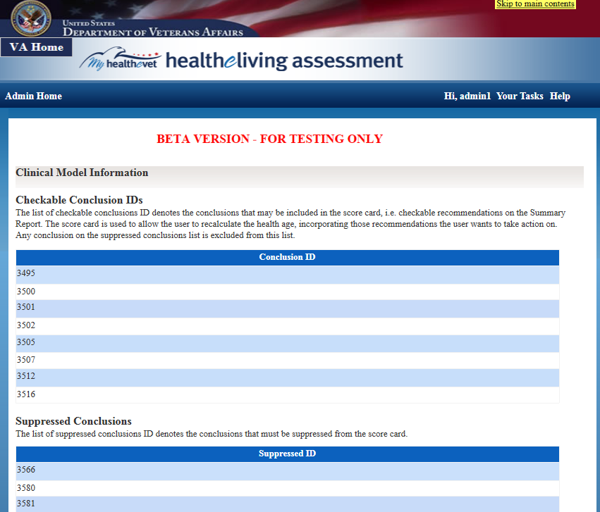

# System Integrity Controls

The application has controls in place to ensure the integrity of the system. These include user names and passwords required to access the application, persistant database information that provides the ability to audit user information, and the creation and modification of all data.

# Appendix A

Attach any addition information that supplements the design specification.

## Requirements Traceability Matrix

See the HLA Requirements Traceability Matrix document.

## Packaging and Installation

See the HLA Developer Manual document.

## Design Metrics

The following design metrics where used during design:

* **Cohesion** - The degree to which the elements of a [module](http://en.wikipedia.org/wiki/Module_%28programming%29) belong together. Thus, it is a measure of how strongly-related each piece of functionality expressed by the source code of a software [module](http://en.wikipedia.org/wiki/Module_%28programming%29) is. As applied to [object-oriented programming](http://en.wikipedia.org/wiki/Object-oriented_programming), if the methods that serve the given class tend to be similar in many aspects, then the class is said to have high cohesion. In a highly-cohesive system, code readability and the likelihood of reuse is increased, while complexity is kept manageable.
* **Coupling** - The degree to which each [program module](http://en.wikipedia.org/wiki/Module_%28programming%29) relies on each one of the other modules. Coupling is usually contrasted with [cohesion](http://en.wikipedia.org/wiki/Cohesion_%28computer_science%29). Low coupling often correlates with high cohesion, and vice versa. Low coupling is often a sign of a well-structured [computer system](http://en.wikipedia.org/wiki/Computer) and a good design, and when combined with high cohesion, supports the general goals of high readability and maintainability.

The system was designed with a high cohesion and low coupling in mind.

## Glossary of Terms

For information on the terms used in this document, refer to section 10.6 Definitions, Acronyms and Abbreviations below.

## Required Technical Documents

The following documents must be submitted for review to support proper approval:

* Product Architecture Document;
* Disaster Recovery Plan;
* Interface Data Mapping; and
* Security Assurance Strategy.

For additional information regarding the VA policies regulating this HLA Project, refer to section 1.6.

## Definitions, Acronyms and Abbreviations

| Term, Acronym, or Abbreviation | Definition |
| --- | --- |
| AIDE | Agile Integrated Development Environment |
| CCB | Change Control Board |
| COTS | Commercially available Off-The-Shelf |
| CPRS | Computerized Patient Record System |
| CR | Change Request |
| DBA | Database Administrator |
| DDL | Data Definition Language |
| EAR | Enterprise Archive |
| EPS | Enterprise Product Support |
| HLA | Healthy Living Assessment, original name for the Health*e*Living Assessment project. |
| HTTP | Hypertext Transfer Protocol |
| HTTPS | Hypertext Transfer Protocol Secure |
| IDE | Integrated Development Environment |
| IIS | Internet Information Services |
| IPT | Integrated Project Team (articulated in PMAS) |
| IV&V | Independent Verification and Validation |
| Java EE | Java Enterprise Edition |
| JDBC | Java Database Connectivity |
| JPA | Java Persistence API |
| JSP | JavaServer Page |
| MHV | MyHealtheVet |
| MVC | Model-View-Controller |
| NCP | National Center for Health Promotion & Disease Prevention |
| ODBC | Open Database Connectivity |
| OHI | VHA Office of Health Information |
| OIT | VA Office of Information and Technology |
| ORM | Object-relational mapping |
| PMAS | Program Management Accountability System |
| RAID | Redundant Array of Independent Disks |
| RPO | Recovery Point Objective |
| RQM | IBM Rational Quality Manager |
| RRC | IBM Rational Requirement Composer |
| RSD | Requirement Specification Document |
| RTC | IBM Rational Team Concert |
| SAN | Storage Area Network |
| SCC | Source Code Control |
| SCM | Software Configuration Management |
| SEDR | Systems Engineering and Design Review |
| SM | Secure Messaging |
| SQA | Software Quality Assurance |
| SQL | Structured Query Language |
| SSL | Secure Socket Layer |
| SSO | Single sign-on |
| TRM | Technical Reference Model |
| TRR | Test Readiness Review |
| UAT | User Acceptance Test |
| UML | Unified Modeling Language |
| VAMC | VA Medical Center |
| VDD | Version Description Documents |
| VHA | Veterans Health Administration |
| XML | EXtensible Markup Language |
| XSD | XML Schema Definition |
| XSL | EXtensible Stylesheet Language |

# Attachment A - Approval Signatures

This section is used to document the approval of the HealtheLiving (HLA) System Design Document.

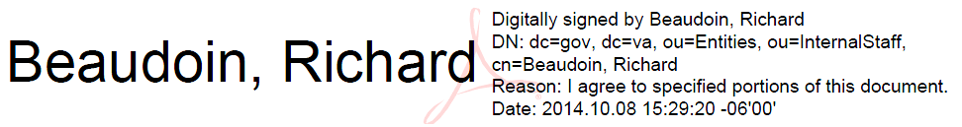Richard Beaudoin

MHV Program Manager/MHV IPT Co-Chair/HLA Project Manager

Theresa Hancock, Director and MHV IPT Co-Chair / VCHIO

Business Sponsor

//es// Vijayakumar R. Bekkem

Bekkem, Vijayakumar R., OI&T Office of Architecture, Strategy & Design

Enterprise Architecture

//es// Jennifer K. Berg

Berg, Jennifer K., SDE PAO Project Manager

Service Delivery & Engineering

1. Signature Verification

